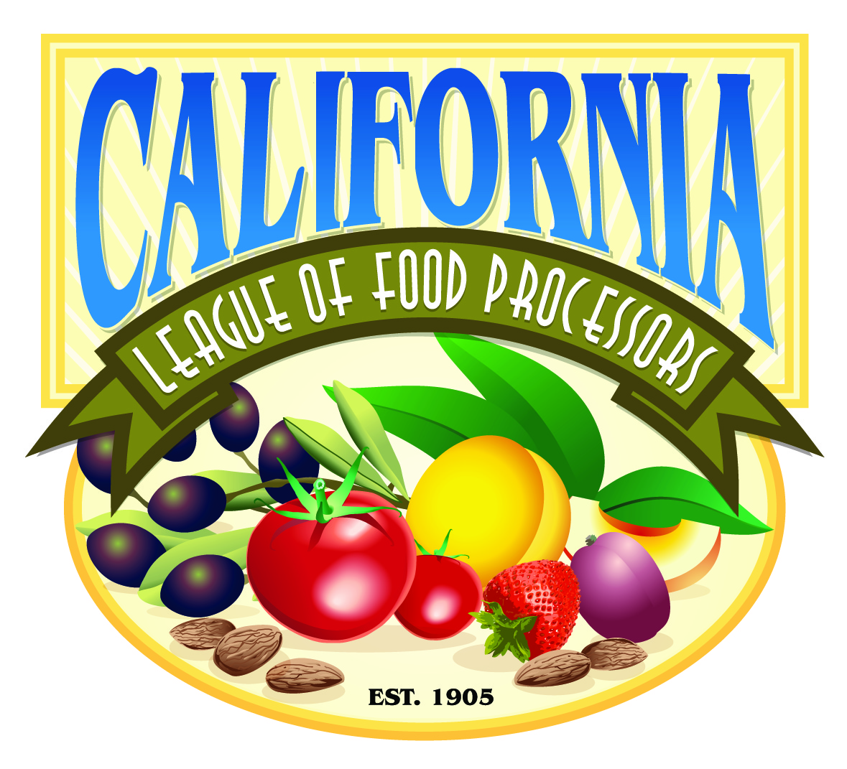

July 28, 2011

TO: The Honorable Mary Nichols, Chair
California Air Resources Board

FR: John Larrea, Governmental Affairs
California League of Food Processors (CLFP)

RE: Comments on Revised Functional Equivalent Document

__________________________________________________________________

In a previous workshop on the Supplement to the AB 32 Scoping Plan Functionally Equivalent Document (FED) staff heard comments from parties familiar with California Environmental Quality Act (CEQA) as to the need to allow for more time in order to produce a document sufficient to meet the requirements under CEQA. Clearly, this remains the case.

A thorough review of the alternative compliance mechanisms set forth in the FED is a necessary part of the process of determining the best methodology for achieving the greenhouse gas reductions required under AB 32. Add to that that this is a California-only endeavor, the costs of which will be borne by over 600 of California’s industries, there is clearly a need for much more than a second cursory review of the alternative programs. While CEQA doesn’t require a state agency to develop a full environmental impact report (EIR), CLFP believes that the issues demand something more than what is presented.

Lack of Economic Analysis of Alternative Compliance Mechanisms Violate Board’s Direction under Resolution 10-42
In CARB Resolution 10-42 (passed December 16, 2010), the Board addresses the FED (pages 8-10) and specifically directs the Executive Officer to take the following actions regarding the FED:
“…
4. Determine whether there are feasible alternatives or mitigation measures that could be implemented to reduce or eliminate any potential adverse environmental impacts while at the same addressing the serious economic recession and its impact on industry and residents of the State; …” (emphasis added)

In the latest FED iteration, though CARB staff discuss the possible alternative compliance options for the regulated industrial community they have not, in any reasonable manner, met the Board’s requirement to address the recession and its implications in the comparison of alternative compliance mechanisms.

Relocation of Facilities Should be Considered as Additional Alternative Compliance Mechanism
In previous comments, CLFP urged staff to consider an additional alternative compliance option to the five listed; that of relocation of facilities. Food processing facilities, subject to either cap-and-trade or a carbon tax rule or other compliance mechanism, will be hard pressed to pass any compliance costs on to the consumer. It is very likely that the facilities will either relocate out of the state or shutdown the operation. In the event of a shutdown, the demand for the end product will be unchanged and production will be increased in other areas. This will cause an economic loss in California and will not reduce greenhouse gas emissions as well as lead to an increase of GHG emissions because California processing facilities are some of the most efficient in the world. The CEQA analysis needs to fully address the high potential for leakage among processing facilities.

Additionally, the economic and social impact on the rural communities either through reduced food processing and production or a shutdown will be severe. These small agricultural communities are highly dependent on food processing operations as a substantial source of employment CARB staff needs to examine the impacts on both the food processing industry and the residents of these California communities pursuant to the Board’s direction on page 10, item 4, cited above.

Additional Considerations per Resolution 10-42
Other factors that need to be considered in CARB’s analysis of alternative compliance methodologies should include:

- The continuing economic decline both in California and in the U.S.: There is diminishing likelihood of any cap-and-trade being initiated at the federal level before 2020. That in and of itself should spur more inquiry into determining if a California-only program is sufficient to achieve the GHG goals without imposing significant economic damage to an already injured state economy. At the least, the current economic situation, and likely continuing economic malaise, will have a major impact ANY compliance program the CARB decides upon.

- The enfeebled Western Climate Initiative (WCI): The WCI is a ghost of its former self, with more observers than active partners. Not a single partner stands ready to join California’s cap-and-trade program in any significant way. New Mexico, the most viable U.S. cap-and-trade partner, is currently addressing a strong challenge to its climate regime. Most of the remaining partners of WCI are all hopeful international offset providers looking to cash in on California captive industries in a restricted market.

California’s Economic Reality No Longer Supports an Aggressive Climate Policy
Clearly, since the adoption of the scoping plan in 2008, the state’s economic landscape, touted to support an aggressive climate policy, has suffered a significant reversal. Since 2008, California has consistently ranked either first, second or third among the states hit hardest by the recession. Unemployment hovers at or near 12%, three to four percentage points above the national average and shows no sign it will move anytime soon. Actual new jobs created in California in the last few years can be counted in the hundreds, not in the four to six figures necessary to signal true economic recovery.

In its Final Resolution, the CARB Board found that “economic growth between 2007 and 2020 is projected to continue at a rate of 2.4 percent;” Yet, since 2008, the state's GDP growth rate slowed to 0.4% in 2008 after having grown 3.1% in 2006 and 1.8% in 2007 (Bureau of Economic Analysis, U.S. Dept. of Commerce). For a state of 35 million, the need for policies that will spur economic growth and put people back to work is vital.

In light of these factors, CLFP urges CARB to, at the very least, determine the two most viable compliance options, whether cap-and-trade and a carbon tax or a command and control mechanism, and provide an in-depth analysis of these alternatives so as to allow stakeholders to make informed decisions as to which will likely achieve the AB 32 goals in the most reasonable and rational means possible.

Given there is little chance for any federal program before 2020 (let’s be honest, there is zero chance for any federally mandated program occurring before 2020), CARB should review all elements of the scoping plan to ensure that 1) a California-only program will best provide for meeting the emission reduction goals and providing the much touted economic stimulus promised under AB 32 and, 2) that the stakeholders and the public are provided the best possible information, a thorough understanding of the choices and potential detriments based on realistic assumptions as to the true costs of the proposed compliance mechanisms.

Thank you for considering our comments. Should you have any questions or need anything further, please feel free to contact John Larrea at (916) 640-8150.

