University of California, San Diego
3900 Fifth Avenue, Suite 310
San Diego, CA 92103-3138
Tel. 619-260-5534 Fax 619-260-1510
www.activelivingresearch.org
Active Living Research
Using Evidence to Prevent
Childhood Obesity and Create
Active Communities

March 8, 2013

Ms. Mary Nichols
Chair, California Air Resources Board
1001 I Street
Sacramento CA 95814

RE: Investment plan for cap-and-trade auction revenues

Dear Chair Nichols:

Active Living Research (ALR), along with 50 other organizations, supports the Sustainable Communities for All proposal, which proposes allocating a significant percentage of cap-and-trade auction revenues to improve clean transportation choices and build affordable housing near transit. We urge you to recommend these proposed strategies in the investment plan for cap-and-trade auction revenues.
ALR is a national program of the Robert Wood Johnson Foundation that supports and shares research on environmental and policy strategies that can promote daily physical activity for children and families across the United States. We place special emphasis on research related to children of color and lower-income children who are at highest risk for obesity.
Investing in transit and affordable housing will significantly help reduce greenhouse gases (GHG). For example:
- One person who uses existing public transportation in lieu of driving can prevent 4,800 pounds of CO2 from entering the atmosphere each year.
- Transportation needs are largely determined by where people want—and can afford--- to live. When lower-income people have access to public transit, they are the most likely to give up their cars. And they are also the most likely to be displaced when property values near new transit lines go up, thus robbing the transit system of ridership and reducing the GHG benefits.
- Lower-income families use 28% more energy per square foot than more affluent households, primarily because they live in older, less energy-efficient housing.
We want to express particular support for investing in the Transit-Oriented Development Housing Program and the State Transit Assistance Program and proposed Active Transportation Program. Ample research shows that when people live in dense, mixed-use neighborhoods with access to transit, they are more likely to walk or bike, thus reducing GHG emissions. Thus there is compelling evidence that urban design and transit strategies can be mutually beneficial to public health and climate change. Increased investment in transit coupled with increased walkability of local neighborhoods can collectively lead to a more active, healthier, and sustainable future. This is especially important for lower-income populations because of the high prevalence of obesity among them.

Unfortunately funding cuts across the state have hurt people’s ability to access transit or to be able to walk or bike safely and conveniently to places they need to go. And these cuts make it difficult to implement AB 32 and/or SB 375.

  - There is currently a shortfall of 555,792 in California of rental homes affordable to households earning eighty percent (80%) or less of the median income. The state’s dissolution of redevelopment agencies eliminated more than one billion dollars a year of funding that helped develop homes to meet this need. Additionally, the federal government cut programs like the Community Development Block Grant by forty percent (40%) and little funding remains from state housing bonds.
  - For nearly two decades, transit ridership has been growing at nearly triple the rate of population growth and twice as fast as the growth in VMT. But during the last ten years, California transit agencies lost more than four billion dollars in funding resulting in service cuts, fare increases, aging infrastructure, and delayed projects.
  - Low-income and disadvantaged communities have higher rates of biking and walking and also higher rates of fatalities and injuries; One third of our total trips are walking or on a bike, yet only about two percent (2 percent) of our transportation funds are spent on bike and pedestrian infrastructure, and recently, federal spending on active transportation was cut by 33 percent.
A cap-and-trade revenue investment plan that keeps these needs at the forefront will have the greatest impact on the communities that need transit the most and that are most impacted by climate change. By investing in affordable and accessible transit, along with housing that is affordable and close to jobs and services, the state can help meet both health and greenhouse gas emissions goals.

Sincerely,

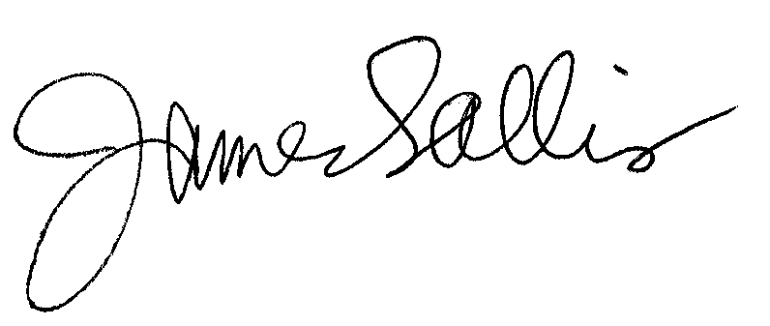

James F. Sallis, PhD
Director

