TransForm, California’s largest nonprofit dedicated to building world-class transportation and walkable communities, appreciates this opportunity to comment on the use of greenhouse gas auction revenues, and the time and effort the State of California has dedicated to addressing climate change and its impacts.

In addition to comments TransForm is submitting with our “Sustainable Communities for All” platform, we wanted to highlight additional economic, health and social equity co-benefits that will accrue should a significant portion of GHG auction revenues be used in ways that provide Californians with real transportation choices and equitably integrate transportation, land use and housing.

**THE TRANSPORTATION BURDEN ON CALIFORNIANS**

Transportation in California is responsible for 38% of our carbon emissions – more than any other sector – and is a major contributor of dangerous levels of nitrous and sulfur oxides, CO, and particulate matter. All of these pollutants damage our environment and our health. Today, one in four children in the Central Valley has a respiratory ailment, and in a classroom of twenty students, the average teacher in the state must be ready for an asthma attack from at least four of her children.

Transportation costs are also a tremendous burden on Californians’ wallets, saddling households with unsustainable transportation expenses and burdening regions with expensive congestion and infrastructure demands.

Most transportation costs are out-of-pocket. In 2009, for example, Bay Area residents spent 7.4 times more than all of their public agencies did on transportation – including roads and transit. Last year, the typical driver spent $8,946 on their car. Of that total, fuel costs made up only about 1/5th of the total cost – the rest derived from maintenance and ownership costs. So efficiency is no panacea - regardless of fuel type and usage, car travel will remain a heavy economic burden on Californians.

This burden is felt disproportionately by poor and disadvantaged households. While transportation costs a typical family earning over $100k/year under 10% of their income, families earning $20-30K/year have to spend nearly one-third of their entire budget. Even Californians earning between $50-75K/year spend nearly twenty percent of their total income just to get around.

**REAL TRANSPORTATION CHOICES SAVE MONEY AND HELP THE ENVIRONMENT**

TransForm’s report, “Windfall for All” identifies the myriad positive climate-related and economic impacts that accrue by providing real transportation choices to Californians.

Californians with the best access to transit in the largest metropolitan areas emit significantly fewer greenhouse gases (GHG’s) and save thousands of dollars on transportation costs each year. Attached to this letter is a short fact sheet with some of these benefits. For a full description of the economic and

greenhouse benefits of using GHG auction revenues to truly transform the ways in which Californians live and move, please accept our attached “Windfall for All” report.

By prioritizing disadvantaged households and communities to receive benefits from California’s cap-and-trade mechanism, the State can achieve large numbers of the economic, health, safety and equity co-benefits intended by its guiding bill language while still meeting its requirement to reduce GHG emissions. Since people in lower-income brackets use transit at far higher rates than those in upper income brackets, since they are expected to be disproportionately impacted by climate change, and since they are more likely to forego the automobile altogether when given real transportation choices, it is vital that significant revenues be used to prioritize these communities and households.

Thank you for your efforts to effectively address California’s greenhouse gas emissions in ways that provide sustainable communities for all.

Sincerely,



Stuart Cohen

Executive Director

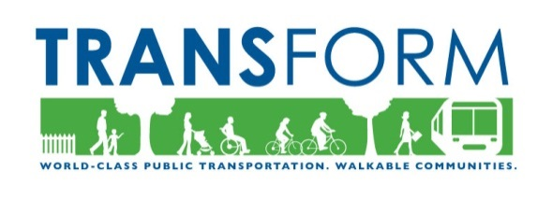Public Transit Saves Families Billions  
while Protecting Our Climate  
  
To examine the savings being harnessed by families living in more efficient neighborhoods, TransForm analyzed spending differences for the four largest regions of California: Los Angeles, San Francisco Bay Area, San Diego and Sacramento.

The census dataset is quoted in 2009 dollars.



Household Transportation Costs by Census Block

As is evident on the map to the right of the Bay Area, the highest transportation costs (darker colors) tend to be in areas not served by transit. In contrast, many of the Bay Area’s most convenient neighborhoods are the urban and suburban areas designed more than 75 years ago, which:

* put housing, jobs and services closer together;
* provide more compact and walkable areas;
* support more public transportation service, in part because of the first two factors.

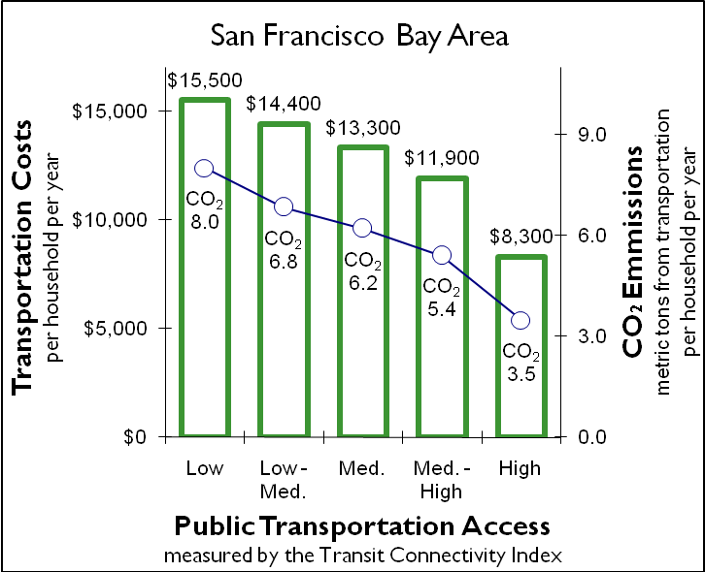Households in neighborhoods that have very good access to public transportation spend significantly less on transportation each year. The one-out-of-five Bay Area households that have the best public transportation access have annual transportation costs that are **39 percent lower** than other households, on average. If the other 80% of communities had the same levels of transit access and transportation spending they would **save, combined, $10.7 billion each year on transportation costs.** That would give the average household $5,450 more to spend on education, health care, etc. As seen in the chart to the right, the correlation is nearly perfect; the higher the transit access, the lower the costs and emissions.

Providing strong public transportation options will also help our efforts to combat global warming.



Transportation-related CO2 Emissions per Household, by Census Block

The differences in emissions are huge. Compared to the 20% of households with the best public transportation access, other households emit on average 42% more CO2 from driving.

As public transit service is cut, it forces more families into the higher spending quintiles. This means they are spending more money on gasoline, insurance and other costs, and less money is being cycled back into our local economy. Transit cuts also result in greatly reduced access to jobs and other opportunities, harming employers and potential employees alike.

As can be seen from a statewide comparison, the Bay Area’s strong transit is creating the greatest potential for saving families money by supporting more jobs and housing growth near transit.

All information from TransForm’s *Windfall for All* report. Full report available at [www.TransFormCA.org](http://www.TransFormCA.org))

**Financial savings and CO2 reductions if all neighborhoods matched the 20% of neighborhoods that have the best public transportation in that region.**

|  |  |  |  |  |
| --- | --- | --- | --- | --- |
| **Region** | **Total Annual Cost Savings (billions)** | **Personal Cost Savings/household** | **CO2 reduction from Vehicles** |  |
| SF Bay Area | $10.7 | $5,450 | 42% |  |
| Los Angeles/SoCal* | $15.4 | $3,600 | 38% |  |
| San Diego | $2.8 | $3,515 | 30% |  |
| Sacramento | $2.2 | $2,825 | 27% |  |
| **TOTAL** | **$31.2** | **$3,847** | **34%** |  |

* Analyzed for the six-county region of the Southern California Association of Governments (SCAG)

Author’s calculations of CNT 2009 data.