

August 5, 2013

Mr. Mike Tollstrup
California Air Resources Board
State Environmental Protection Agency
Sacramento, CA 95814

RE: Comments on the California Air Resources Board (CARB)
2013 Update to AB 32 Scoping Plan

Dear Mr. Tollstrup:
The Center for Energy Efficiency and Renewable Technologies (CEERT) appreciates the opportunity to provide these comments regarding the California Air Resources Board’s (ARB) 2013 Update to the AB 32 Scoping Plan. The 2013 AB 32 Scoping Plan begins to set the stage for the post-2020 greenhouse gas (GHG) reduction plan for California.
In order to accelerate the implementation of strategies to achieve targets of the previous scoping plan, and to set California on a course to achieve the much deeper reductions in GHG emissions needed by 2050, CEERT recommends the following six actions:

- Methane, black carbon and other short-lived pollutants. AB 32 called for CARB to develop a plan to reduce black carbon and other short-lived climate pollutants (SLCPs). These actions, which could have an immediate effect in reducing global warming and improving air quality, have not been developed or publicly presented. CARB should work with local air pollution districts to define and implement a regulatory plan to reduce emissions of SLCPs, which would complement the state’s plan for reducing emissions of CO₂. This plan should include:
  - Appointing a scientific advisory panel on SLCPs to ensure accurate metrics and assumptions upon which to base SLCP-reducing measures. Independent scientific experts from Scripps, Stanford, the University of California , and around the world are conducting crucial scientific research and applied studies, which should guide CARB in developing its regulatory strategy for SLCPs.

  - Work with air pollution control districts to develop, adopt, and enforce rules on stationary and fugitive sources of methane and black carbon, and enforce control measures and monitoring practices to reduce SLCPs, including the following:
    - Designating methane as an ozone precursor and measuring emissions at oil and gas operations.
    - Installing methane digesters and capture systems and collecting slash and other debris from forest and agricultural waste.
    - Further reducing emissions from existing on and off road diesels; requiring pellet- or catalyst-equipped burning on stoves and fireplaces; and accelerate the phase out of agricultural burning, diverting these wastes to cleaner biomass energy plants.
    - Working with CalRecycle to implement regulations to greatly reduce landfill methane emissions by limiting leakage, capturing and converting methane into near zero distributed clean energy uses, and reducing the amount of organic material entering landfills.
    - Prohibiting HCF-134a leaks, requiring reprocessing, switching refrigerants, and capturing “banked” gases from automotive and appliance air conditioning and refrigeration.

The following graph from the UNEP 2011 Assessment (Drew Shindell et al) shows the importance of SCLP reductions for lessening global warming in the near term.
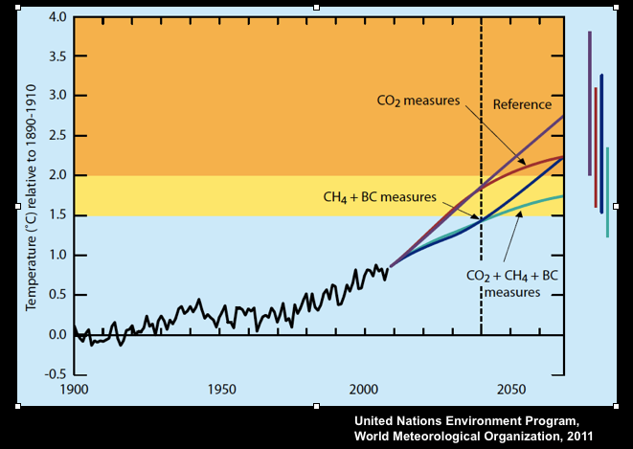

- The need to minimize GHG emission when replacing electric energy previously provided by San Onofre Nuclear Generating Station (SONGS). The permanent shut down of SONGS, when combined with the pending retirement of once through cooling plants on the coast, will result in substantial need for replacement power. There is also significant uncertainty regarding the long term operation of Diablo Canyon nuclear plant near San Luis Obispo, and contingency planning for its possible retirement should begin now.

In these circumstances, every effort should be made to ensure that any “replacement resources” procured by the utilities minimize or reduce GHG emissions. An important distinction should be made between replacement of local capacity needs and energy previously provided by retiring power plants. Local capacity provides the ability to provide local grid support during rare emergencies. Facilities providing replacement energy need not all be local and, when producing energy, should have low GHG emissions (from zero and near-zero to significant GHG emissions). For example, to replace SONGS, the local capacity requirements are likely to be in the 300 MW range, which requires quick start-up in key locations. SONGS energy replacement would likely be in the 2,000 MW range from any location.

It is important that the portfolio of sources of replacement power not result in significant increases in GHG emissions or a substantial increase in California’s already significant dependence on natural gas, which currently provides more than 60% of the state’s electricity in net dependable capacity. This is essential, given the wide range of uncertainty regarding the actual life cycle emissions of natural gas, and the climate forcing potential of methane.
Demand response, energy efficiency, clean distributed generation, renewables, transmission expansions, and sharing resources with municipal utilities should be the primary sources of replacement power. Advanced, high efficiency, quick start, fast ramp natural gas plants should provide needed capacity but be designed and allowed to operate only when preferred resources are not available.

- Setting Medium and Long Term Clean Energy Targets. California is well on its way to producing 33% of its energy from wind, solar thermal, photovoltaic, and geothermal renewable energy by 2020. However, California must not lose momentum in reducing dependence on fossil fuels after the 2020 deadline of AB 32. We must evaluate the successes and failures of the RPS procurement system and determine what changes are needed to move toward greater reliance on energy efficiency, renewables, and other low-carbon resources and technologies. Recent analyses by grid operators and energy agencies suggest that increasing penetration of renewables must be undertaken with greater attention to load balancing, geographic diversity, and a diverse renewable portfolio. Out of state wind and solar and Imperial Valley geothermal can make large contributions to system balancing, given the geographic diversity of their output. California must look regionally in order to balance the system with least emissions.

AB 177 by Assembly Member Manuel Perez is currently pending before the State Legislature and would establish an integrated planning and procurement policy for the electric sector, based on the simultaneous achievement of renewables, reliability, and GHG goals, with an interim renewables target of 51% by 2030 and a long term GHG target for 2050, as determined by the ARB.
In order to provide long term direction to California’s energy infrastructure toward sustained, orderly reductions in GHG emissions, utilities should be required to achieve a target of 51% of its electricity from renewable or zero carbon energy sources by 2030. CARB, working with the CEC, CPUC, and CAISO, should conduct analyses to determine appropriate goals for 2040 and 2050. These goals must be in place soon in order to plan for and achieve them.

- Energy efficiency and Demand Response. We must greatly expand targeted energy efficiency, demand response, and clean distributed generation as the core strategy for meeting the load balancing needs of California’s electric grid. If California is to successfully achieve greater reductions in greenhouse gas emissions and sustained, orderly expansion of clean energy, we must tear down the silos of energy planning and procurement and recognize the linkages between greenhouse gas emissions, renewables, reliability, and affordability, and adopt policies and planning to achieve these goals simultaneously.

- Extending energy efficiency measures through building/appliance programs.. California should consider setting up an Energy Efficiency Utility as a state-chartered, non-profit corporation, as Vermont and Delaware have done, in order to achieve higher levels of energy savings in every region of the state at lower cost. This corporation could be organized by county, building on new/existing Regional Energy Efficiency Networks such as CCSE in San Diego. Similarly, Sonoma County is actively considering setting up a non-profit corporation to pursue EE savings in the region.

Zero or near-zero carbon distributed generation needs a policy framework to guide evolution of intelligent local networks. Such a framework could start with: a) principles for Open Access to the distribution system; and b) rate restructuring and time of use pricing, with a distribution charge to pay for upgrading and maintaining more capable local grids. An all-technology feed-in tariff tied to GHG reductions should also be considered.
- Reducing Existing CO₂. California should begin developing plans and mechanisms for reducing and ultimately eliminating carbon dioxide from the ambient air and water.

