March 6, 2013

Ana Matosantos, Director
California Department of Finance
915 L Street
Sacramento, CA 95814

Mary Nichols, Chair
California Air Resources Board
1001 I Street
Sacramento, CA 95814

RE: Cap-and-Trade Auction Proceeds Investment Plan

Dear Director Matosantos and Chair Nichols:

The Rural County Representatives of California (RCRC) represents thirty-two counties statewide. Our Board is made up of County Supervisors who work tirelessly to overcome the challenges facing rural communities in today’s trying economy to improve the quality of life for the constituents they represent. RCRC appreciates this opportunity to comment and offer recommendations on the proposed Cap-and-Trade Auction Proceeds Investment Plan before the state issues a draft for public comment.

Rural counties hold great potential for projects that could reduce greenhouse gas (GHG) emissions while benefiting those living in rural communities. Unfortunately, our counties face a significant shortage in funding to maintain and improve our transportation networks, which both prevents GHG reduction projects and impacts the quality of life in our communities. RCRC’s member counties have some of the highest unemployment rates in the state and, with state general fund support all but vanishing, rural county governments are struggling to maintain the operations they already have in place, much less start new projects to help reduce greenhouse gas emissions.

In light of those challenges, RCRC recommends that the state consider carving out a portion of the auction proceeds to directly benefit rural counties and local planning agencies. Local planning agencies are in tune with the needs of the communities they serve, and have the land use authority to utilize these funds to initiate and complete projects that will both reduce GHG emissions and increase the quality of life in those counties.

Ultimately, RCRC asks that the state of California think outside of both the urban realm and already-established funded projects and invest cap-and-trade proceeds in projects that not only reduce GHG emissions, but also benefit economically challenged rural communities around the state. We look forward to working with you in the future as you continue to develop the investment plan.

Sincerely,
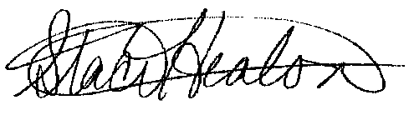

Staci Heaton
Regulatory Affairs Advocate

CC: RCRC Board of Directors

