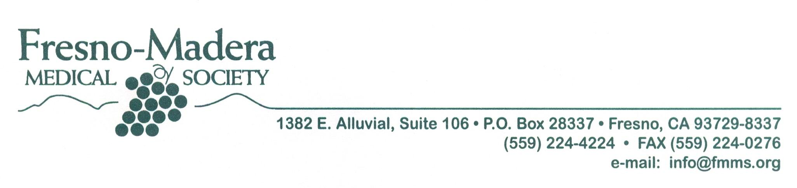

December 13, 2010

Mary Nichols, Chair

James Goldstene, Executive Officer

California Air Resources Board

1001 “I” Street

P.O. Box 2815

Sacramento, CA 95812

Dear Ms. Nichols and Mr. Goldstene:

The Air Quality Sub-Committee of the Fresno-Madera Medical Society would like to comment on the amendments proposed in October 2010 for the “truck and bus” and “off-road” regulations. We have always and continue to be appreciative of ARB board and staff commitment to cleaning up our air. We know that this is no easy task but still you remain committed to protecting the health of Californians.

When the economy took a turn for the worse we too felt the effects. A poor economy affects us all so we understand and support the need to provide some relief to diesel equipment and truck owners during the economic downturn. As businesses suffered, so did families, many of them losing their health coverage making them more vulnerable to the effects of poor air quality. We are firm believers in finding middle ground and a workable solution for everyone. Clean air and a vibrant economy are essential to us all so a fair but aggressive plan is essential.

The rule changes, which are being proposed, do a great job of identifying areas of relief for truck owners; however, in some areas they seem to go beyond what is necessary in the short term. As physicians we are always concerned with health protections. With the proposed changes, communities in the San Joaquin Valley living around the State’s most important transit corridors will have to suffer longer from the impacts of diesel pollution. Our Valley will also have a **ZERO** SIP margin making us very susceptible to small changes in the economy With some of the dirtiest air in the nation the Valley needs to be on the fast track to meeting SIP requirements not delaying attainment or even failing to meet attainment. We therefore urge your consideration of the amendments recommended here in order to achieve the following:

1. Reduce localized impacts, especially for the San Joaquin Valley, and retain the mid- and long-term benefits of the On- and Off-Road rules.
2. Eliminate loopholes to ensure all off-road equipment is cleaned up by 2023.
3. Create a State Implementation Plan margin for 2014 and beyond, especially for the San Joaquin Valley.
4. Create or make available more incentives for truck drivers to encourage compliance.

In closing we appreciate the hard work of staff, as well as board members to adjust these important regulations in these changing circumstances while making an effort to maintain health benefits. Your decisions to enforce a balanced yet aggressive plan bring us closer to a better California, a California that embodies good health and a good economy.

We urge you to continue to incorporate changes, which help to find solutions and incentives for reducing the financial burden to truck owners and that more importantly improve health benefits Thank you for your time and consideration.

Sincerely,

William L. Ebbeling, M.D., F.A.A.P., F.A.A.A.A.I.

Chair, Air Quality Sub-Committee

Fresno-Madera Medical Society