Clerk of the Board
Air Resources Board
1001 I Street
Sacramento, California 95814

RE: Proposed S. B. 375 Targets

Dear Honorable Board Members,

On behalf of the board of directors of the Greater Bakersfield Chamber of Commerce and its members, I am writing to express our concerns regarding proposed emission reduction targets specified in the Air Resources Board’s (ARB) August 9, 2010 staff report. While we appreciate the ambitious efforts to achieve climate change goals, we are concerned that though well-intended, the targets prescribed by the ARB staff report are unreasonably unattainable and will have negative impacts on local area businesses and industries, and were developed with what seems is an arbitrary methodology that fails to consider the unique demography and geographic attributes of Kern County.

The 10 percent reduction by 2035 goal suggested is beyond reach and goes far beyond the scope of any modeling provided from any Valley Metropolitan Planning Organization (MPO) to date. Kern County bears little resemblance to the big four major metropolitan areas, and basing targets for Kern on what other regions can do is arbitrary, unfair and could have serious environmental and economic repercussions.

It is for theses reasons the Greater Bakersfield Chamber of Commerce respectfully asks the ARB to bear in mind local input and adopt a placeholder target of a two-percent decrease by 2010 and a five-percent decrease by 2035 for the seven Valley MPOs. This will allow more time to enhance the modeling to more accurately reflect local conditions on what is ambitious, yet achievable, as well as, inter-regional travel and strategic employment areas.

We thank you in advance for your consideration and ask that you please contact me at (661) 327-4421, should you have questions or require additional information.

Respectfully submitted,

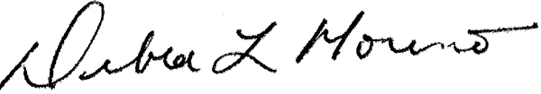

Debra L. Moreno
President/CEO

