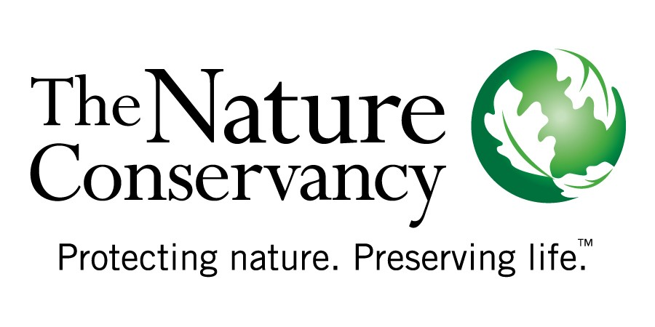

California Regional Office

201 Mission Street, Fourth Floor

San Francisco, CA 94105

**tel** [415] 777-0487

**fax** [415] 777-0244

*nature.org*

*nature.org/california*

**Summary of The Nature Conservancy’s recommendations for ARB regarding SB 375 implementation**

1. In addition to the direct benefit of reducing transportation related emissions, full implementation of SB 375 can and should promote other public benefits, including the protection of open space, biological sequestration by forests and other natural lands, and improved air and water quality. **ARB should play a guiding role in SB 375 implementation to facilitate the attainment and integration of public benefits, including natural land conservation into Sustainable Communities Strategies (SCS’s)**, as outlined in the Regional Targets Advisory Committee (RTAC) report and SB 375 legislation.
2. Specifically we recommend ARB facilitate the attainment of co-benefits in the following manner:
   1. Identify existing resources and tools (e.g., models, greenprints, accounting methodologies, etc.) that can provide guidance to the MPO’s in the near term to inform SCS design to optimize the public benefits.
   2. Identify existing resources and tools so that MPOs can monitor and report on the attainment of public benefits through SCS implementation and attainment of targets.
   3. Coordinate with the Strategic Growth Council, member agencies and staff working groups to build capacity and direct resources to MPO’s to ensure SB 375 implementation achieves the full suite of public benefits and land use goals intended by the statute and Proposition 84.



California Regional Office

201 Mission Street, Fourth Floor

San Francisco, CA 94105

**tel** [415] 777-0487

**fax** [415] 777-0244

*nature.org*

*nature.org/california*

**Recommendations for ARB regarding SB 375 implementation – details and background**

**Ensure the incorporation of natural resource conservation in SB 375 implementation**

The strong nexus between land use, land conservation and public well-being makes it critical that SB 375 implementation incorporate natural resource conservation. Better integration of land use and transportation planning including designation of priority natural and agricultural areas for conservation can not only help regions meet their SB 375 targets by focusing growth, transit and infrastructure in areas that provide the greatest advantages to local communities but will also preserve the broad suite of essential benefits provided by these lands including removal of carbon and other Greenhouse Gases (GHG) from the atmosphere, clean air and water, provision of food and jobs, protection against severe weather events and habitat for fish and wildlife. We encourage ARB to maintain an ongoing role in the implementation of SB 375 to help ensure that these public benefits are preserved and promoted.

**There is a strong basis in statute and state policies and programs for the integration of natural resource protection in SB 375 implementation:**

One of the strongest themes emerging from public comment throughout the Regional Targets Advisory Committee (RTAC) and target setting process has been the need to maximize the public benefits of SB 375 implementation, including natural resource protection, public health and social equity to ensure the continued well-being of all Californians. Local elected officials expressed the desire to see these benefits clearly articulated to help their constituents better understand the opportunity SB 375 presents to them to shape the future of their communities. Furthermore, a number of policy documents emphasize the value of including natural resource conservation in SB 375 implementation:

1. SB 375 includes the requirement that a Sustainable Community Strategy “gather and consider the best practically available scientific information regarding resource areas and farmland in the region”.
2. The RTAC report recommends that MPOs “identify, quantify to the extent possible, and highlight co-benefits throughout the SB 375 target setting and implementation processes”. Listed co-benefits include “Conservation of Open Space, Farm Land and Forest Land”.
3. AB 32 includes multiple provisions stating the legislature’s intent that policy and regulation developed under the law should maximize environmental and natural resource protection, among other benefits. SB 375 is included as part of the AB 32 Scoping Plan.
4. Funding sources - One of the largest existing sources of funding, the Strategic Growth Council’s Sustainable Communities Planning Grants has tied SB 375 implementation funding to natural resource protection. In addition the Economic and Allocation Advisory Committee (EAAC) report recommends that a portion of AB 32 allowance revenue be devoted to (among other things), SB 375 implementation consistent with RTAC and Strategic Growth Council recommendations.

**Context: Comprehensive climate change policy must include a central role for nature**

California’s natural resources have a critical role to play in efforts to reduce GHG emissions and respond to the impacts of climate change. The loss of forests and other natural lands contributes significantly to our state’s total emissions but these lands can also play a significant role in the solution by removing large quantities of carbon dioxide from the atmosphere and storing it for centuries. Globally, forests absorb nearly 20% of annual GHG emissions from burning fossil fuels[1] substantially buffering the rate of climate change. In addition to these vital climate regulation benefits, natural lands are critical to helping human communities respond to the impacts of unavoidable climate change. For example wetlands and coastal habitats buffer communities from storm surges associated with severe weather events and forested watersheds can help alleviate the impact of changes in water supply and quality by filtering water and regulating flows. Comprehensive climate change policy must include a robust role for nature and protection of the climate regulation functions and broad suite of other benefits provided by our natural lands.

Contacts:

* Julia Gardiner

[jgardiner@tnc.org](mailto:jgardiner@tnc.org)

* Michelle Passero

[mpassero@tnc.org](mailto:mpassero@tnc.org)

1. Lewis, S. L., Lopez-Gonzalez, G., Sonké, B., Affum-Baffoe, K., Baker, T. R., Ojo, L. O., et al. (2009). Increasing carbon storage in intact African tropical forests. *Nature*, *457*(7232), 1003-6.

  