Global Warming is Now Worse than the Worst Predictions
By Jim Stewart, PhD., Jim@EarthDayLA.org, June 8, 2007

Recent analysis shows that global CO2 emissions are much worse than the worst-case scenario considered by the UN IPCC in its latest reports. Below are figures from an article titled “Global and regional drivers of accelerating CO2 emissions,” Proceedings of the US National Academy of Sciences, published online on May 22, 2007, (http://www.pnas.org/cgi/content/abstract/104/24/10288).

The left figure below shows the various global warming scenarios considered by the UN. The top red line is the worst-case, which leads to disastrous climate changes, including huge rises in sea levels over 40 feet and massive crop failures and species extinctions. The right figure presents the latest global data, showing “a sharp acceleration in global emissions occurred in the early 2000s.” Indeed, you can see the current observed EIA* data on CO2 emissions in the white circles are already above the red line. An analysis shows the actual emissions are increasing at a rate 50% higher than the worst-case scenario, so the planet will reach catastrophic levels much sooner.

The article reports 52% of the emissions growth is from China, as dramatically shown in the large blue section in the third bar in the lower figure. (And this is just using 2004 data, which does not reflect the recent increased emissions from China in 2005 and 2006.) In addition, the paper does not include the large climate effects from methane and other greenhouse gases.

So currently humanity is headed for a disaster beyond the most catastrophic predictions. Clearly this is a planetary emergency almost beyond our imagination. Any more burning of fossil fuels is folly.
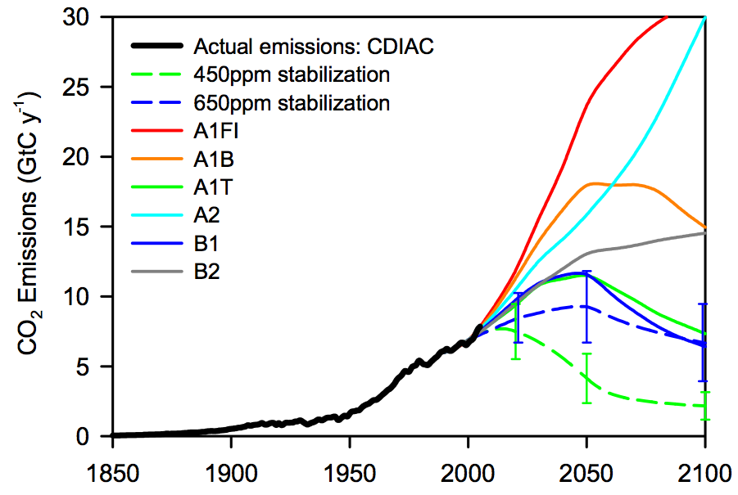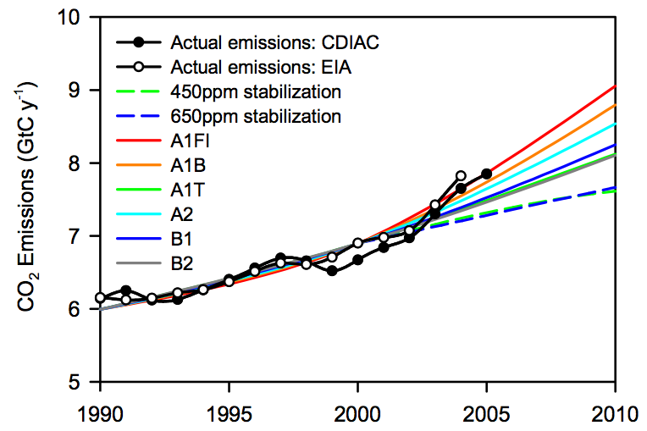

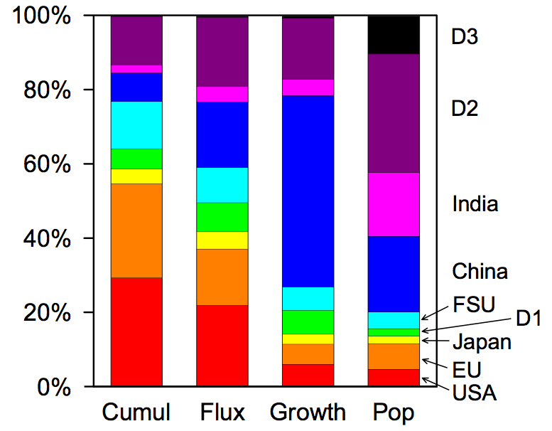
* The authors of the paper state: “However, the CDIAC data [in the black dots] are currently undergoing revisions for China. Therefore we use EIA as the primary source for emissions data subsequent to 1980.”

