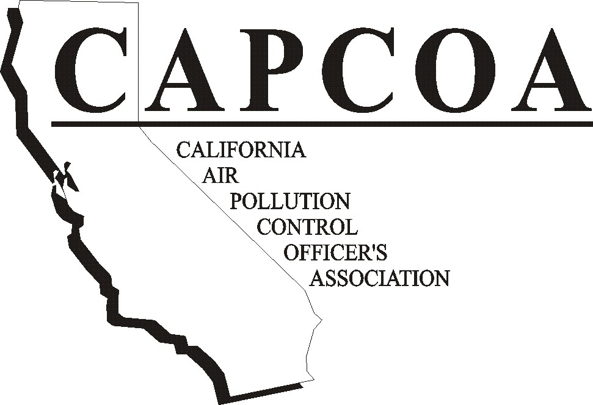

PRESIDENT
Larry Allen

San Luis Obispo County APCD

VICE PRESIDENT
Douglas Quetin

Monterey Bay Unified APCD

PAST PRESIDENT
Barbara Lee

N. Sonoma County APCD

SECRETARY/CHIEF
FINANCIAL OFFICER
Terry Dressler

Santa Barbara County APCD

DIRECTORS

Stephen Birdsall

Imperial County APCD

Jack Broadbent

Bay Area AQMD

Thomas Christofk

Placer County APCD

Mat Ehrhardt

Yolo-Solano AQMD

Larry F. Greene

Sacramento Metro AQMD

Jim Harris

Amador County APCD

Seyed Sadredin

San Joaquin Valley APCD

Richard Smith

San Diego County APCD

W. James Wagoner

Butte County AQMD

Barry Wallerstein

South Coast AQMD

EXEC. DIRECTOR
Melvin D. Zeldin
mel@capcoa.org

980 Ninth Street, 16th Floor

Sacramento, CA 95814
(916) 449-9603 (916) 449-9604 FAX
www.capcoa.org

November 13, 2006

Clerk of the Board
California Air Resources Board
1001 I Street 23rd floor
Sacramento, CA 95814

Re: Comments Regarding CARB’s Proposed Amendments to the Airborne Toxic Control Measure for Stationary Compression Ignition Engines

The California Air Pollution Control Officers Association (CAPCOA) appreciates the opportunity to submit comments regarding the proposed amendments to the Airborne Toxic Control Measure for Stationary Compression Ignition Engines. We support the efforts of the California Air Resources Board to reduce public exposures to toxic air contaminants through airborne toxic control measures (ATCM). Diesel particulate emissions are a significant source of toxic air contaminants in California and the proposed ATCM amendments are an important step in reducing these emissions.

The following comments represent issues of common interest to the entire CAPCOA membership. Some districts have identified issues of individual concern and may submit separate comments addressing their concerns.

Substantive Comments

1. Outreach

We appreciate including the requirement for a registration or permitting program in the ATCM since it provides Districts with a mechanism to implement the regulation. As you know, agricultural operations have not previously been regulated by many air districts and the task of identifying and informing all the operators of agricultural engines subject to the regulation will be daunting. Although coordination with Agricultural Commissioners, Farm Bureaus, and farming organizations will help make agricultural operations aware of the regulation, considerable effort will be required to locate specific engines and inform their owners about registration and compliance requirements. CAPCOA appreciates ARB’s willingness to work with us on outreach activities and underwrite much of the outreach cost. We also acknowledge the comprehensive outreach effort that ARB and the San Joaquin Valley District conducted over the last two years with the San Joaquin Valley agricultural community. While adequate outreach has been conducted in the San Joaquin Valley, we believe that
Clerk of the Board – CARB Page 2 November 13, 2006

much more is needed in a number of other air districts throughout the State. Despite currently planned outreach efforts, we remain concerned that many agricultural engine owners could remain unaware of the regulation, which will result in missed grant funding opportunities for cleaner engines as well as missed compliance deadlines. Outreach to individual farming operations (not just associations) prior to the OAL approval of the ATCM would help avoid implementation and awareness problems.

2. Use of Incentive Funding

The Staff Report for this regulation identifies a number of funding sources that may be used to replace engines with the cleaner diesel engines required by the regulation or electric motors. A primary source of funding identified is the Carl Moyer program. Based on ARB information, there could be several thousand engines subject to the ATCM, many of them noncertified (Tier 0) engines. In fact, it is highly likely that the staff report estimate of total number of engines is significantly lower than the actual number of engines that will be subject to the regulation. Pursuant to the draft regulation most of the non-certified engines, those between 100 hp and 750 hp, must be replaced by December 31, 2010. In order to qualify for Moyer funding these engines would need to be in the Moyer program by December 31, 2007. Moyer funds are an option but will not provide sufficient funding to replace that many engines in this short time frame. In some Districts, less than one third of the engine replacements could be accommodated by available Moyer grant funding. Moyer funds could be made available for a greater number of engines if the NOx, HC, and CO standards were applicable two years after the diesel PM limits become effective. Such a policy would allow for timely installation of certified engines, but the NOx, HC, and CO emissions would remain surplus for another two years and allow additional time to apply Moyer funding to engine replacements.

3. Biofuels

The draft regulation clarifies that biofuels (biodiesel and biodiesel blends) are allowable fuels for engines subject to the regulation. However, no documentation is provided regarding toxic air contaminants that may be produced by combustion of biofuels. Additional review is needed to determine if the emissions from biofuels should be regulated, the impacts from emissions of criteria air pollutants from biofuels, and if biofuels may be used to comply with the regulatory requirements.

4. Fiscal Impact on Districts

The staff report prepared for this regulation lists anticipated fees that will be charged by the Districts. The staff report did not develop the range of fees from district fee information and districts were not consulted prior to publication of these fees. We believe that for many Districts the fees contained in the staff report significantly underestimate the cost of administering a registration program necessary to ensure compliance with this regulation. Fees reported in table F-1 (Appendix F page 3) are $145 to $190 for initial registration, $26 to $75 for annual renewal without inspection and $242 for inspection fees. These fees do not reference or consider fees recently adopted by the South Coast Air Quality Management District for agricultural engines, nor are they consistent with fees charged by ARB for the Portable Equipment Registration Program (PERP). The current initial PERP registration fee is $275, which is simply an administrative fee. District costs will be significantly higher to include the cost of establishing the necessary compliance increments and
Clerk of the Board – CARB Page 3 November 13, 2006

working with the applicant to ensure the regulatory requirements are understood and will be met. Likewise, the continuing periodic fees must represent the true cost of administering the necessary program. Districts will have to undertake such activities as outreach, development of registration and permitting programs, development and maintenance of databases, engine inspection and location verification, other implementation and compliance activities and, in some cases, toxic risk assessment. It is difficult for CAPCOA to estimate what the fees would be before the proposed revisions to the ATCM and Hot Spot regulations are in their final forms. However, it is possible that, depending on such diverse factors as the attainment status of a district, the sophistication of a district’s computer resources, the number of engines within the district, the number of non-certified engines within a district, and the applicability and complexity of Toxic Hot Spot reporting, the fees could be several times higher than the ARB estimate.

5. Compliance Extensions

Section 93115.8(a)(1)(A)5 of the draft regulation allows for compliance extensions of up to three years for installation of electric motors or a very clean diesel engine where the District finds that the thresholds for significant risk would be exceeded. Section 93115.8(b)(6) allows only a two year extension for engines without establishing a significant risk. It is requested that 93115.8(b)(6) be changed to three years.

Clarifying Comments

Exempt Engines

Several engine types are listed in Section 93115.2(a) of the draft regulation with the intent that the regulation does not apply to these engines. However, Section 93115.2(b) only excludes engines as provided in Section 93115.3 and 93115.9. To clarify that the engines in 93115.2 are exempt from the ATCM they should be moved to 93115.3.

Thank you for the opportunity to comment on the proposed ATCM. CAPCOA acknowledges and appreciates the work performed by ARB staff on this difficult project. CAPCOA’s member districts look forward to working with the ARB to implement this important regulation.

Sincerely,


Larry Allen
President, CAPCOA

cc: Catherine Witherspoon, Executive Officer

