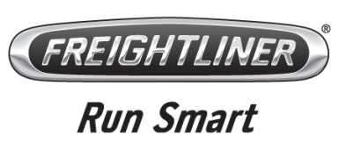

July 21, 2011
Re: Proposed AB 118 Air Quality Improvement Program Funding Plan for Fiscal Year 2011-12

To Whom It May Concern:
On behalf of Freightliner Trucks, I would like to make a few comments regarding the proposed AB 118 Air Quality Improvement Program Funding Plan for Fiscal Year 2011-12. Specifically, I would like to voice our support for maintaining funding levels for the Hybrid Voucher Incentive Project (HVIP).

- 2010 was by banner year for hybrid sales, not only for Freightliner Trucks, but for the commercial vehicle manufacturing industry as a whole, due in large part to the availability of funds through HVIP.

- The reduced per-truck amounts have reduced utilization of the program thus far in 2011. With the current cost of the available hybrid electric technology, the length of time it takes to pay back a hybrid purchase is a tough sell and these funds made it palatable to many fleets.

- Fleets that purchased last year are still testing and deploying these units purchased in 2010 to their fleets and many of them are not expected to purchase hybrids again until next year. At that point they will determine whether or not performance meets expectations. The availability of HVIP funds is a key piece of that additional purchase consideration.

- HVIP funds continue to be the "only game in town", with the federal government failing to extend the tax credits that expired at the end of 2009 and are essential if hybrids are to remain a viable near term option for customers in California.

Freightliner Trucks
2477 Deerfield Drive
Fort Mill, SC 29715
803-578-3001 Phone
803-578-3737 Fax

Best regards,

Gregory Treinen
Segment Manager, Product Marketing
Freightliner Trucks

