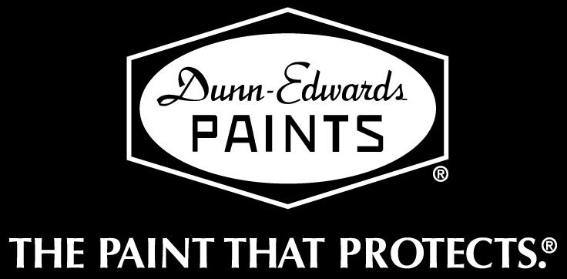

DUNN-EDWARDS CORPORATION
4885 East 52nd Place, Los Angeles, CA 90040

ENVIRONMENTAL AFFAIRS
Phone: (323) 826-2663
Fax: (323) 826-2653
Via E-Mail to California Air Resources Board
http://www.arb.ca.gov/lispub/comm/bclist.php

October 23, 2007

California Air Resources Board
1001 “I” Street
Sacramento, CA 95814

RE: PROPOSED AMENDMENTS TO THE SUGGESTED CONTROL MEASURE FOR ARCHITECTURAL COATINGS

Dear Members of the Board:

Dunn-Edwards Corporation is a California-based manufacturer and distributor of architectural coatings, serving the Southwestern United States. Our Main Office & Factory, as well as a majority of our retail outlets, are located in California, where we employ more than 1,500 people directly and contribute indirectly to the livelihoods of thousands more professional painting contractors and maintenance staff painters. Dunn-Edwards coatings are frequently specified for use on public buildings, including State of California office buildings, in addition to industrial, commercial, and residential structures of all kinds.

This letter is to comment on the Proposed Amendments to the Suggested Control Measure (“SCM”) for Architectural Coatings, which are to be heard at your meeting on October 26, 2007. When the Air Resources Board last revised its SCM in June 2000, Dunn-Edwards was one of the few paint industry members to express support for the revision. We regret that we are unable to support the current proposed amendments to the SCM, for the reasons given below.

(1) Inappropriate Use of SCAQMD Rule 1113 Limits

For several major coating categories (e.g., Flat Coatings, Primers Sealers & Undercoaters, and Specialty Primers), the revised SCM would use VOC limits from South Coast AQMD Rule 1113. In the context of Rule 1113, however, the limits on those categories are, in effect, “average” limits because the categories are subject to the Averaging Compliance Option of Rule 1113. Under that option, a manufacturer may
California Air Resources Board
October 23, 2007
Page 2

distribute limited amounts of product with VOC contents above the applicable limit, so long as the excess VOC content can be offset by distribution of product with VOC contents well below the limit (in accordance with a District-approved “Averaging Program” that includes regular reporting requirements).

Using these “average” limits as “absolute” limits in the SCM (which no longer offers an Averaging Compliance Option) means that as local districts adopt the revised SCM, California will revert to a two-tiered regulatory system in which products that are allowed to some users will be denied to other users. In this case, low-volume high-performance coatings for certain specialized needs will continue to be available to about half the population of California in the South Coast AQMD, but not to the other half in the rest of the state. This situation will likely impede compliance and enforcement with respect to SCM-based local district rules.

Also, we find it somewhat ironic that the SCM would ban more products than Rule 1113, yet achieve less emission reductions overall – in part, because Rule 1113 places much lower “average” limits on other major categories that the SCM leaves untouched, even though complying marketshares are very high in these categories (e.g., Industrial Maintenance Coatings and Stains, which retain their current limits at 250 g/L in the SCM). This does not appear to be efficient rulemaking.

(2) Insufficient Options for Priming Metal

The revised SCM would put a VOC limit of 250 g/L on Rust Preventative Coatings, thus banning the solventborne alkyd products that make up 96 percent of the sales volume in this category. The remaining available options would include: waterborne acrylic latex coatings; solventborne coatings with high acetone content; and industrial high-solids two-component catalyzed coatings. Because of performance limitations, application requirements, and health & safety concerns, none of these options is suitable for the residential, institutional, and commercial uses that this category was intended to accommodate.

This is particularly true for metal primers, which make up about 20 percent of the sales volume in the Rust Preventative Coatings category and must be capable of being applied directly – and adhering well – to metal substrates in less than perfect condition. Corrosion of metal can cause serious safety issues as well as wasteful consumption of energy and material resources to replace corroded building components. We believe these considerations justify retaining adequate metal primers as suggested below in the section on “Recommendations.”

(3) Lack of Environmental Impact Analysis

Contrary to ARB policy and the California Environmental Quality Act (CEQA), the potentially significant adverse environmental impacts of the revised SCM, specifically in
California Air Resources Board
October 23, 2007
Page 2

regard to the issues discussed above, have not been investigated or analyzed. The general discussion of environmental impacts presented in Chapter 6 of the Technical Support Document (TSD) does not take even the preliminary step of identifying which products would be banned by local district implementation of the SCM, and how the performance of those products would differ from that of remaining alternative products. Instead, the TSD discusses the analysis that was performed for the 2000 SCM, and various studies related to other rule requirements.

Consequently, we believe that local districts adopting versions of the revised SCM may not lawfully rely upon the TSD, or previous analyses and studies, to satisfy their obligations under CEQA. A new and comprehensive assessment is needed.
(4) Lost Opportunities to Improve Rule Effectiveness
In several respects, it seems that opportunities to re-think and improve the regulatory strategy of the SCM were passed by in favor of keeping to a pre-determined rulemaking schedule. One such opportunity would involve a radical simplification of the categories and definitions in the SCM. Many categories with the same, or essentially similar, limits can be consolidated to reduce the number of separate categories by one-third to one-half. A simpler rule would promote easier understanding, compliance, and enforcement.
Another opportunity would deal with development of a more effective form of standard for architectural coatings. The VOC content standard, expressed as mass of VOC per volume of coating, is not a reliable indicator of the potential environmental impacts of a coating because it does not account for various key factors, including: VOC reactivity, availability, and toxicity; and coating performance characteristics such as coverage and durability. As the American Chemistry Council has noted in its comments on the revised SCM, it would appear that the time has come to consider reactivity-based standards in the SCM, if the goal is actually to reduce the ozone formation potential of VOC emissions, and not just mass of emissions.
RECOMMENDATIONS
Dunn-Edwards would like to suggest that certain modifications be made to the revised SCM, or to local district rules implementing the revised SCM, to address in the near term some of the major issues discussed above. These modifications would be to change the VOC limits for four categories, as shown in the following table:
Flat Coatings………………..……………75 g/L
Primers Sealers & Undercoaters……..150 g/L
Rust Preventative Primers……………..350 g/L
Specialty Primers……………………….300 g/L
California Air Resources Board
October 23, 2007
Page 3

Additionally, the Rust Preventative Coatings category should be re-defined as Rust Preventative Primers, and the definition of the Specialty Primer category should remain as it is in the current SCM. Beyond these immediate modifications, we would suggest a continuation of the recent dialogue between ARB, paint industry members, and other interested parties to explore the improvement opportunities mentioned above.

Thank you for allowing us the opportunity to express our views. If you have any questions regarding this letter, please feel free to call me at (323) 826-2663.

Very truly yours,

DUNN-EDWARDS CORPORATION

RWendoll
Robert Wendoll
Director of Environmental Affairs

cc: Naveen Berry, SCAQMD
David Darling, NPCA
Andrew Jacques, ACC
James Nyarady, ARB

