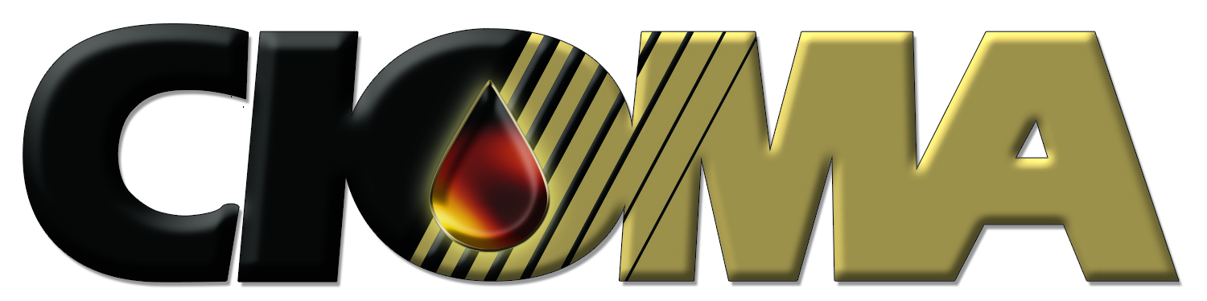


November 2, 2007

Clerk of the Board
Air Resources Board
P.O. Box 2815
Sacramento, California 95812
letter submitted via email

Subject: 15-Day comments re: Public Hearing To Consider Adoption Of Regulations For The Certification And Testing Of Gasoline Vapor Recovery Systems Using Aboveground Storage Tanks.
Referencing: CIOMA comments on June 21, 2007 Board Agenda Item 07-7-6; Regulations for the Certification and Testing of Gasoline Vapor Recovery Systems Using Aboveground Storage Tanks.

To Whom It May Concern:

This letter is written to express concerns regarding omissions to the recent 15-day changes to various documents related to the above-noted regulatory proceeding. On June 21, 2007 CIOMA provided comments to this regulatory proposal in the above-referenced letter – a copy is attached for your convenience. In this letter, CIOMA noted various comments and suggestions to CARB staff and the Board. In our review of the 15-day changes we have determined that several of our comments have not been addressed and wish to reiterate our requests that have not been dealt with. Specifically:

Beginning on the bottom of Page 2 of the 6/21/2007 letter:
- An important aspect of the new tank requirements – i.e. insulation – will be the number of qualified installers/applicators that are available, especially as the deadline of 1/2013 approaches. We request that CARB keep track of qualified installers/applicators for certified insulation installment. If there appear to be insufficient resources available, the deadline should be adjusted allowing owner/operators to comply with the requirements in a timely, organized and cost-effective manner.

No provision in the resolution or other materials has been included to address this concern. We would agree to inclusion of a requirement that would:
- require CARB staff to report the number of qualified installers/inspectors four months prior to the implementation date, and;
- allow the CARB Executive Director to administratively extend the deadline if problems are perceived, rather than having to take the regulation back to the Board as a fully noticed regulatory change.

At the top of page 3 in the 6/21/2007 letter:
- We request that the term “commercially available” be defined in the D-200 document. Although there are references in other locations providing that delay of 3-8 weeks in delivery of needed parts – which we feel is unacceptable – we believe this important term needs definition in the most logical place. We offer our assistance in developing an appropriate definition.

We do not see any changes regarding the definition of “commercially available” in document D-200 in regards to our comments, nor have we had any meetings with CARB staff to discuss a possible adjustment. We request that this issue be addressed.

If you have any questions or need further clarification please contact me at your earliest convenience.

Sincerely,
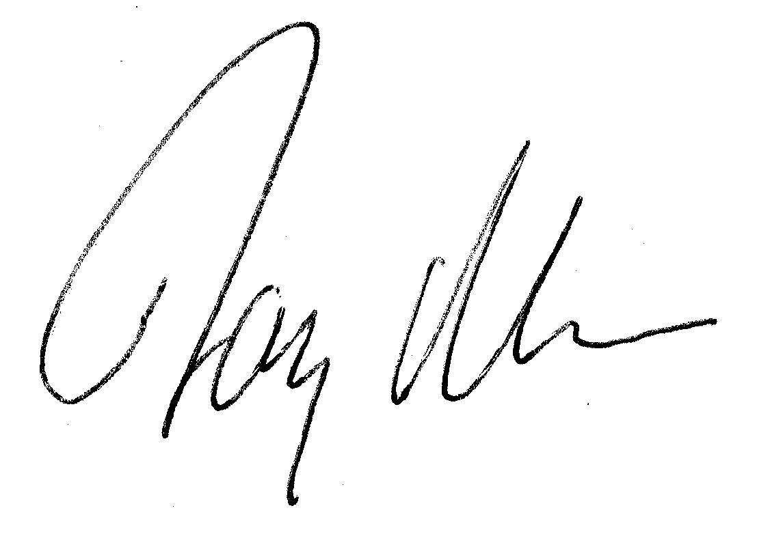
Jay McKeeman,
Vice President of Government Relations and Communications

cc: Kathleen Quetin, CARB Ombudsperson
Bill Loscutoff, Chief, CARB Monitoring & Laboratory Division
Manjit Ahuja, , CARB Monitoring & Laboratory Division

June 19, 2007

Clerk of the Board
California Air Resources Board
P.O. Box 2815
1001 "I" Street
Sacramento, CA 95812

Subject: CIOMA comments on June 21, 2007 Board Agenda Item 07-7-6; Regulations for the Certification and Testing of Gasoline Vapor Recovery Systems Using Aboveground Storage Tanks.

To Board Members and Staff:

This letter contains commentary from the California Independent Oil Marketers Association (CIOMA) on the above noted regulation package, abbreviated as EVR/AST for purposes of this letter. CIOMA represents independent marketers who purchase gasoline and other petroleum products from refiners and sell the products to independent gasoline retailers, businesses, and government agencies, as well as representing branded “jobbers” who supply branded retail outlets, especially in rural areas. Our members are primarily small, family owned businesses who encounter unique difficulties in meeting California’s complex and increasingly expensive environmental requirements. We represent approximately 400 members, about half of whom are actively engaged in the marketing and distribution of petroleum products and fuels.

Importantly, CIOMA members both deliver to a great majority of the state’s aboveground storage tanks and/or provide such tanks to their customers. We have been involved in this regulatory development since 2001. Over the course of our involvement we have seen a very onerous initial regulatory proposal modified to something that we can largely support. We credit CARB staff with listening to our concerns and ultimately recommending a program that will achieve significant reductions in ozone-forming pollutants, while recognizing the significant costs – especially to small businesses – inherent in emission controls. Where significant reductions in emissions can be achieved through simple, effective and economical means a win-win condition such as this is created.

We would first like to point out the important features in this innovative regulatory program:
- The most important feature is the recognition that standing losses from aboveground storage tanks (AST’s) can be substantially reduced through the application of white paint and a commonly available pressure/vacuum relief valve. This recognition provides owners of such tanks to achieve an almost 2/3^{rds} reduction in emissions with readily available, cost-effective technology.
- The program also provides an innovation in certification procedures where groups or individuals can obtain certification, rather than having a certified company provide the retrofit service through performance standards. We look forward to working with CARB in obtaining certifications for various standing loss control measures in the near future.
- The program also provides technologies which can achieve higher, optional reductions, depending on the financial condition of the tank owner, and the motivation of obtaining emission offsets.
- The definition of “major modification” has been appropriately designed to allow replacement of older tanks with refurbished tanks that have standing loss adjustments (paint and p/v valve).
- The willingness of CARB staff to work with our membership when significant problems were detected earlier in the regulatory process. This willingness has helped alleviate concerns over what was perceived as dogged entrenchment, regardless of regulated community objections or good faith input.

Second we would like to point out some remaining concerns we have with the staff recommendations:
- As with other CARB certification programs we have grave concerns that the extensive and expensive certification process CARB establishes – especially for the carbon canister, shade and insulated tank certifications – will lead to a single source for certified systems. We have voiced this concern in the past and will continue to raise it whenever appropriate – that the operative date of the regulations should NOT begin until AT LEAST TWO SYSTEMS ARE CERTIFIED. We have a relevant example currently under the UST enhanced vapor recovery program where only one system is certified, and that system is not appropriate for the vast majority of dispensers in the state. It should be CARB policy to insure that there are competitive systems available for the equipment that needs to be retrofitted.
- We suggest that CARB staff be required to prepare two status reports on the evolution of certifications for required systems (shade, canisters, and insulation). Since these are newly designed protections we believe it is important to understand how development of these technologies is progressing as regulatory implementation dates mature. In the status report we recommend that the staff evaluate:
  - development of the technology (i.e. have parties had discussions with staff regarding interest in certifying equipment/systems)
  - certification status – what is the current status of pending certification for equipment/systems?
  - certified systems – describe what systems/equipment have been certified with description.
  - economic analysis – what is being charged for certified equipment/systems and how does that differentiate from the estimates provided in the staff analysis for this regulation?
  - These reports should be prepared: (1) 3 months prior to the initial effective date (9/2008) and, (2) 2 years prior to final deadline (1/2011).
- An important aspect of the new tank requirements – i.e. insulation – will be the number of qualified installers/applicators that are available, especially as the deadline of 1/2013 approaches. We request that CARB keep track of qualified installers/applicators for certified insulation installment. If there appear to be insufficient resources available, the deadline should be adjusted allowing owner/operators to comply with the requirements in a timely, organized and cost-effective manner.
- We request that the term “commercially available” be defined in the D-200 document. Although there are references in other locations providing that delay of 3-8 weeks in delivery of needed parts – which we feel is unacceptable – we believe this important term needs definition in the most logical place. We offer our assistance in developing an appropriate definition.

Third, for the record, we would like to provide our understanding of issues we raised with CARB staff recently, and how their comments have reduced our concerns:
- Phase 1 requirements: We note that there are a number of agricultural tanks which may need to meet Phase 1 equipment installation as part of the retrofit requirements. The analysis does not provide a thorough review of what this means, although there are some indications that this requirement may cost as much as $4700 in the report. In a recent conversation with CARB staff (George Lew and Manjit Ahuja, 6/18/07) it was clarified that this retrofit would basically be a new fuel gauge and emergency vent valve. It would not include new fuel input plumbing. It was also clarified that local districts will have the option of requiring Phase I improvements as part of the retrofit requirement, and may limit its application to higher throughput tanks.
- We have discussed the possibility of using the location where the fuel tank evaporation estimates were calculated (our member Tim Ward, Tom R. Ward Inc. in Firebaugh) to certify paint and p/v valve combinations for the standing loss performance standards. We appreciate the initial cooperation CARB has offered in getting these certifications accomplished in the most efficient and cost-effective manner.

In conclusion we believe that staff has developed a fundamentally sound proposal. With the few minor adjustments noted in this letter we recommend approval of this regulatory package. Should you have any questions or need further clarification on this communication please contact me at your earliest convenience.

Sincerely,
Jay McKeeman,
Vice President of Government Relations and Communications

cc: Air Resources Board Members
Kathleen Quetin, CARB Ombudsperson
Bill Loscutoff, Chief, CARB Monitoring & Laboratory Division
CIOMA Board of Directors & Government Relations Committee

