 | Earth Day Los Angeles  1216 S. Westlake Avenue, Los Angeles, CA 90006  (213) 487-9340 tel • (310) 362-8400 fax  Jim@EarthDayLA.org • www. EarthDayLA.org  A Project of International Humanities Center 501(c)3 TID 33-0767921 | 

August 11, 2011

James Goldstene

Executive Officer

California Air Resources Board

1001 “I” Street, Sacramento, CA, 95812

Subject: Comments on Proposed 15-Day Changes to the AB 32 Cap-and-Trade Regulation

Dear Mr. Goldstene,

We strongly support ARB’s efforts to implement a cap-and-trade program to back up the robust package of clean energy policies in the Scoping Plan and ensure we hit AB 32’s greenhouse gas (GHG) emission reduction targets.

1. Allowance Allocations to the Utility Sector
We are very opposed to the method proposed for Allowance Allocation to the Utility Sector. The actual proposal uses “customer cost burden” for more than 90% of each utility’s allowance allocation. We request the customer cost burden factor should be no more than 10% of each utility’s allowance allocation. One need for this shift is that LADWP calculates that the ARB allocation results in LADWP having absolutely no cost impact from AB 32 cap and trade, even while burning many, many tons of coal all the way to 2027. Surely, letting LADWP benefit from hanging on to coal is not what the legislature had in mind in passing AB 32.

2. Excess Reliance on Offsets has Environmental Justice issues
Research shows that out-of-state offsets will increase criteria pollution. (David Roland-Holst, “Carbon Emission Offsets and Criteria Pollutants: A California Assessment,” March, 2009, University of California, Berkeley.) Air pollution is worst in low-income communities and communities of color, such as the neighborhoods downwind from oil refineries in the LA area. We call upon ARB to eliminate out-of-state offsets and greatly reduce the allowed in-state offsets. It is embarrassing that over 85% of the GHG reductions could come from offsets. Fix this. Relieve low-income communities and communities of color from this heavy burden.

3. GHG performance benchmarks too low
We note that, in many of the cases presented in Table B, the proposed California emission intensity benchmarks are significantly higher than EU benchmarks, resulting in much higher emissions per ton of product. For example, the California emissions standard for Potash, Soda, and Borate Mineral Mining is 124% of the EU standard and for Recycled Boxboard Manufacturing is 200% of the EU standard. We are also concerned that the California benchmark for emissions intensity for cement plants is proposed at 0.786, while the EU standard (when adjusted) is only 0.716 (a significant 10% lower). We believe that ARB should be setting a world-class standard for GHG performance, and California industry should be able to meet or exceed EU standards.

4. Transportation biofuels exemption is wrong
We are completely opposed to the transportation biofuels exemption.

Sincerely,
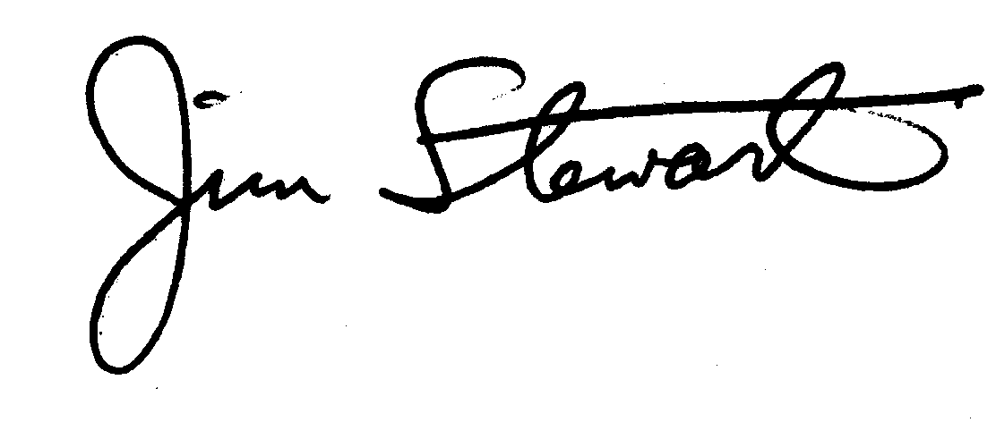
Jim Stewart, Organizing Director
Earth Day Los Angeles

