

September 19, 2007

Dr. Tao Huai
California Air Resources Board
P.O. Box 2815
Sacramento, CA 95812

Dear Dr. Huai:

The California League of Food Processors (CLFP) is a voluntary trade association that represents fruit and vegetable processors. There are about 230 fruit and vegetable processing plants in California that produce canned, frozen, dried, dehydrated and other products for markets around the world. Food processors provide an important market for thousands of growers, purchasing over $5 billion worth of commodities from California farmers annually. Processors rely on contract truckers to haul 15 – 18 million tons of fruits and vegetables from the farms to the processing plants each year.

CLFP would like to express several specific concerns regarding one of the items selected by ARB staff for potential AB 32 Discrete Early Action. The proposed SmartWay truck efficiency measure would require that trucks and trailers be retrofitted with devices that reduce aerodynamic drag and rolling resistance. CLFP believes that ARB must carefully craft this rule to ensure that any new regulations do not impose an unreasonable burden on the trucking industry. The Staff Analysis Report issued by ARB includes a discussion of this proposed early action item. The report indicates that older trucks “are typically considered short haul trucks” and that those trucks might only be required to comply with new measures regarding rolling resistance. However, the report does not indicate:
- Which, and how many, trucks will fall into the “older” category.
- How “short haul” trucks will be defined in terms of annual mileage traveled.
- Whether all short haul trucks will be exempt from some, or all, of the regulations even if they have a gross vehicle weight in excess of 33,000 pounds.
- Whether seasonal or specialty equipment will be required to comply with the regulations.

Many of the trailers used to haul agricultural products to processing facilities are specialty equipment (e.g. gondola trailers) only used on a seasonal basis. The design of some of the trailers may not be amenable to adding aerodynamic devises, and in many cases the retrofit will be cost prohibitive given the limited annual usage of the equipment. CLFP recommends that ARB exempt all seasonal agricultural trailers and short haul truckers from the rulemaking as the costs of compliance may exceed the value of any reductions in fuel usage and greenhouse gas emissions.
Small independent truckers account for a significant portion of the commercial fleet in California. These truckers are coping with high fuel prices, driver shortages, and expensive new diesel engine emissions regulations. ARB staff has recommended that the agency conduct an evaluation to determine whether a financial assistance program would be needed to help small businesses comply with the requirements of the SmartWay proposal. CLFP supports this recommendation as small truckers could be pushed out of business due to the cumulative impact of new regulations and higher operating costs.

CLFP is a member of the AB 32 Implementation Group, a coalition that represents a wide spectrum of the business community in California. The Group advocates for policies that will achieve greenhouse gas reductions while protecting and growing California’s economy. One of the Group’s guiding principles is that ARB’s greenhouse gas program should be simple, easy to implement, fair, equitable, and cost-effective. CLFP believes that this concept should be applied to deciding which items should be selected by ARB for discreet early action, and the specific manner and time frame in which these proposals are implemented.

Please contact me if you have any questions regarding CLFP’s recommendations.

Sincerely,

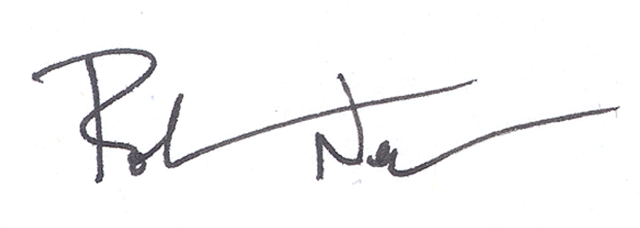
Rob Neenan
Director of Regulatory Affairs

