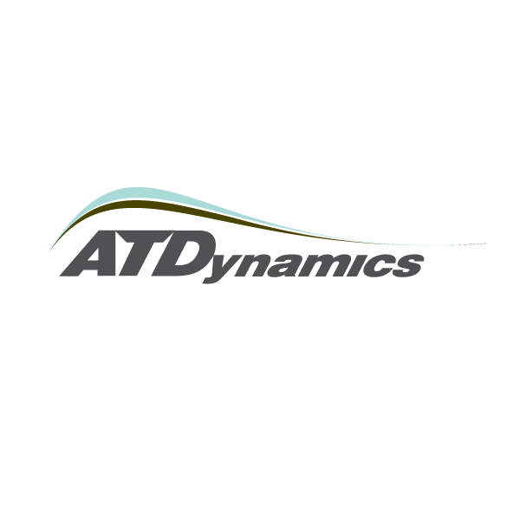
4329 California Street • San Francisco, CA 94118 • www.atdynamics.com

September 17, 2007
Stephen Lemieux
Section Manager
California Air Resources Board
1001 I Street
P.O. Box 2815
Sacramento, CA 95812

RE: Measures to Reduce Greenhouse Gas Emissions in California: Tractor-Trailer Efficiency, Advanced Transit Dynamics, Inc. and the TrailerTail™ Product Launch

Dear Mr. Lemieux:

Advanced Transit Dynamics, Inc. (ATDynamics) is a start-up company founded in 2006 to commercialize aerodynamics technology for tractor-trailers. ATDynamics is bringing to market in 2008 a line of “trucker-tough” drag reduction technology developed to meet the rigorous operating needs of fleet operators, enhance on-road vehicle safety and immediately reduce the fuel consumption and carbon footprint of the trucking industry. We write this letter in response to CARB’s request for public comment on practical methods for implementing the California Global Warming Solutions Act of 2006 (AB 32).

First, we would like to commend CARB and the state of California for taking a leadership role in encouraging the rapid adoption of fuel saving technology across industries. Only a combination of dedicated leadership in the private sector, the government and the non-profit second will succeed in driving large scale environmental change. Our company’s mission is to dramatically reduce fuel consumption in the global trucking industry. We look forward to collaborating with you to demonstrate ways to reduce carbon emissions at a net profit to the industry.

Second, we are well aware of resistance in the US trucking industry to new technologies which the industry fears may interfere with traditional trucking operations. Before launching our company we studied the market opportunity for tractor-trailer aerodynamics technology for over a year. We realized that there was a tremendous opportunity to reduce the low pressure drag formed at the back of a tractor-trailer if trucker needs could be met effectively. Over the last 18 months our company has met this goal with our flagship TrailerTail™ rear drag reduction technology which does not interfere with driver operations and can pay for itself in one to two years through the fuel it saves. In summary, the technology which California hopes to eventually require for its trucking fleets its rapidly becoming available. As trucking companies become aware of this technology it will be adopted throughout the state and the country. We will continue to keep you up-to-date as our technology becomes commercially available over the coming months.

We look forward to answering questions and providing additional information as required in the future. Please feel free to contact me directly at anytime at asmith@atdynamics.com or 415.812-7357.

Sincerely,


Andrew F. Smith
Chief Executive Officer
Advanced Transit Dynamics, Inc.

Attached: 2-page TrailerTail™ flyer

Driving the Efficiency Revolution
A long rectangular box is an ideal shape to hold cargo, but it also is the least aerodynamic shape to move at high speeds on US highways. More than half of commercial truck fuel goes toward overcoming aerodynamic drag of tractor-trailers.

Suction drag at the tail end of a trailer causes the greatest amount of aerodynamic inefficiency still unaddressed by modern trailer designs. ATDynamics TrailerTail™ technology addresses this area of inefficiency by streamlining the air flow at the rear of the trailer and dramatically reducing fuel consumption by thousands of dollars annually.
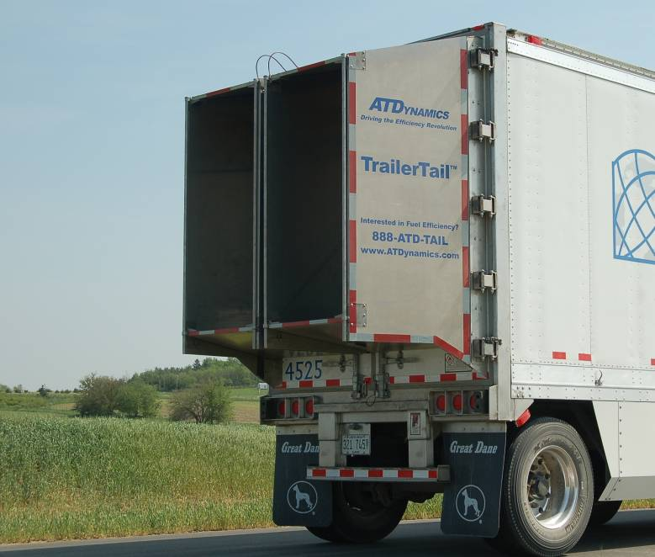
PROTOTYPE DEVICE - OPEN
TrailerTailTM
TrailerTailTM devices bring to market leading concepts of aerodynamic efficiency without interfering with driver operations.

TrailerTailsTM collapse from 4 feet in length to just a few inches in less than 15 seconds. Patented TrailerTail™ double hinges allow truckers to operate doors and access loading bays normally. Most importantly, TrailerTails™ enhance the safety and performance of the fleets that use them.
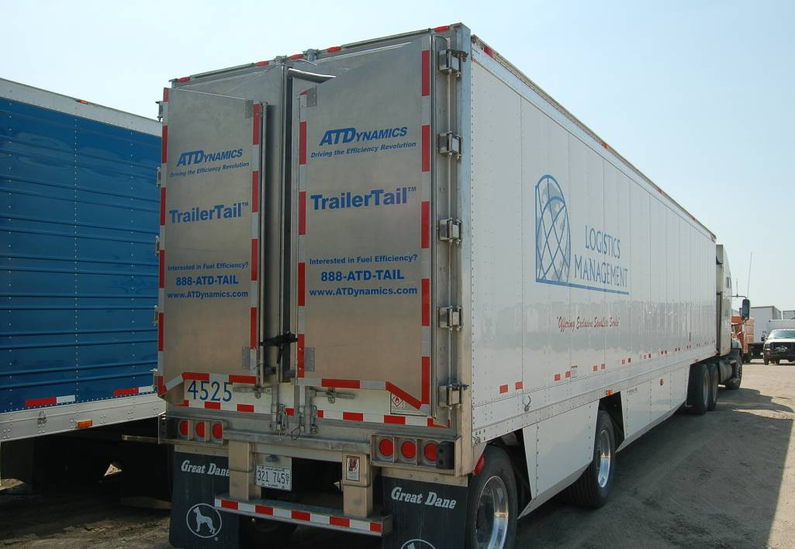
PROTOTYPE DEVICE - CLOSED

TrailerTailsTM Streamline the Airflow at the Rear of the Trailer

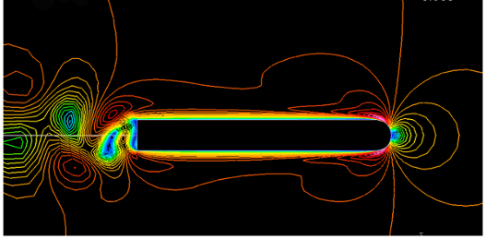
Airflow without TrailerTailTM

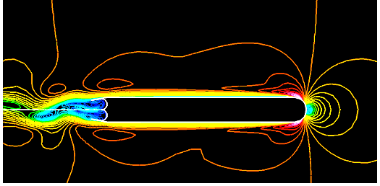
Airflow with TrailerTailTM

Over 30 years of research, wind tunnel modeling, and on-road testing by research universities, government laboratories and NASA have shown that:

- Drag at the rear of a trailer contributes as much fuel inefficiency as the wind resistance at the front of the tractor
- The TrailerTailTM design will deliver a 6 % increase in fuel efficiency during highway driving
- Streamlined airflow provides enhanced stability and safety to both truckers and passenger cars

TrailerTailsTM Save Fuel:

For every 100 trailers outfitted with a TrailerTailTM:

  - Over 45,000 gallons of fuel conserved per year (@50K mi/trailer)
  - Over $100,000 saved at the gas pump ($2.20/gallon)
  - Over 900,000 pounds of CO₂ reduced from entering the atmosphere as exhaust

TrailerTails™ are Built Trucker Tough.

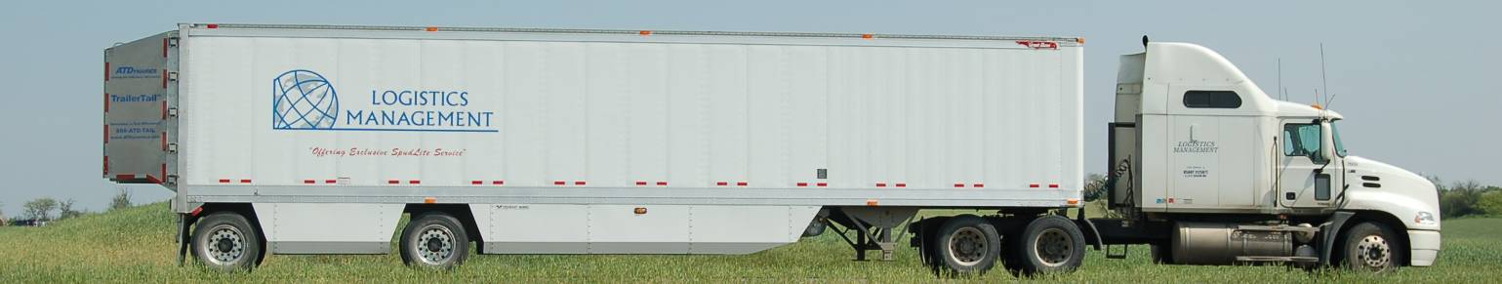

TrailerTailsTM Meet the Needs of Leading Fleet Operators
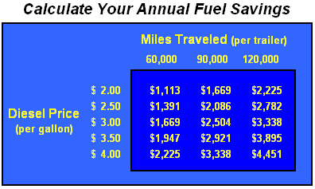
Expected Fuel Savings at 6% Efficiency Gain
(Base Case: 5.5 mpg and 85 % highway driving)

- TrailerTails™ deliver thousands of dollars of fuel savings per trailer annually – and each device pays for itself in 1-2 years.
- TrailerTailsTM allows easy and quick access to trailer cargo and do not interfere with shipment loading and unloading.
- Lightweight, rugged panels endure daily wear and driver abuse, yet are designed to ensure smooth opening and closing.
- TrailerTailsTM improve the safely, handling and appearance of tractor-trailers and are designed to reduce the dirt, grime or ice build up on a trailers’ rear doors.

