November 20, 2008

Mr. Kurt Karperos, Chief
Air Quality and Transportation Planning Branch

Planning and Technical Support Division
California Environmental Protection Agency
Air Resources Board
P.O. Box 2815
Sacramento, California 95812

Subject: Public Comments On Recommended Approaches For Setting Interim Significance Thresholds For GHG’s Under CEQA

Dear Mr. Karperos:
I have been a CEQA practitioner for approximately 35 years. I have authored well over 1,000 CEQA documents. During my career, I have witnessed the transformation in EIR’s from about 100 pages to 6,000 pages for the most complex and controversial projects. I have the following comments on the draft thresholds.
Greater consideration must be given to the most frequent types of CEQA documents and the affect a GHG Threshold will have on a Lead Agency’s ability to implement CEQA. In addition, the Threshold’s delay on an Applicant’s ability to timely receive approval to proceed with a project must be factored in.
Please evaluate and provide clarity on what additional information will be required in development Applications for minor projects normally qualifying for a Negative Declaration. Not all Lead Agencies are large. Not all Lead Agencies can afford, nor have CEQA experts.
What additional information will be required from an Applicant in order for a Lead Agency to deem an application complete?
If additional studies are required for the simplest of projects, what will be the resulting delay and cost to our State?
A foundational element of CEQA is public involvement. All other CEQA thresholds of significance are relatively simple straightforward statements. Will the public be able to understand the proposed GHG Threshold?
When is enough mitigation enough? Take the case when a Lead Agency proposes to approve a project subject to a Statement of Overriding Considerations. The Findings require that all feasible mitigation measures be implemented. Where does this stop? Should a cradle to grave GHG analysis of a household’s electrical wire, doorknob, or type of carpet be required for a housing development?
Do not implement a GHG Threshold or implementing procedures that will add 1,000 pages to an EIR and further exacerbate the public and decision maker’s ability to understand a project!
A detailed and complicated Threshold and implementing procedures will only benefit the attorneys!
I recommend you adopt the following set of recommendations:
- Establish a clear and simple threshold. I recommend you adopt a ZERO threshold:
- Exempt from GHG consideration, all projects that would otherwise qualify for a Negative Declaration;
- Require Lead Agency’s to comply with ARB targets for reducing GHG’s; and
- Empower Lead Agency’s to determine a reasonable level of mitigation

Thank you for consideration of my comments. I will be happy to address and questions. I can be reached by email at: dave@earsi.com, or by phone at 949 233-0895.

Sincerely,
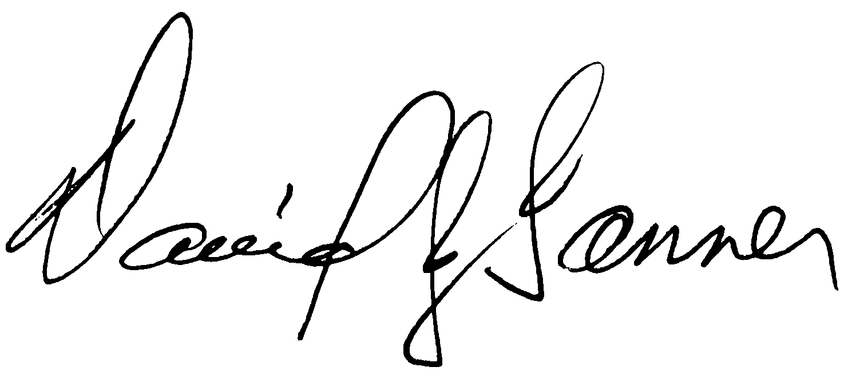

David J. Tanner
President

