115 Sansome Street, Suite 900
San Francisco, CA 94104
415-929-8876 • www.turn.org
Mark W. Toney, Ph.D., Executive Director
Lower bills. Livable planet.


June 9, 2011

Chairperson Mary Nichols
California Air Resources Board
Sacramento, CA 95814

RE: Replace Cap-at-Trade with More Effective GHG Reduction Measures

Dear Chairperson Nichols,

TURN has been a strong advocate for AB 32 as innovative and comprehensive policy to reduce emissions and to help transform California to a zero-emissions, clean energy economy. As the AB32 statute acknowledges, fairness in reducing air pollution and avoiding increased air pollution in these heavily burdened communities also turns out to be the best thing for all Californians to address climate change, smog, and rebuild California with a green economy.

TURN strongly urges the Air Resources Board to comply with the recent court ruling directing it to conduct a thorough assessment of cap-and-trade alternatives before choosing a final mechanism for reducing industrial GHG emissions. It is our position that such an assessment will identify a strategy to replace the cap-and-trade proposal with effective direct emission control programs that will enable California to meet the crucial goals of AB 32 to avoid catastrophic climate change, while also reducing the co-pollutants that contribute to severe health problems in low-income communities of color, where the very largest polluters are located.

It is important that this assessment of emission reduction alternatives to cap-and-trade facilitate full public participation and stakeholder input, especially from the environmental justice and consumer advocacy communities. Done properly, this assessment can provide the ARB with the opportunity to thoroughly examine proven alternatives to cap-and-trade measures and to adopt those that prove most effective in meeting the requirements of AB 32.

We believe that replacing cap-and-trade with more effective GHG reduction measures will make a significant contribution in advancing California as the leader in the global effort to stop global warming, and in safeguarding the environment and health of all Californians.

Sincerely,
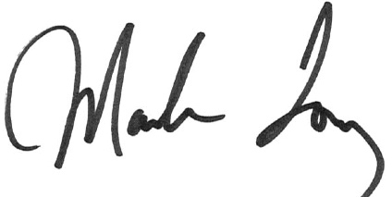
Mark Toney
Executive Director

