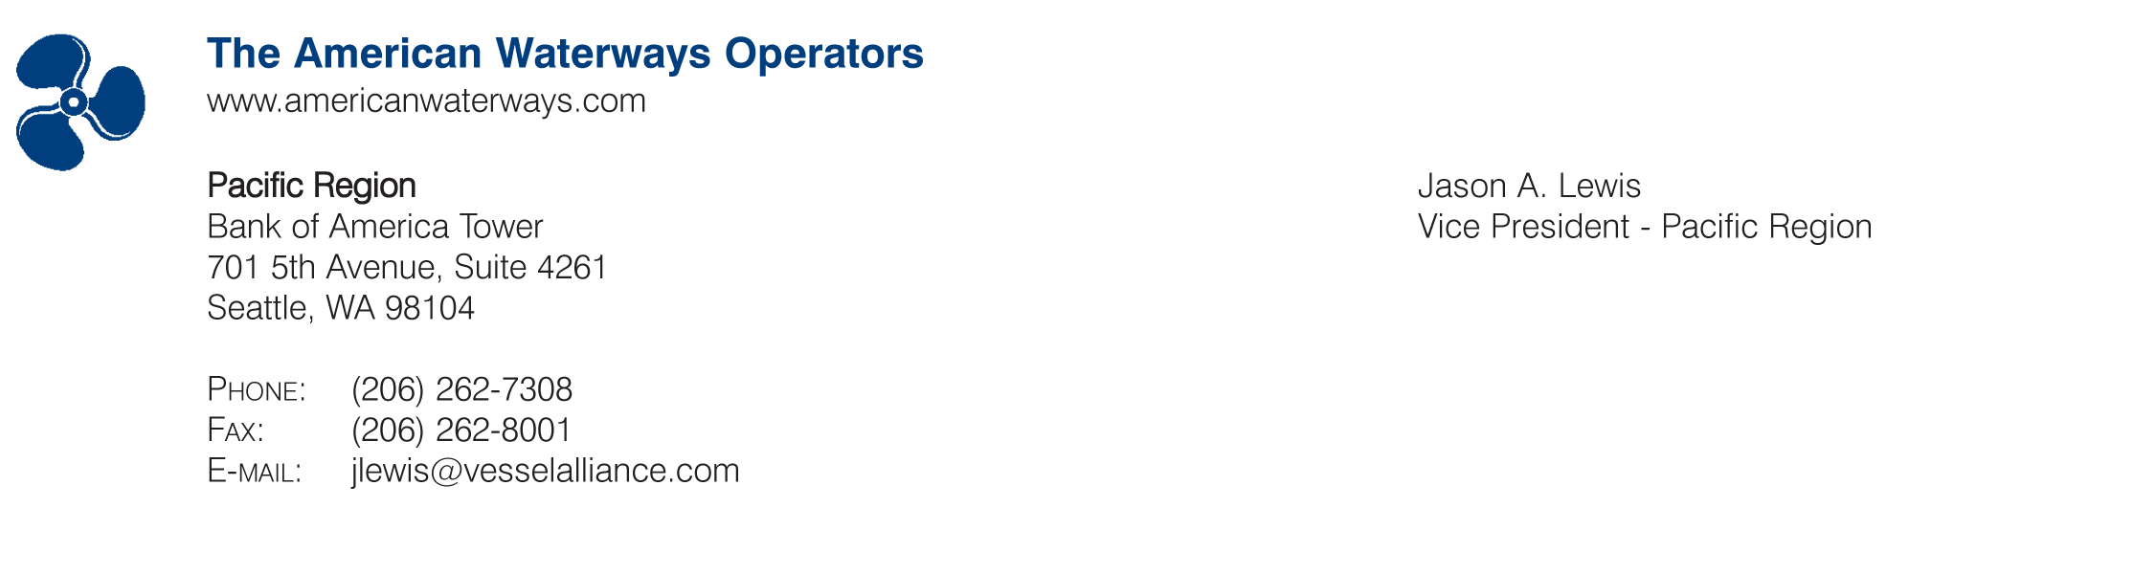
July 3, 2008

Ms. Mary D. Nichols
Chairwoman
California Air Resources Board
1001 I Street
Sacramento, CA 95814

Dear Ms. Nichols:

The American Waterways Operators (AWO) is the national trade association for the U.S. tugboat, towboat and barge industry. AWO is vital not only to the nation’s economy, transporting goods to American businesses, but also to California’s economy, keeping the nation's two busiest container ports, the Ports of Los Angeles and Long Beach, running.

AWO has been actively involved in California Air Resources Board’s (CARB) drafting of the harbor craft regulation because it will have an enormous impact on AWO members operating in California. AWO members and staff had the opportunity to testify at the CARB harbor craft regulation hearing on October 26 and submitted comments on October 24; however, CARB staff did not address the industry’s concerns. The proposed amendments to the original draft regulation only make it more onerous to conduct business in Southern California and do little to help mitigate the negative impact of the regulation’s compliance schedule. Because the regulation in its current form severely harms businesses owned and staffed by Californians, and may put some of them out of business, AWO has no choice but to once again oppose the harbor craft regulation.

AWO has expressed concerns with this regulation since its first drafting and has seen little effort by CARB staff to resolve its overwhelmingly harmful impact on the tug and barge industry. It is unfortunate that CARB has elected to make the tugboat, towboat and barge industry an enemy in reducing emissions instead of a partner. AWO members pride themselves in their dedication to the environment, the communities in which they live and do business, and the workers they employ. The punitive measures outlined in this regulation will have a lasting negative impact on the industry and California’s ability to handle the increased maritime traffic in its ports.

Sincerely,

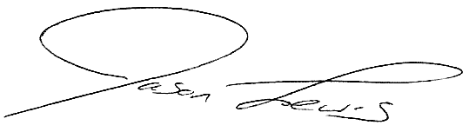

Jason A. Lewis

