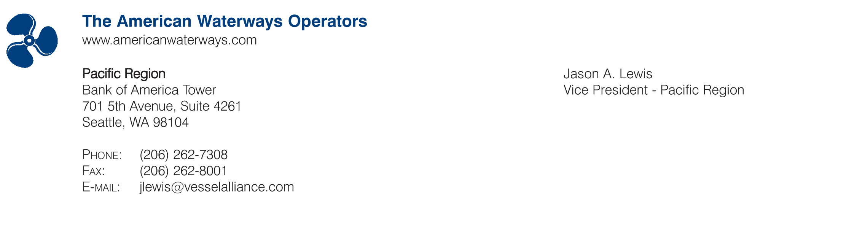

October 24, 2007

Mary D. Nichols
Chairman
California Air Resources Board
1001 I Street
Sacramento, CA 95814

Re: AWO Comments on Harbor Craft Regulation

Dear Ms. Nichols:

The American Waterways Operators (AWO) is the national trade association for the U.S. tugboat, towboat and barge industry. AWO members are vital to the nation’s economy, transporting goods to American homes and business, including 20 percent of America's coal and over 60 percent of U.S. grain exports. In California, the towing industry keeps the nation's two busiest container ports, the Ports of Los Angeles and Long Beach, running. The industry also has a strong commitment to environmental protection, marine safety and national security, evidenced by AWO’s Safety Partnership with the U.S. Coast Guard, the AWO Alternative Security Program and the AWO Responsible Carrier Program (RCP). The RCP is a U.S. Coast Guard-recognized code of “best practices” for towing companies to use when developing safety and environmental programs. Achieving third-party audited compliance with the RCP is required for membership in AWO.

The areas in which AWO member companies work and do business are the same areas where they live and raise their families. The protection of the environment is of paramount importance to our organization and its membership, personally and professionally. In fact, waterways transportation is the most environmentally-friendly mode of commercial freight transportation due to the enormous capacity of a barge. For example, a typical inland barge has a capacity 60 times greater than one semi trailer truck, making it more fuel efficient to transport goods via barge. The barges that operate along the California coast move freight off of the state’s crowded highways, helping to reduce congestion and traffic.

Even though AWO supports, and has advocated for, environmental measures such as ones that would help achieve the goals of reducing diesel Particulate Matter (PM) and Oxides of Nitrogen (NOx), we oppose the California Air Emissions Board’s draft harbor craft regulation. It places unnecessary and overly burdensome regulations on the tugboat, towboat and barge industry that have the potential to put many operators out of business, thereby striking a severe blow to California’s economy, as well as the nation’s. AWO believes that because many of the businesses in California operate in multiple states, it makes more sense to tackle the problem of engine emissions at the federal level. This alleviates the burden of a company trying to adhere to a patchwork of state regulations to achieve significant emissions reductions.

Unfortunately, AWO’s concerns with previous drafts of the harbor craft regulation have, in large part, gone unaddressed, and we are now presented with a draft regulation that will have an enormously negative economic impact on the tug and barge industry. AWO has no choice but to strongly oppose the proposed California Air Resources Board (CARB) regulation on harbor craft vessels for the following reasons:

- It does not accurately address the true economic impact of the regulation;
- It unfairly requires ocean-going tugs to comply with the low-sulfur fuel regulation;
- It does not explicitly accept existing engine hour meters to comply with the regulation;
- It sets unrealistic compliance dates;
- It contains a burdensome application for extension process; and
- Sections of the regulation are unconstitutional in their current form.

These points are detailed below, followed by an example of the impact of the regulation on one tugboat company, as well as suggestions on how California and the towing industry can work together to achieve emissions reductions. The comments presented in this document are meant to assist CARB in the adoption and implementation of a harbor craft regulation that will meet the goals of reducing emissions while protecting the marine industry. AWO urges CARB to amend the current draft regulation in order to reduce emissions while not doing harm to the tug and barge industry.

1. Ocean-Going Tugboats

The harbor craft regulation states,

(b) Applicability.
(4) Notwithstanding the provisions of title 13, CCR, section 2299.1 and title 17,
CCR, section 93118, this section shall apply to any ocean-going tugboats and towboats and shall supersede the requirements of 13 CCR 2299.1 and 17 CCR 93118 in their entirety for ocean-going tugboats and towboats. For purposes of this paragraph, “ocean-going tugboats and towboats” shall mean tugboats and
towboats with a “registry” (foreign trade) endorsement on its United States Coast Guard certificate of documentation, or tugboats and towboats that are registered under the flag of a country other than the United States.

AWO recommends that ocean-going tugboats be required to adhere to the low-sulfur fuel guidelines contained within the regulation. Ocean-going tugs operate in similar fashion to ships, in that they make calls to California ports but their home ports are often outside California waters. These vessels are involved in interstate commerce and are not utilized in ship assist work or other duties generally assigned to harbor craft. The growing demand on the national transportation system means that ocean-going tugs will be a major component of the future of commodity transportation, and including them into the harbor craft regulation will only limit the number of vessels able to service California ports.

2. Economic Impact

The ramifications of this regulation have not been adequately addressed by CARB staff in the economic impact statement. For example, imposing a short life cycle on marine engines will be so costly that it will push smaller vessel operators out of business, which will decimate the ship assist business in California waters and cause employees to lose family-wage jobs, and also possibly severely limit the number of vessels that operate in California from outside of the state and weaken the state’s economy.

One example of a similar situation in the past is in the 1990’s when California imposed an eight percent sales tax on bunker fuel. Ships simply chose to buy fuel elsewhere. This increase obliterated the bunkering business and, in turn, approximately 75 percent of the market left California. The impact of the harbor craft regulation on the tug and barge industry will have a greater negative impact than the bunker tax and, unlike the bunker tax, the harbor craft regulation will impact multiple business sectors. Ocean-going tugs operating as ships and only making port calls, ship assist vessels and marine construction companies will all be severely impacted. The tug and barge industry powers the nation’s economic engine and this regulation will irreparably harm the industry.

3. Engine Hour Meters

The harbor craft regulation states,

All Harbor Craft – Installation and Use of Non-Resettable Hour Meters.
As of January 1, 2009, no person shall operate a harbor craft within any of the
Regulated California Waters without an installed and properly operating nonresettable hour meter, which accurately measures the number of hours an
engine operates. The hour meter shall be installed on each diesel engine on the
vessel in a manner that allows reasonable personnel access without impediment.

AWO recommends that this section be clarified so that existing engine hour meters are accepted to comply with the regulation.

4. Compliance Dates

The harbor craft regulation states,

(C) Compliance Schedules and Determination of Engine Model Year.
2. the engine’s effective model year based on the “Engine’s Model Year + 5” method, which is as follows: The “Engine’s Model Year + 5” method extends the effective model year if the person uses an emissions control strategy pursuant to this paragraph. To use this method, the person must use an emission control strategy with the existing in-use engine that reduces either diesel PM or NOx by a minimum of 25 percent and does not increase either pollutant by more than 10 percent, relative to the emissions of those pollutants without the use of the emission control strategy. If the emission control strategy is not a VDECS, the person shall demonstrate compliance with this paragraph by submitting emissions data that demonstrate the non-verified emission control technology achieves a
diesel PM or NOx emission reduction of 25 percent or better, using the
test methods specified in subsection (j). Upon approval of the E.O., the
person may submit data derived from the use of other test methods to
demonstrate the required 25 percent minimum emission reductions,
such as:
a. marine engine certification test data for the harbor craft propulsion
or auxiliary engine, or engine manufacturer emission test data; or
b. emissions test data derived from another engine that is configured
and used in a substantially similar way to the in-use engine on
which the emission control strategy is to be used; or
c. emissions test data used to meet the regulatory requirements of the
ARB Verification Procedure for the non-verified emission control
strategy implemented.
A person’s use of an emissions control strategy pursuant to this provision extends the engine’s effective compliance date to the compliance date for a similar engine that is five model years newer (i.e., the actual model year for the engine with the emissions control strategy + 5). For example, the owner of a 1995 model year engine on a tugboat with a homeport outside of SCAQMD and which operates in Regulated California Waters for 750 hours in 2013, would normally be required to meet a December 31, 2014 compliance date, as set forth in Table 7. However, if an emissions control strategy that meets the requirements of this provision is implemented with this engine prior to the 2014 nominal compliance date, the engine’s effective compliance date would be extended to the compliance date for a 2000 model year engine (i.e., the 1995 model year + 5). Accordingly, in that scenario, the engine’s effective compliance date would be December 31, 2016;

AWO recommends that CARB increase the compliance schedule for Tier 0 to Tier 1 engines from January 2008 till July 2009. There will not be enough time to comply with the January 2008 timeline.

AWO also recommends that the “Engine’s Model Year + 5” model be changed so that five years are added to the compliance date instead of the to the engine model year. This would allow operators utilizing engines built before 2003 to have more time to comply with the regulation. The operators using older equipment are often doing so out of necessity because they are small businesses or lack the financial resources to upgrade their engines. It is reasonable to request that these small operators be given more time to comply with the regulation. After the 2003 model year date, the +5 formula would apply to both engine model year and compliance dates. This would also allow companies to replace the engines during a major overhaul cycle.

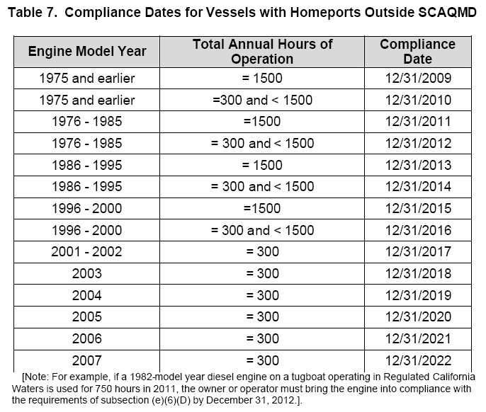

AWO recommends that engines with the model year 1996 and newer should have a compliance extension of five additional years. By taking into account those companies that have been purchasing new engines for their vessels using a company replacement cycle, CARB will help offset the fiscal impact those companies will face. An engine with a model year 2003 would then be subject to compliance on December 31, 2023. This engine life cycle still does not reflect the true life cycle of a tug engine; however, it does reflect a compromise that will reduce the financial burden on the industry.

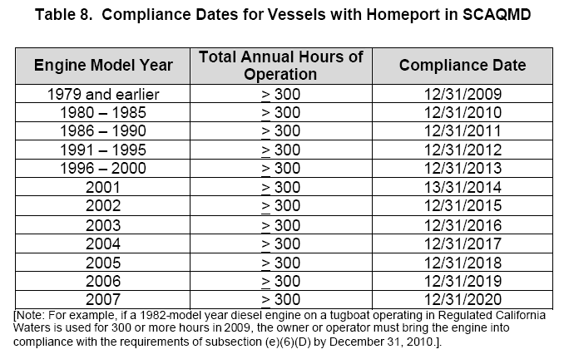

The SCAQMD timeline should be removed from this regulation. It is unreasonable to expect companies operating within California waters to adhere to two separate and unique timelines. This will undoubtedly limit the number of tugs able to operate in southern California and place even more burden on those companies attempting to conduct business in California.

5. Extensions

Section (E) of the harbor craft regulation explains compliance extensions as follows:

“There is no suitable engine replacement (one year extension).”

AWO recommends that a three-year automatic extension be granted when there is no suitable engine replacement. Requesting annual extensions for engines that have not been developed is unnecessary and burdensome for a company. The industry already has to face the brunt of this regulation and it should not have to also face an undue administrative burden.

“A delay in engine delivery due to the manufacturer (six month extension).”

AWO recommends that an automatic extension be granted to the company as long as it submits documentation showing both that it has ordered the engine and the manufacturer’s expected delivery date. There is an economic incentive for the engine manufacturers to ensure that there are as few delays as possible in the delivery of a new engine. However, the burden should not fall on the operator to continually submit requests for six-month extensions when the manufacturer is delayed. In order to alleviate the administrative burden that this section imposes on the industry and expedite the extension process, documentation from the operator and manufacturer should be sufficient to warrant an extension to the compliance date that reflects the manufacturing delay.

“Installation difficulties (six month extension).”

AWO recommends that this extension should mirror the extension comments made previously in regards to manufacturer delays. Currently this regulation imposes the burden on the operators when the delays are out of their hands.

“An owner has multiple vessels whose engines need to comply during the same year (one time, one year extension).”

AWO recommends that this extension not be a one-time only extension. The impact on an operator with multiple vessels coming into compliance will only be compounded if this extension is limited to one use.

6. Unconstitutionality

AWO believes that portions of the regulation are unconstitutional. First, the ability of California to regulate vessels up to 24 nautical miles offshore is unconstitutional. The Submerged Lands Act of 1953 granted coastal states ownership of the lands and resources out to three nautical miles offshore. The Outer Continental Shelf Lands Act of 1953 established federal jurisdiction over the resources beyond three nautical miles offshore. USC 43 CH 29 SUBCH II § 1312 states,

The seaward boundary of each original coastal State is approved and confirmed as a line three geographical miles distant from its coast line or, in the case of the Great Lakes, to the international boundary.

USC 43 CH 29 SUBCH III § 1331 states,

- The term “outer Continental Shelf” means all submerged lands lying seaward and outside of the area of lands beneath navigable waters as defined in section 1301 of this title, and of which the subsoil and seabed appertain to the United States and are subject to its jurisdiction and control;

The harbor craft regulation states,

(65) “Regulated California Waters” means all of the following:
(A) all California internal waters;
(B) all California estuarine waters;
(C) all California ports, roadsteads, and terminal facilities (collectively “ports”);
(D) all waters within 3 nautical miles of the California baseline, starting at the
California-Oregon border and ending at the California-Mexico border at
the Pacific Ocean, inclusive;
(E) all waters within 12 nautical miles of the California baseline, starting at the
California-Oregon border and ending at the California-Mexico border at
the Pacific Ocean, inclusive;
(F) all waters within 24 nautical miles of the California baseline, starting at the
California-Oregon border to 34.43 degrees North, 121.12 degrees West;
inclusive; and
(G) all waters within the area, not including any islands, between the California
baseline and a line starting at 34.43 degrees North, 121.12 degrees West;
thence to 33.50 degrees North, 118.58 degrees West; thence to 32.48
degrees North, 117.67 degrees West; and ending at the California-Mexico
border at the Pacific Ocean, inclusive.

AWO believes that CARB is violating the Submerged Lands Act and exceeding its authority by regulating vessels up to 24 miles off its coast. Therefore, items (E), (F) and (G) of the harbor craft regulation should be deleted.

Secondly, it is the responsibility of CARB to adopt a regulation that adheres to the spirit and letter of the Clean Air Act 209(e)(2), which states:

No such authorization shall be granted if the Administrator finds that—
(i) the determination of California is arbitrary and capricious,
(ii) California does not need such California standards to meet compelling and extraordinary conditions, or
(iii) California standards and accompanying enforcement procedures are not consistent with this section.

The regulation is not consistent with the Clean Air Act because it exceeds federal standards while severely negatively impacting the towing industry. The impact to industry is to reach goals far beyond federal standards.

Thirdly, AWO believes that the harbor craft regulation is unconstitutional because it requires companies to allow CARB staff to board their vessels, when this authority is solely under the jurisdiction of the U.S. Coast Guard. The regulation states,

(k) Right of Entry.
An agent or employee of the Air Resources Board has the right of entry to board any harbor craft for the purpose of inspecting propulsion and auxiliary engines, emission control strategies, fuel systems and fuel storage; collecting fuel sample(s) not to exceed one liter per fuel tank; and acquiring and inspecting records required pursuant to this section.

AWO believes the state is overstepping its regulatory authority by requiring companies to allow CARB staff to board their vessels to ensure compliance with the regulation. First, the authority to board the vessel is under the domain of the U.S. Coast Guard. Second, because of the post-September 11, 2001 atmosphere of heightened security and resultant security requirements, there are many instances in which CARB personnel would not be allowed to board the vessel. It is critical that the rule be written so that it protects the integrity of existing federal security regulations, requirements and procedures.

Suggestions

AWO hopes that CARB will finally change its approach and listen carefully to the concerns of industry. The tug and barge industry should be looked upon as a resource to assist the state in meeting its goals. Some suggested means of achieving emissions reductions without punitive measures are as follows:

- Increase the compliance schedule for Tier 0 engines from January 2008 till July 2009. There will not be enough time to comply with the January 2008 timeline.
- Increase the compliance schedule for engines purchased after 1995 by five years. This increase would allow companies to more easily offset the enormous expense of a new engine. It should be noted that an increase of five years to the compliance schedule would still require the industry to retire engines before their typical life cycle.
- Ocean-going tugs should only be required to comply with the fuel requirements contained in the harbor craft regulation. It is unreasonable and potentially unconstitutional to impose this onerous regulation on a vessel whose home port is in another state that is participating in interstate commerce. These vessels routinely stay outside of the three-mile limit of state authority and are often outside the 24-mile limit outlined in this regulation.
- Allow for an automatic extension to the compliance deadline when the engine, parts or service are not available. A tug company should only be required to submit to CARB staff the documentation showing that an engine, part or service has been ordered and the manufacturer or service company’s documented response with the anticipated date that the order can be accommodated to receive an extension.
- There should only be one compliance schedule for the state of California. Adopting a separate compliance schedule for the South Coast Air Quality Management District (SCAQMD) only further exacerbates the expense and burden of the regulation.
- Authorize tax incentives and grants to tug companies to invest in cleaner burning, more efficient engines. It is uncertain whether or not Carl Moyer funding will be available after the adoption of the harbor craft regulation, since the funding is not available to meet regulatory compliance. This would allow small businesses and companies heavily invested in equipment the opportunity to find capital to make the necessary modifications to their engines to meet the compliance standards.

Industry Impact

To get a better understanding of how flawed the financial impact statement is, this section will detail how a real California tug company will comply with this regulation. The company has a total of 10 tugs and operates a ship assist business. The numbers contained within this example will be in today’s dollar; any future impacts would need to have an escalator of at least 10 percent annually due to inflation.

The engines in the tug company are model years 1996 and 1997 and operate more than 1,500 hours annually. Based on the proposed regulation, the compliance date for these tugs would be 2015, which means that this company would have to replace its entire fleet’s engines during the same year. Each tug would be out of service for approximately 30 days, during which time the tug will have to be ripped open and have the engines removed with a crane. Also, during this time the company would have to pay a charter tug to cover the company’s existing contracts.

After taking into account lost revenues, engine costs, service costs, service equipment costs and the expense to charter a vessel, the company will have to invest $2.2 million per tug. This means that within a two-year period, if the one-time extension for multiple vessels is utilized, the small business in question will have to spend $22 million.

This is one tug company of many that will probably not be able to afford compliance with the harbor craft regulation as it is currently written. Companies will also have to examine the various ports to determine if the enormous additional expense of complying with the regulation is worth continuing to stay in operation in California.

However, if AWO’s suggestions are incorporated, the tug company in the previous example will be able to spread the $22 million expense over a period of five to 10 years. This time will allow the company to continue to use part of its fleet to generate revenue so that it can pay the costs imposed by the regulation and not be forced out of business.

Conclusion

The proposed regulation on harbor craft emissions reduction is punitive and will strike a serious blow to the viability of the towing industry in California waters. The economic impact statement is incorrect and does not accurately capture the true costs associated with the regulation. The regulation also does not take into account the environmental benefits of transporting goods along the waterways as opposed to on land.

AWO has worked cooperatively with CARB staff to help craft a regulation that would allow the industry to continue providing such a vital service. Working in partnership with CARB, the industry has submitted trip and vessel information to show that ocean-going tugs should not be captured under the full weight of this regulation. AWO has requested automatic compliance extensions in situations where there is no equipment available. Implementing a hastily-constructed regulation would cripple an industry and harm the overall economic health of the state. AWO also opposes the state regulating vessels beyond its constitutionally-mandated limit.

The harbor craft regulation illustrates a policy with noble intentions going awry. The towing industry has attempted to work with the state on a common-sense approach, offering its expertise to achieve the goal of reducing engine emissions. However, the state has largely ignored our attempts at crafting a reasonable yet effective regulation and is now on the verge of passing a rule that would devastate the tug and barge industry. There is not an appreciation by the state of the severity of the regulation’s impact on the entire maritime community. The department is attempting to impose an excessive, unreasonable regulation that exceeds the state’s authority under the U.S. Constitution.

We strongly urge CARB to substantially modify the regulation, taking into account comments submitted by AWO and the tug and barge industry.

Sincerely,

Jason A. Lewis

cc: Governor Arnold Schwarzenegger

