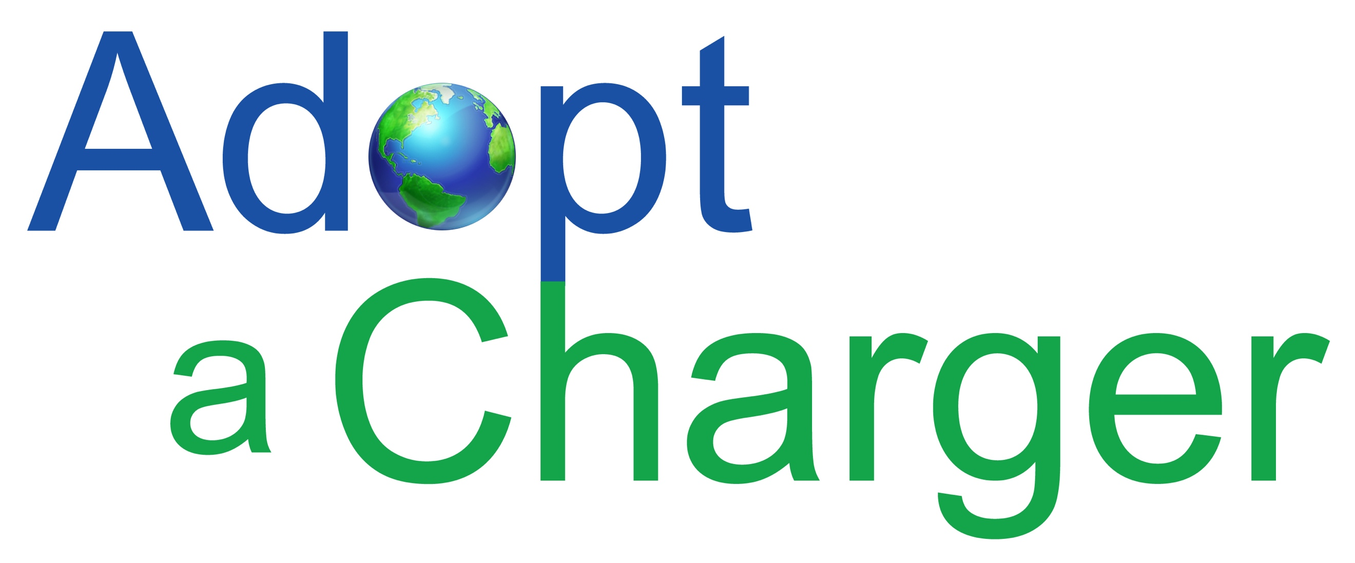

May 21, 2019

Dr. Elise Keddie
California Air Resources Board
1001 I St.
Sacramento, CA 95814
RE: Electric Vehicle Charging Stations Open Access

Dear Dr. Keddie:

Adopt a Charger, Inc. (AAC) is grateful to provide feedback to California Air Resources Board (CARB) lead staff on the SB 454 (Corbett) [Chapter 418, Statutes of 2013] Electric Vehicle Charging Station Open Access regulatory language as proposed.

AAC is a non-profit organization that has facilitated the installation of hundreds of EV charging stations in over 10 states. We advocate for simple, low cost solutions that enable the host site to provide fee-free electricity as an amenity to the EV driving community. The purpose of this approach is to encourage folks to plug-in, raise awareness of electric transportation, and provide a chance for the EV curious to engage in conversation with actual owners. The owners have proven to be the best sales people for the new technology. If EV charging is too expensive, people are dissuaded from plugging in, and the outreach and education opportunity is squandered.

California has a long way to go to reach the goals set forth by Governor Brown’s, which call for 1.5 million PEV by 2025 and 5 million by 2030. The plan also calls 250,000 EV charging stations by 2025. In order to drive adoption of plug-in electric vehicles and meet these infrastructure targets, we need to drastically increase the amount of publicly-accessible, easy-to-use charging stations.

The suggestions offered by AAC are with the goal of achieving simple access to charging stations for EV drivers, and keeping the cost of public charging as close as possible to the actual cost per kWh. This is especially important considering CARB’s goals of increasing adoption of PEV in disadvantaged and low-income communities, where there are few alternatives. CARB is first and foremost a public health agency and all actions should support the common goals of stimulating the sale of PEV, increasing electric vehicle miles traveled, and reducing the amount of carbon in the atmosphere.

AAC recommends the following amendments to the proposed language.

- Exempt existing stations from the necessity of compiling with the new proposed standards. It is a waste of money to require replacing existing assets that are in perfect working order.
- Free and non-networked stations should not be required to comply with reporting provisions. Language in the rule should be clear that non-networked chargers will not be required to become networked, and the site host should not be obligated to report usage for free stations.

- Amend the definition of “publicly available Electric Vehicle Supply Equipment (EVSE)” to clarify that charging stations installed at locations exclusively for the use of visitors, employees, or residents are not considered publicly available EVSE. As an example, the legislative manager at the California State Parks stated that vehicles hooked up to electricity would be considered a “private transaction” for the purpose of AB808, which establishes policies and procedures contingent upon the “public sale of fuel”, which now includes electricity. As a result, AB808 and the new CARB requirements would not have an impact of the State Parks charging stations or AC hookups. Confusion and misinterpretation of the regulations has the potential to negatively affect the expansion of charging infrastructure.

Thank you for your consideration of my comments. Please do not hesitate to contact me if you have any questions.

Sincerely,

Kitty Adams
Executive Director
Kitty.Adams@adoptacharger.org
(310)766-7160

