Equitable and Environmentally-Sound
Car-Parking Policy at a Work Site
By Mike Bullock mike_bullock@earthlink.net
Aug. 30, 2015
Introduction
This paper describes a parking policy that distributes the benefit of parking to all employees, regardless of how often they choose to drive. It does this by
- Charging a fair price for the parking, per unit of time parked, and by
- Giving the total earnings (total parking-lot earnings) to the employees, such that each employee’s share of the total parking-lot earnings is proportion to the time they spend at the work site served by the parking.
The following, additional, optional action would guarantee that no driver loses money under the policy:
- Adding a must-drive bonus to each driver’s share of the parking-lot earnings, if it happened that their share of the parking-lot earnings is less than their parking-lot charge. This means that the employee’s must-drive bonus would be equal to their parking-lot charge minus their share of the parking-lot earnings.
If an employer decided to pay a must-drive bonus to its employees, it would be possible to allow employees to effectively “opt out” of the program so they would not need to be mailed the car-parking statements. The system would feel like “free parking” to them.
Reference 1 describes a more comprehensive policy that will efficiently and conveniently unbundle the cost (or the benefit) of parking in all circumstances. It is available at the following URL: http://www.sandiego.gov/environmental-services/pdf/sustainable/parkingcosts.pdf.
The system described herein is less complex because it does not include congestion pricing, price predictions, or policies that are unique to on-street parking. These features can be eliminated, because it is assumed that there will be an adequate supply of parking, so no congestion pricing is needed; that the price can be relatively stable, so no price predictions are needed; and finally, that employees can be successfully required to park only in their employee parking, so there is no need for new, on-street parking policies, designed to protect adjoining neighborhoods from the intrusion of additional parked cars. If the adjoining neighborhoods had permit parking with a 2-hour limit for cars with no permit, very few employees would ever park in those neighborhoods, in any case.

Rationale
This system of “unbundled parking cost” will allow all stakeholders to see the actual value of the parking. It will reduce single-occupancy driving to work. Less driving will reduce traffic congestion, air pollution and greenhouse gas (GHG) emissions.
Parking is expensive to provide. Therefore, if no parking had been provided, the saved money could have been invested to increase employee salaries. The method described in this paper allows employees to gain some of that lost salary back, by driving less.
Providing free or underpriced parking only benefits employees that would drive every day, even if they had a method to recover some of their lost salary.

Methods
The parking is operated on the behalf of the employees, as if it were their own business. Those that drive to work are therefore their own customers.
Charge for parking is proportional to time parked and is charged to the employee associated with the car. (A charge rate that is acceptable to all must be established.) For example, if sixty cents per hour is selected, the charging software could round off the parking duration time to the nearest minute and apply a one-cent-per-minute charge. The data-collection method could be implemented with RFID’s on cars being detected at parking-lot entrances and exits. Unauthorized cars coming into the employee parking facilitiy would be identified with license-plate detection and, if a car belonging to a felon is driven into the parking lot, a warning notice could be sent to authorities, if this is desired by the company leaders.
Earnings (net revenue, minus the cost of collection and distribution) are given to the employees; in proportion to the time they spend at the work site. This could be based on an employee’s schedule or, for more accuracy, could be based on “time-at-the-work-site” data, collected using personal radio frequency identification units (RFIDs) and detectors that are tied to a central, implementing computer. The variables used to compute the amount of money to be paid to an employee are shown in Table 1. The corresponding formula is shown in Figure 1.
Parking statements are automatically sent out monthly, showing the individual’s charges and earnings. If desired, the statements could include a must-drive bonus, so that no driver losses money under the system. The must drive bonus would probably need to come from funds available for employee compensation.

Implementation
Since this is a new system, it would be prudent for the company leaders to have the vendor take the full responsibility for operating the system, for the first 10 years. This arrangement would ensure that the vendor would debug the system and continue to look for operational efficiencies, over the 10 year period. A sliding scale of vendor-compensation could be specified in the contract, as follows: The vendor could operate the system for 10% of the revenue, for the first 5 years; 5% of the revenue, for the next 3 years; and 2% of the revenue, for the final 2 years. For example, if it is assumed that, on average, 600 cars are parked for 8 hours, for 200 days per year, at a rate of 50 cents per hour, then the yearly revenue would be $480,000 per year. The vendor would therefore collect $240,000 over the first 5 years, $72,000 over the next 3 years, and $28,800 over the last two years. Figure 2 shows contact information and excerpts of received emails, from a San Diego vendor. This vendor has stated that the design and installation of a fully-automated system would be easy to perform.
Table 1 Variables Used to Compute an Employee’s Monthly Earnings

Figure 1 Formula Used to Compute an Employee’s Monthly Earnings

Introducing a New Price Differential, for Driving, Compared to Not Driving
Table 2 shows that introducing a price differential into the choice of how often to drive will decrease the amount of driving.
Other Benefits
Depending on the work site’s location and the size of its access roads, there could be a substantial decrease in local congestion, improving the health of all employees and those living near the congestion. This parking policy will show neighbors that the company is working to be a good citizen. This program will encourage active transportation, meaning modes that provide exercise for the employees. It will also teach the employees the value of parking. It is recommended that the method of determining the selected rate of charge be shared with both the employees and the community at large. This program can be thought of as a demonstration project of a new approach to parking.
Figure 2 One Set of Identified-Vendor Information
Green House Gas Impacts
S-3-05 is a California Governor’s Executive Order to drop the state’s Year 2020 levels of greenhouse gas (GHG) emissions to the state’s level of 1990 emissions and to drop the state’s Year 2050 level of GHG emissions to 80% below the state’s 1990 levels. If the world were to achieve similar reductions, the earth’s level of atmospheric C02 would be capped at 450 parts per million (PPM). Figures 3, 4, and 5 show how large 450 PPM is, compared to values over the last 800 thousand years. Reference 2 shows that the goal of S-3-05 is to limit atmospheric C02 to 450 PPM and it also shows that even if this cap is achieved, the risk of a human catastrophe caused by global warming is significant. Reference 3’s Figure 1 shows that a significant reduction in driving is critically needed.

Conclusion
Adopting this program would benefit the employer, the employees, and the community, in many ways. They will all gain an added understanding of economics, technology, and the power of the free-market principle that sometimes it is better to have people pay for what they use and not force people to lose money for something they don’t use. All the members of the work-place community could take pride in being part of this pioneering effort to reduce driving and greenhouse gas emissions. It would be a demonstration of the fundamental features of Reference 1. It would set an example for other employers.
Table 2 Eleven Cases of Pricing Impact on the Amount of Driving
Figure 3 Atmospheric CO2, Increasing Over Recent Decades
Figure 4 Atmospheric CO2 and Mean Temperature,
800,000 Years Ago, with 450 PPM C02 Shown
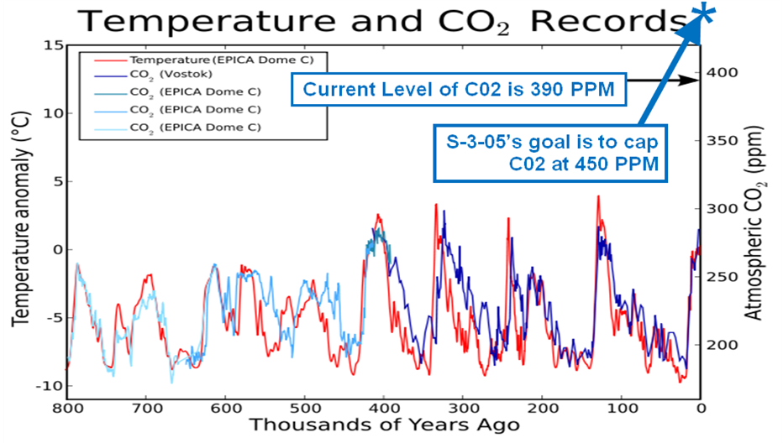

Figure 5 Atmospheric CO2 and Mean Temperature,
Over the Last 1,000 Years
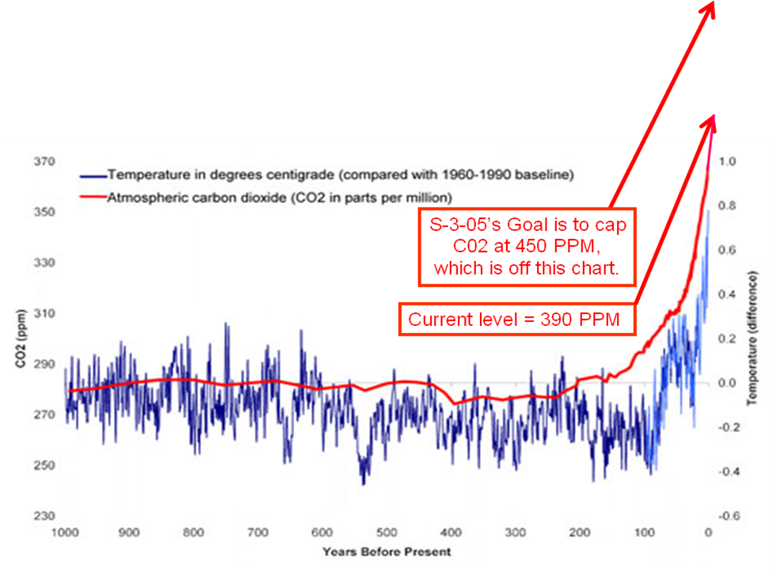
References
- A Plan to Efficiently and Conveniently Unbundle Car Parking Costs, Paper 2010-A-554-AWMA of the proceedings of the 103rd Conference and Exhibition of the Air And Waste Management Association; Mike R. Bullock and Jim R. Stewart, PhD; presented on June 22nd, 2010. http://www.sandiego.gov/environmental-services/pdf/sustainable/parkingcosts.pdf.
- Letter from Center for Biological Diversity, to Elaine Chang, Deputy Executive Officer of Planning, Rule Development, and Area Sources of the South Coast Air Quality Management District; Comments on CAPCOA’s Conceptual Approaches Regarding Potential Significance Thresholds for Greenhouse Gas Emissions; April 17, 2008. http://www.aqmd.gov/docs/default-source/ceqa/handbook/greenhouse-gases-(ghg)-ceqa-significance-thresholds/year-2008-2009/ghg-meeting-1/ghg-meeting-1-comment-letter-center-for-biological-diversity.pdf
3.) Communities Tackle Global Warming, Tom Adams (California League of Conservation Voters), Amanda Eaken, and Ann Notthoff (Eaken and Notthoff are employees of the Natural Resources Defense Council); June 2009. http://www.nrdc.org/globalwarming/sb375/files/sb375.pdf

