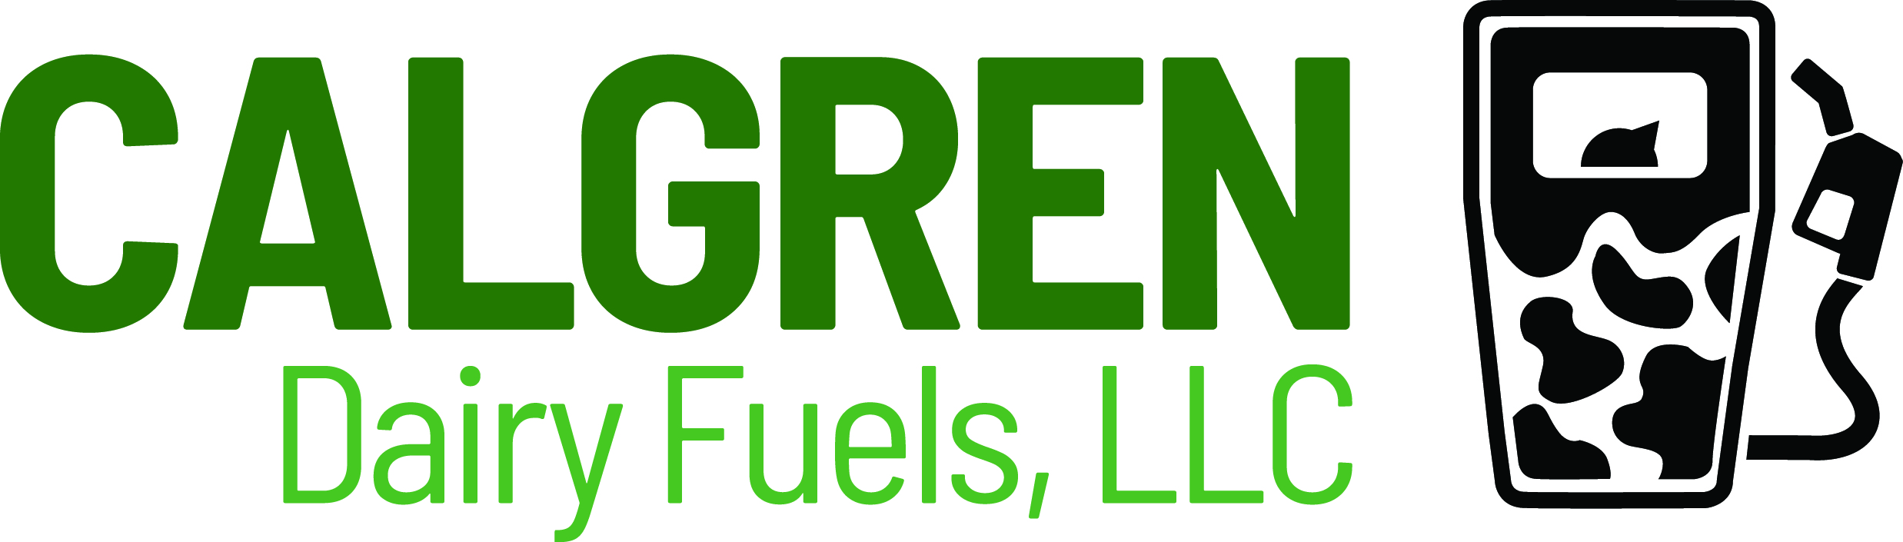

August 8, 2022

Low Carbon Fuels Standard Program
California Air Resources Board
Sacramento, CA 95814

Re: Comments Regarding LCFS Workshop on July 7, 2022

To LCFS Staff:

Calgren Dairy Fuels, LLC (CDF) submits these comments in response to the presentations and discussions at the July 7, 2022 workshop regarding possible changes to the LCFS program. CDF has responded to SB 1383 policy directives to reduce short lived climate pollutants (SLCP) by reducing methane emissions by well over 600,000 MMBtus per year, with more such reductions in the works. We are strong supporters of the LCFS program. We see it as the premier decarbonization policy tool in the U.S. and possibly the world relating to transportation vehicles.

CDF’s comments address five issues:

- Congratulations to staff for such a successful program, support for continuing that success by increasing the carbon intensity requirement for 2030, and support for establishing 5-year interim targets between 2025 and 2040.
- Enthusiastic support of staff efforts to streamline and speed up review and approval of pathway applications.
- Applause for the proposal to limit capacity eligibility for MHD/FCI capacity payments to in-state projects and encouragement to staff to consider other changes to level the playing field between in-state and out-of-state LCFS credit generators.
- Support for commenters that noted the need to consider providing a viable market for biomethane produced from waste, notwithstanding the policy preference for EVs.
- Endorsement of the efforts to advance carbon capture and storage (CCS), especially as it relates to high purity CO2 generated by non-petroleum sources.

- Congratulations to LCFS Staff and Support for Increasing the 2030 Requirement and Setting 5-year Interim Targets to 2040.

The workshop presentation on July 7th underscores that the LCFS is working well. Indeed, as plate 6 of the presentation graphically notes, the program is over-performing. As plate 8 shows, the LCFS is increasing the diversity and volume of low carbon transportation fuels. LCFS staff and the Air Board are to be congratulated. Early in the life of the program, petroleum companies (and a few misguided renewable fuel producers) launched withering attacks on the LCFS program. One of the more consistent criticisms was that the CI reduction goals were unattainable. Thankfully, LCFS staff and the Air Board had both the foresight and the fortitude to withstand such attacks. It is noteworthy that many of those same petroleum companies that once criticized the LCFS are now swamping California with products designed to profit from it (often, regrettably, from out of state). As is well known, Oregon, the State of Washington, and portions of Canada have adopted similar programs. Others are considering following. Clearly, congratulations are in order.

During the presentation, LCFS staff asked whether the 2030 target CI reduction should be changed from the current 20 percent to 25 or 30 percent in 2030. CDF supports increasing the 2030 target to 30 percent. Just as with the original LCFS reduction target when first adopted, the new target appears to be a bit of a stretch. Current California climate goals need to be bold to provide attractive incentives. One of the criticisms of the original goals was that compliance would be too expensive. The Air Board has removed that objection by capping the value of LCFS credits at $200, adjusted for inflation. Considering the rush by petroleum companies to announce renewable diesel projects, that cap would appear to be working to attract new investments.

The Workshop presentation asked whether the Air Board should set interim CI reduction target at 5-year intervals out to 2045. CDF supports that concept, though only to 2040. The original CI reduction target was for 20 years and now appears to be outdated. Setting CI reduction targets beyond 20 years would appear to be ill advised.

- CDF Strongly Supports Staff’s Efforts to Streamline and Speed Up the Review and Approval of LCFS Pathway Applications.

In response to comments at the July 7th workshop, LCFS staff mentioned the strong desire to speed up review and approval of pathway applications. Clearly, LCFS staff recognizes the need to this. CDF pledges its support for this endeavor. CDF is a regular filer of such applications. We have adopted comprehensive pre-application checklists and incorporated review of pathway applications by multiple third-party consultants. The objective is to cut down on the back and forth with LCFS reviewers that occurs when pathway applications are incomplete or unclear. We are confident other serial applicants are doing the same.

As a further sign of its success, the LCFS has prompted a slew of new applications. As mentioned by staff during the workshop, this exceeded the volume anticipated. Tardy prosecution and approval of pathway applications will potentially discourage new investment in low carbon projects. Given the obvious success of the LCFS to date, that would be most unfortunate. However, with routine staff turnover and tight employment markets, hiring and training new LCFS reviewers might be difficult. Thus, CDF urges LCFS staff to continue and possibly expand their current practice of looking to third party verification/validation bodies to reduce LCFS staff obligations whenever and wherever reasonably possible.
- CDF Applauds the Proposal to Limit Capacity Credits to In-State Projects and Urges LCFS Staff to Consider Additional Ways to Level the Playing Field for In-State Producers

The workshop presentation on July 7th showed that biomethane use is increasing in California. Unfortunately, the vast majority of the biomethane earning LCFS credits is generated out of state and little, if any, of the out-of-state biomethane is physically delivered to California. While out-of-state biomethane clearly provides climate benefits, those benefits do not directly help California. More importantly, as described below it puts in-state biomethane producers at a competitive disadvantage.

Only in-state production of biomethane meets the well-crafted policy objectives of SB 1383. Specifically, SB 1383 requires state agencies to: “consider additional policies to support the development and use in the state of renewable gas, including biomethane and biogas, that reduce short-lived climate pollutants in the state.”

Out-of-state biomethane is rarely if ever actually physically delivered to California, meaning it does not displace fossil fuel gas use in California and does not provide jobs or economic development benefits in the state.

Worse yet, out-of-state biomethane is cheaper and easier to produce since out-of-state projects do not have to comply with California’s extensive pipeline injection standards. Out-of-state biomethane producers also have far lower interconnection, permitting, and development costs.

In fact, the strongest criticism of the LCFS is that it often ignores legitimate local objectives and interests. While not directly related to biomethane, the unintended consequences are sometimes hard to fathom. A non-biomethane example is the fact that the U.S. exports fuel ethanol from the Gulf to satisfy Brazilian demand while Brazil exports ethanol to California to capture LCFS benefits. The incremental energy unnecessarily consumed in cargos going north while others go south is bad enough. But the current administration in Brazil ignores global requests to avoid Amazon rainforest destruction. CDF urges that LCFS staff and the Air Board preserve a level playing field for in-state producers when considering the import of out-of-state products.

For all these reasons, CDF urges LCFS staff and the Air Board to limit the
use of book-and-claim accounting for new EV charging and new CNG refueling to in-state production. If this is deemed unworkable under the Interstate Commerce Clause of the U.S. Constitution, CDF recommends requiring that book-and-claim can only be used for biomethane that meets California’s pipeline injection standards.

- CDF Supports the Commenters Recommending the LCFS Assure a Viable Market for Biomethane from In-State Waste

Energy produced from municipal waste and dairy waste generated within California must be afforded a commercially viable market. Several municipal waste processors noted the pressing need for this during the comment period at the July 7th LCFS workshop. CDF supports the concept. As noted earlier, SB 1383 is in accord. The most desirable market for in-state waste is currently CNG heavy duty vehicles using in California. The push for heavy duty freight haulers to switch to EVs “where feasible” is admirable. CDF urges that the qualifier “where feasible” take into consideration the need to have a commercially viable outlet for energy products made from municipal, food and dairy wastes from existing California operations.

- CDF Endorses the In-State Use of Carbon Capture and Storage, especially as it Relates to Non-Petroleum Sources of CO2

CCS is a valuable tool to reduce green house gases. However, not all CCS is equally effective. While the concept of direct air capture (DAC) is laudable, the concentration of CO2 in air is minute. Far better to use a pure stream of CO2 such as found in cement making, wine making, and bioenergy production that directly or indirectly involves fermentation. The latter category includes both fermentation and anaerobic digestion. The purity of the CO2 stream that results from these preferred sources approaches 99.9% (as opposed to the CO2 in air, which is less than 0.05%). And much of the CO2 in air comes from the combustion of petroleum-based fuels. It would be far better for the LCFS program to encourage CCS from high CO2 purity, non-petroleum related streams. In essence, CCS when applied to cement manufacture, wine making, biofuel production by fermentation and/or anaerobic digestion is like DAC on steroids.

Thank you for your consideration of these comments.

Sincerely,

/s/

Lyle Schlyer
President

