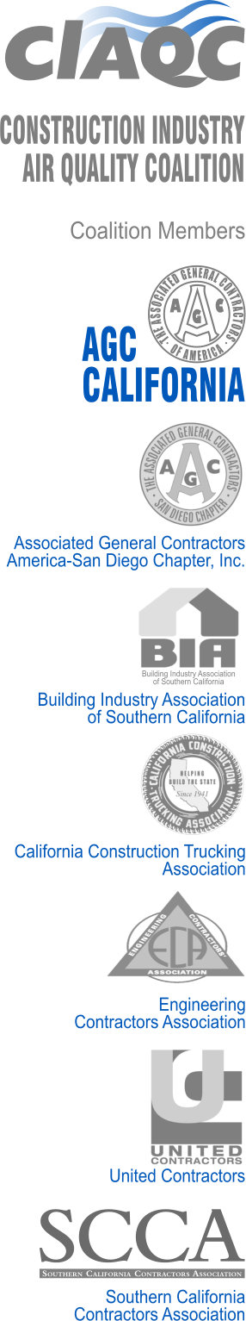

December 6, 2024

California Air Resources Board

1001 I Street

Sacramento, CA 95812

**Ref: Comments on Proposed Amendments to the Advanced Clean Trucks**

**Regulation and the Zero-Emission Powertrain Certification Test Procedure (Second Notice of Public Availability, dated November 21, 2024)**

Dear Air Resources Board:

The Construction Industry Air Quality Coalition CIAQC is a non-profit organization with interstate and instate motor carrier members that are impacted by the Advanced Clean Trucks (ACT) Regulation. We request that you consider the following comments in this regulatory action.

***CARB Continues to Ignore Market Impacts of the ACT on Small Fleets***

Although the Regulation text points to manufacturers as regulated entities, our members are impacted in the same way that the towing industry revealed to the Board at the May 2024 and October 2024 meetings. Members of all fleet sizes are being told by their truck dealers that they must buy zero emission vehicles if they buy new clean combustion vehicles. We dispute the conclusion in the California Truck Availability Analysis that frames the on-going truck market disruption as a communication problem between manufacturers, dealers and fleet customers. The fact is that the ACT Regulation and the Omnibus Regulation have the combined effect of limiting access to affordable cleaner trucks for our members. This is both anti-consumer and a predictable outcome from forcing zero emissions technology that is not ready for adoption due to cost, lack of performance and lack of infrastructure. Our suggestions below are offered in the spirit of trying to create a relief valve for our members and others that seek to purchase and operate the cleanest engines prior to 2027.

***CARB Should Extend the Proposed “2026 Model Year California Certified Engine Flexibility” to the 2025 Model Year Engines***

This so-called “cleanest engines amendment” would remove manufacturing deficits for manufacturers producing the cleanest combustion engines. It should be expanded to all 50 milligram N0x engines for 2025 in addition to 2026 as proposed. We believe that if the manufacturers are provided with this additional flexibility, then additional clean combustion engines will become available to our members. This change could potentially provide flexibility for our members when combined with an ACF amendment as discussed next.

***CARB Should Initiate an ACF Amendment Process to Allow Fleets to Add 2025 and 2026 Model Year California Certified Engines and Treat Them as an NZEV***

Under the Board-approved Advanced Clean Fleets (ACF) Regulation, the High Priority, Drayage and State and Local Government Fleets will face prohibitions from adding combustion engines to their fleets over time. The Regulation allows fleets to purchase a “near-zero-emissions vehicle” in lieu of a zero-emission vehicle and puts a limitation on the time that that vehicle can count towards, or

CARB Should Provide Manufacturers with Cross-Category Transfers for Class 7-8 Tractors

Under the current proposal we do not see that the flexibility offered to Class 2b-6 truck manufacturers is given to Class 7-8 tractors, which are expected to be a lower volume of ZEV production than Classes 2b-6. However, we understand that Class 7-8 tractors are exempt from the cross-category credit transfers. We believe this should be fixed prior to final approval of the Regulation.

Thank you for considering these comments.

Sincerely,

Michael Lewis

Senior vice President

951-206-4420

mike@lewisandco.net

https://ww2.arb.ca.gov/sites/default/files/2024-09/240925_actmemo_ADA_0.pdf

.



operate, in the fleet. For the cleanest engines amendment to have value for fleet owners, we suggest that the Board consider allowing fleets who purchase certified 50 milligram N0x engines in the 2025 and 2026 to treat those as an NZEV until 2035 while counting as a ZEV toward the Milestone Phase-in Option they choose.

***CARB Should Provide Manufacturers with Cross-Category Transfers for Class 7-8 Tractors***

Under the current proposal we do not see that the flexibility offered to Class 2b-6 truck manufacturers is given to Class 7-8 tractors, which are expected to be a lower volume of ZEV production than Classes 2b-6. However, we understand that Class 7-8 tractors are exempt from the cross-category credit transfers. We believe this should be fixed prior to final approval of the Regulation.

Thank you for considering these comments.

Sincerely,



Michael Lewis

Senior vice President

951-206-4420

mike@lewisandco.net

<https://ww2.arb.ca.gov/sites/default/files/2024-09/240925_actmemo_ADA_0.pdf>