ARB Must Consider Radiative Forcing of Tropospheric Ozone and Black Carbon
Comments on California Air Resources Board Draft Short-Lived Climate Pollutant Reduction Strategy by Jim Stewart, PhD, DrJimStewart@gmail.com, 213-820-4345
ARB staff is well aware the Earth’s climate is determined by the planetary radiation balance, which is the balance between energy entering at the top of the atmosphere as sunlight and that leaving the atmosphere as reflected light and heat back to space. The departure from the pre-industrial equilibrium is referred to as radiative forcing, which is expressed in W/m2. The Integrated Assessment of Black Carbon and Tropospheric Ozone by UNEP and WMO in 2011 reports the dramatic impact of black carbon (BC) and tropospheric ozone (O₃) on global warming: the best estimate (in 2010) for BC is 0.6 W/m2 and for O₃ is 0.35 W/m2, which together nearly equal the then radiative forcing for CO₂ of about 1.5 W/m2.
Tropospheric Ozone
The UNEP report states, “The increase of tropospheric ozone (O₃) in the past 100 years has made it one of the most important contributors to human-induced global warming, together with CO₂, CH₄ and BC. Even though its globally averaged tropospheric human-derived concentration is about 10,000 times smaller than that of CO₂, O₃’s current global radiative forcing is about one-sixth to one-third that of CO2.” “Ozone is not an emitted pollutant and thus for control purposes it is appropriate to attribute the radiative forcing for O₃ to the precursor emissions of methane (CH₄), carbon monoxide (CO), non-methane volatile organic compounds (NMVOCs) and nitrogen oxides (NO_{x}).”
At the October 14 ARB workshop, Ryan McCarthy of the ARB staff asserted that tropospheric ozone was nearly all caused by methane, so the ARB would not consider it as a separate SLCP. However, the UNEP report states, “Two-thirds of the O₃ radiative forcing to date may be attributed to the increase in atmospheric CH₄ over the last century.” This implies that the other components contribute about a third, and thus should be considered by ARB as separate SLCPs.
The ARB SLCP draft report uses GWP-20 values (which is to be commended -- in contrast to the outmoded GWP-100 values used by ARB in other reports and cap-and-trade calculations). However, the UNEP report states, “It is not possible to calculate GWPs or GTPs for O₃ since it is not emitted directly. Instead these metrics can be calculated for emissions of O₃ precursor species. These species often have an impact on radiative forcing agents other than O₃ and their climate metrics need to take these into account (e.g. Collins et al., 2002; Shindell et al., 2009 ).”
The resulting implication is that CO, VOCs and NO_{x} should all be considered as GHGs for the AB 32 Scoping Plan, cap-and-trade, etc. Thus ARB should bring CO, VOCs and NO_{x} under the cap and use Greenhouse Gas Reduction Funds (GGRF) to pay for their reductions. If ARB does not do this, the ARB Environmental Assessment (EA) must explain why not.
The complexity of methane’s effects is illustrated by Figure 3.14 from the UNEP report. But the important thing to note is that the RF of methane is about 1 W/m2, almost as much as carbon dioxide.
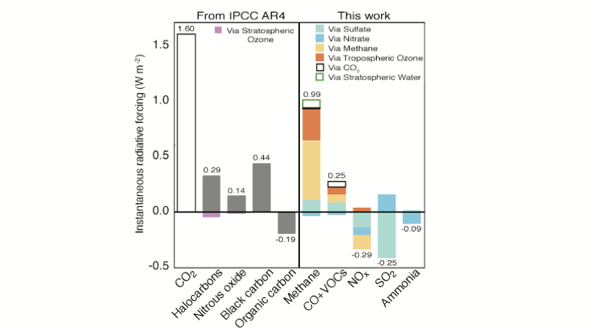
“Figure 3.14. Global mean pre-industrial to present-day RF by emitted species from AR4 and Shindell et al., 2009. Numerical values next to each bar give total forcing summed over all the effects included in the calculations. Aerosol indirect effects are not included, nor are interactions with ecosystems.”
Black Carbon
The UNEP report states, “Even though the globally averaged ground-level concentration of black carbon (BC) is presently about 0.1 micrograms/m3 (Chapter 3), compared to about 200 milligrams/m3 of anthropogenic CO₂, its instantaneous radiative forcing due to absorption alone may be about half that of anthropogenic CO₂.” “Globally averaged net forcing is likely to be positive and in the range 0.0 to 1.0 W/m2, with a best estimate of 0.6 W/m2 (values include the enhanced efficacy of BC forcing due to snow and ice darkening).”
Thus all sources of black carbon (see list in the next figure) are contributing to global warming and need to be considered by ARB as GHGs for the AB 32 Scoping Plan, cap-and-trade, etc. Thus ARB should strictly regulate them, or bring them under the cap and use Greenhouse Gas Reduction Funds to pay for their reductions. If ARB does not do this, the Environmental Assessment (EA) must explain why not.
What is particularly appalling about the ARB Draft Short-Lived Climate Pollutant Reduction Strategy is that no reductions are scheduled for off-road vehicles by 2030. Thus off-road vehicles will continue to be a major contributor to GHGs as well as to health impacts. If ARB strategy does not include off-road vehicles, the Environmental Assessment (EA) must explain why not.
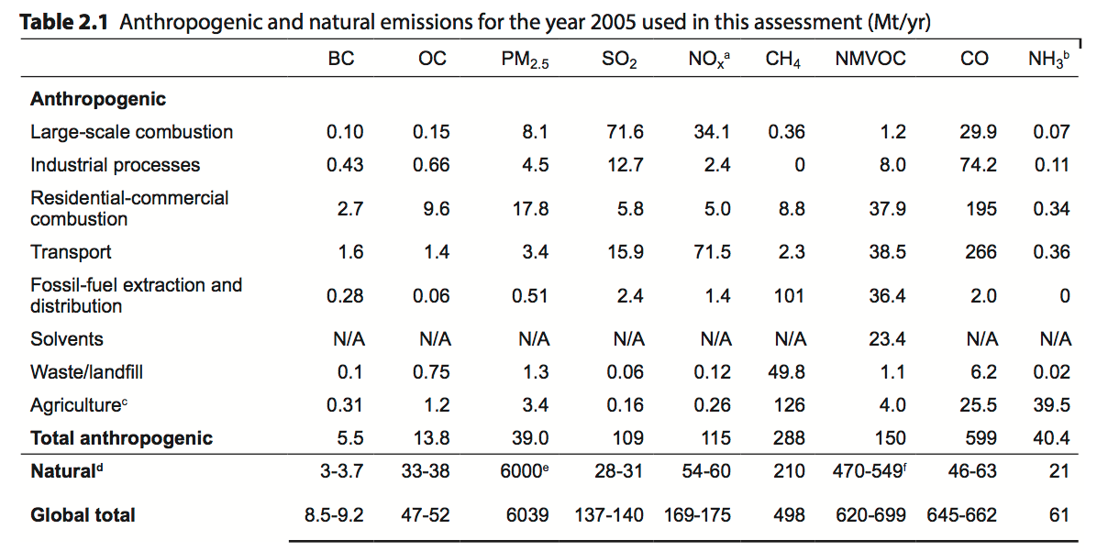

Impacts: Impacts of black carbon and tropospheric ozone are huge. A few of the ones mentioned in the UNEP report include:
- Temperature Rise: “The equilibrium warming that would result from changes in burdens of black carbon (BC) and tropospheric ozone (O₃) from pre-industrial to 2005 is estimated at 0.0 to 0.8°C for BC and 0.1 to 0.4°C for O₃ as a global average, with larger contributions in the northern hemisphere mid-latitudes. For comparison, the equilibrium warming for the observed increase in carbon dioxide (CO2) over the same time period is about 1.3ºC.”
- Health Impacts: “Globally, premature deaths associated with O3 exposure are valued at US$400 billion.”
- Decreased Crop Yields: “Limited evidence suggests that crop yields will be significantly affected by changes in regional climate that are likely to be enhanced in areas with high BC and O3 pollution. Surface warming due to O3 acting as a greenhouse gas and BC will affect temperatures, cloudiness, rainfall amounts and patterns, and river flow, the latter through BC impacts on glacier melting and evaporation; all of these factors will impact agricultural production. Additionally, changes in the amount and quality of photosynthetically active radiation caused by BC and aerosols may also affect crop yields.”
- Global Ecosystems: “Changes in global ecosystem net primary productivity caused by an increase in O3 damage will have a substantial impact on carbon sequestration in ecosystems and hence on radiative forcing. A global modelling study has shown that reduction in carbon sequestration caused by O3 impacts on vegetation could double the effective radiative forcing attributable to tropospheric O3 under a future 2100 SRES A2 scenario.
Near-term Climate Protection Benefits from Controlling Short-Lived Climate Forcers
The chart below sums up the climate benefits of controlling CH4 and black carbon: even with no CO2 control measures, the 2040 temperature rise is limited to 1.4ºC, compared to 1.8ºC for only CO2 measures. The implication of this chart for ARB is that they need to switch immediately from their current emphasis on CO2 measures (almost all GGRF funds go toward reducing CO2) to a balance, perhaps 50-50. If ARB does not do this, the Environmental Assessment (EA) must explain why not.
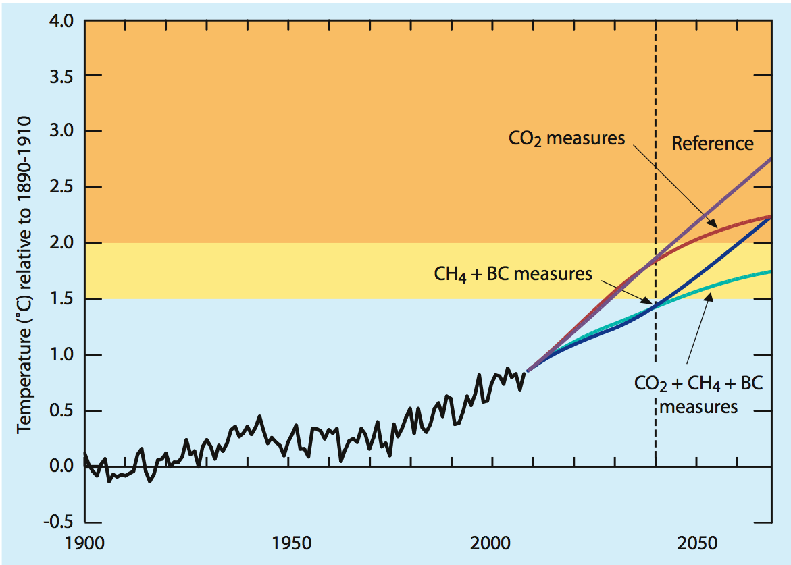
This report also has extensive data on the health benefits from controlling Short-Lived Climate Forcers.

www.unep.org/dewa/portals/67/pdf/BlackCarbon_SDM.pdf
Ibid, p. 59.
Ibid, p. 4.
Ibid, p. 76.
Ibid, p. 59.
Ibid, p. 101.
Ibid, p. 77.
Ibid, p. 4.
Ibid, p. 59.
Ibid. p. 95.
Ibid. p. 96.
Ibid. p. 97.
Ibid. p. 97.
Near-term Climate Protection and Clean Air Benefits: Actions for Controlling Short-Lived Climate Forcers, United Nations Environment Programme (UNEP, 2011), Nairobi, Kenya, http://www.unep.org/publications/ebooks/SLCF/
Ibid p. p. xiii.

