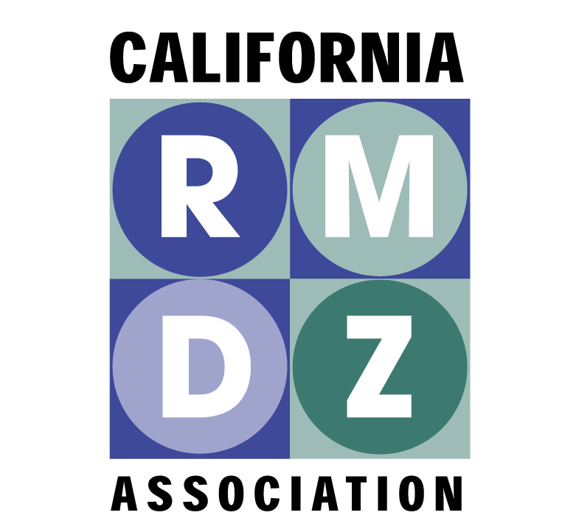

RECYCLING MARKET DEVELOPMENT ZONES

November 1, 2013

Thank you for this opportunity to comment on the Discussion Draft of the Updated Climate Change Scoping Plan. The California Association of Recycling Market Development Zones (CARMDZ) represents primarily local government partners throughout the state that have worked with CalRecycle since 1993 to assist businesses that utilize recyclable materials to make value-added products. These businesses employ thousands of Californians, including many in disadvantaged communities. Currently there are 35 RMDZs in urban and rural communities which collectively cover more than half of California by territory and population.

CARMDZ is also a co-founder of the Recycling BIN (Build Infrastructure Now) Coalition, which includes over 20 recycled-content manufacturers, composters, business organizations, local governments, and environmental groups working to cut greenhouse gas emissions, create decent paying jobs, and enhance domestic usage of recycled materials collected in California. Over the life of the program, the RMDZ loan fund has already distributed over $110 million to more than 160 companies which employ nearly 10,000 Californians and handle more than 7 million tons of recyclable materials each year.

In this context, we are pleased to find reference to the need for development of recycling based infrastructure in California, as evidenced by the following few quotes from the draft:

Achieving the 75 percent goal will require substantial growth in the collection, recycling,
and manufacturing industries within California. This Update sets forth a series of
actions to support this industrial growth, including the State's procurement of recycled content
products, and calls on California to manage its waste at home. Developing this
industry here helps ensure that the GHG emission reductions, environmental co-benefits,
and job growth all benefit California. (from p. ES-5, emphasis added)

As a co-benefit to achieving the AB 341 mandate, it is estimated that in aggregate about 20
to 30 MMTCO2e will be reduced by 2020 compared to business as usual… [with footnote:] Most of the estimated emissions benefits will be outside of California, since the majority of the
recyclable commodities are currently reprocessed outside the state (p. 40, emphasis added).

The challenges to meeting the State’s GHG and waste reduction goals need to be
addressed with the understanding that California must take full ownership for the wastes
generated within its borders. Shipping of waste, even recyclable products, to other
states or nations is not a viable, long-term, environmentally appropriate waste
management practice for California. Furthermore, exporting waste denies California the
economic opportunity of significant job growth that would result if these materials were
processed and remanufactured in California (p. 98, Continuing Progress Beyond 2020 section).

To achieve the vision for the waste management sector, certain overarching actions are
recommended. Financial incentives to build adequate in-state infrastructure and
incentivize activities to accomplish GHG and waste reduction goals are critical.
Collaboration with other agencies, districts, and jurisdictions to streamline the permitting
process and address conflicting requirements, including cross media issues will permit a
sustainable waste management system to grow in California. (pp. 98-99, Continuing Progress Beyond 2020 section, emphasis added).

Based on our work with CARB and CalRecycle in recent years, we are pleased that these points are present in the Discussion Draft for the Updated Scope. However, the placement of the most clear support for recycling market and infrastructure development appears to be in the section entitled “Continuing Progress Beyond 2020”.

This confusion is compounded somewhat by the most specific supportive statement of all, on table 16 at page 110, “Funding of Specific Areas to Support AB 32”. Called out as a short term funding priority on this chart is none other than “Expansion of established programs… including: Recycling Market Development Zone.

As CARB turns its work to integrating the many comments on the updated Scoping document, we are very pleased to have recycling market and infrastructure development included as a prominent solution, but would ask that there might be clarification that this activity area is a near term priority.

Thank you for all of your good work and for your consideration.

Sincerely,

Steve Lautze
CARMDZ President

Printed on recycled paper with 30% post-consumer content.

