June 19, 2015

Mary Nichols, Chairman
California Air Resources Board
1001 I Street
Sacramento, CA 95812

RE: LCFS Re-adoption

Chairman Nichols,

National Sorghum Producers (NSP) is a trade association representing the interests of over 50,000 sorghum producers on issues related to legislative and regulatory policy in Washington as well as various state capitals. NSP led efforts to secure an advanced biofuel pathway for sorghum under the RFS2 and has performed extensive analysis on several models and datasets over the last four years, including several datasets similar to those used by the Argonne National Laboratory as well as the ARB in modeling the CI of sorghum ethanol.

NSP applauds the ARB for undertaking an extensive update of the LCFS and is very appreciative of the time committed by ARB staff to ensure not only the integrity of the data used but their representativeness of real-world conditions as well. NSP also thanks the ARB for its special attention to sorghum fertilizer requirements and N₂O emissions from sorghum stover. In addition to these areas, NSP strongly recommends that the ARB focus attention on information related to sorghum root:shoot ratios, and as it becomes available, incorporate this information into future versions of CA-GREET.

NSP also recommends that the ARB revisit sorghum iLUC as soon as possible. As we have stated previously, we do not feel the EPA’s FAPRI-based analysis of sorghum iLUC was accurate, and we believe that the ARB has the opportunity to shed a correct light on the issue in future iterations of AEZ-EF. We look forward to working with ARB staff and sorghum stakeholders on this in the future.

Thank you for the opportunity to provide feedback. We feel strongly that sorghum ethanol can play a large role in helping California meet the greenhouse gas reduction goals set by the LCFS while at the same time promoting the use of water-sipping crops like sorghum.

Please do not hesitate to let me know if you have any questions.

Regards,

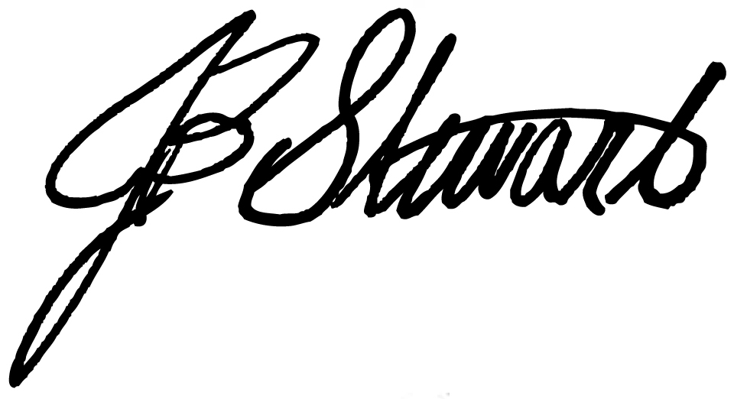

J.B. Stewart
Chairman
National Sorghum Producers
4201 N. Interstate 27
Lubbock, TX 79403
Phone: (806) 749-3478

