California Air Resources Board Formal Comment
California Air Resources Board
Request for Comments
Action: Scoping Plan 2030

Submitted to ARB Clerk of the Board
Electronic submittal: https://www.arb.ca.gov/lispub/comm/bclist.php
April 10, 2017

I, Deborah Gordon, director of the Energy and Climate Program at the Carnegie Endowment for International Peace, am hereby submitting the following comments pursuant to the notice of public board meetings and public comment period on the 2017 Climate Change Scoping Plan Update: The Proposed Strategy for Achieving California’s 2030 Greenhouse Gas Target and Draft Environmental Analysis.

The Proposed Scoping Plan describes actions California can undertake to ensure it continues on a path toward a cleaner, more sustainable and prosperous future. This approach is designed to ensure the State is able to meet its long-term climate objectives that will achieve continual emissions reductions, while simultaneously supporting a range of economic, environmental, water supply, energy security, environmental justice, and public health priorities.

Using the Oil-Climate Index to Target GHG Reductions in the Refining Sector

In terms of achieving or exceeding stated goals to reduce greenhouse gas (GHG) emissions by 20 percent from California refineries, I am submitting analysis provided in the Oil-Climate Index (OCI), a tool developed by the Carnegie Endowment for International Peace in collaboration with research partners at Stanford University and the University of Calgary. The OCI is the first open source web tool to estimate and compare total GHG emissions through the oil supply chain—production, crude transport, refining, product transport, and end use. In an analysis of 75 global oils, we found large differences in GHG emissions between equivalent barrels.

Carnegie then undertook a provisional analysis using the OCI to model California’s 154 oil fields and found similarly wide-ranging GHG differences in the state’s total oil emissions. In order to finalize these estimates, additional data inputs needed to run the PRELIM model will be required as indicated in Attachment A. We recommend that CARB routinely collect the oil data specified in Attachment A in a standardized format in order to run all oils produced in and imported into the state through the OCI.

Our OCI analysis identifies GHG emission relationships between refining and other oil factors. It also finds significant opportunities for refining GHG emission reductions through regulatory targets, best practices, and industry innovation as follows:

- Modeling 75 global crudes (25 percent of current global oil production) through the OCI resulted in an estimated factor of ten difference between the global oil with the highest GHG emissions (98 kg per barrel crude) compared to the lowest (10 kg per barrel crude). Of all the North American oils modeled, all three California fields in the study ranked at the top in terms of their refining GHG emissions. Finding: Those oils with the highest GHG emissions deserve the most attention from CARB in terms of tracking, best practices, and regulatory oversight.
- Canada Athabasca Synthetic Crude Oil (SCO) had among the lowest ranked refining GHGs (13 kg per barrel SCO) had much lower refining GHG emissions than the three California oil fields modeled in the OCI. Finding: Some California oil fields are very climate intensive to refine (as well as produce). And while oil sands are highly GHG intensive in their production and upgrading, if Canada can reduce their upstream emission impacts, they are very low emitting in terms of their refining.
- Since open source, public oil assays are not currently available, Carnegie could only provisionally run all 154 oils through the OCI. By using smart default assays from our library of over 100 public assays, we provisionally estimated an average refining GHG emission value from Californian oils of 42.7 kg per barrel crude. There are wide variances in the distribution of California refining GHG emission around the mean. We provisionally estimate that 51 (one in three) California oils have above average refining GHG emissions; 10 oils are estimated to have refining GHG emissions that are greater than twice the average; and 35 oils are estimated to have refining GHG emissions that are less than one-half the average. Findings: There is no standard oil in California and the state will have to manage oils in a more strategic, targeted fashion in order to significantly reduce refining GHG emissions.
- When plotting refining GHG emissions versus API gravity for the 75 oils modeled in the OCI, there is a weak relationship overall and this relationship does not hold for those oils with the highest and lowest refining GHG emissions. Finding: Oil assays are essential to estimate the GHG emissions from the refining sector.

Conducting Refining Study on Hydrogen Addition

Hydrogen requirements are responsible for as much as one half of total refining GHG emissions. The Petroleum Refinery Life Cycle Inventory Model (PRELIM), used in the OCI to model refining GHG emissions finds that facility emissions, especially those associated with hydrogen (methane-reforming natural gas) and electricity inputs may be significantly greater than the emissions reported in current inventories. We recommend CARB conduct a refining study to reassess refinery GHG emissions from hydrogen. Note that PRELIM indicates that refining GHG emissions from electricity inputs may also be undercounted and should, therefore, be reassessed.

The majority of California’s refineries are coking refineries. These configurations, in general, have higher refining GHG emissions than other refinery configurations. Our OCI analysis identifies GHG emission relationships between coking refineries, petroleum coke production, and alternative configurations as follows:

- When plotting total supply chain GHG emissions versus refining GHG emissions, there is a significant emission reduction if instead of coking heavy, depleted oils, they are managed a new way. This not only eliminates production of petroleum coke (reducing end use emissions), avoiding coking through renewable hydrogen addition and other techniques could significantly reduce refining emissions. Finding: The large emission reduction potential for refining breakthroughs that do not coke require further study.

- For example, regulatory-driven innovation could drive California’s Midway Sunset field (the largest and highest producing field in the state with the highest GHG emissions) to reduce refining GHG emissions by an estimated 69 percent. Finding: Merging the goals of California’s Hydrogen Highway and refining emission reductions could provide low-GHG hydrogen addition alternatives to this sector, contributing significantly to the state’s GHG emission goals.

Conducting Refining Study on Catalyst Coke

National and international GHG emission inventories may not currently account for the petroleum coke that builds up on catalysts (catcoke) in refineries equipped with fluid catalytic cracking (FCC) units, according to the U.S. Energy Information Administration. This may be the case in California as well. We recommend that CARB conduct a study on refinery catcoke in order to assess whether its refining GHG emissions are fully accounted for. CARB should share their research results with EIA and other climate agencies to improve industrial emission inventories worldwide.

Attachment B documents the relevant verbatim text from the U.S. Energy Information Administration explaining GHG emissions omissions from catcoke that need to be included in inventories. In the International Energy Outlook 2016, May 11, 2016, Chapter 2: Petroleum and Other Liquids, there is a shaded box in the middle of this chapter that discusses industrial CO2 emissions and petroleum coke use in refineries. Underlines have been added in Attachment B to underscore EIA’s main findings.

We hope CARB staff can use Carnegie’s OCI refining emission, the University of Calgary’s PRELIM emission, and the U.S. EIA’s emission findings detailed above to think through new refining strategies and the right GHG emission reduction targets to place on this sector. There is tremendous innovative capacity to be realized in updating those refining technologies developed in the last century.

Thank you for the opportunity to submit comments on this important matter to close information gaps, increase oil data transparency, and strategically target GHG emission reduction and innovation potential in the state refining sector.

If CARB staff need any clarification, data, or would like to follow up on any aspect of these comments, please contact:

Deborah Gordon
Director, Energy and Climate Program, Carnegie Endowment for International Peace
1779 Massachusetts Avenue, NW
Washington, D.C. 20036
(202) 957-8849 or (202) 939-2370
dgordon@ceip.org

Attachment A

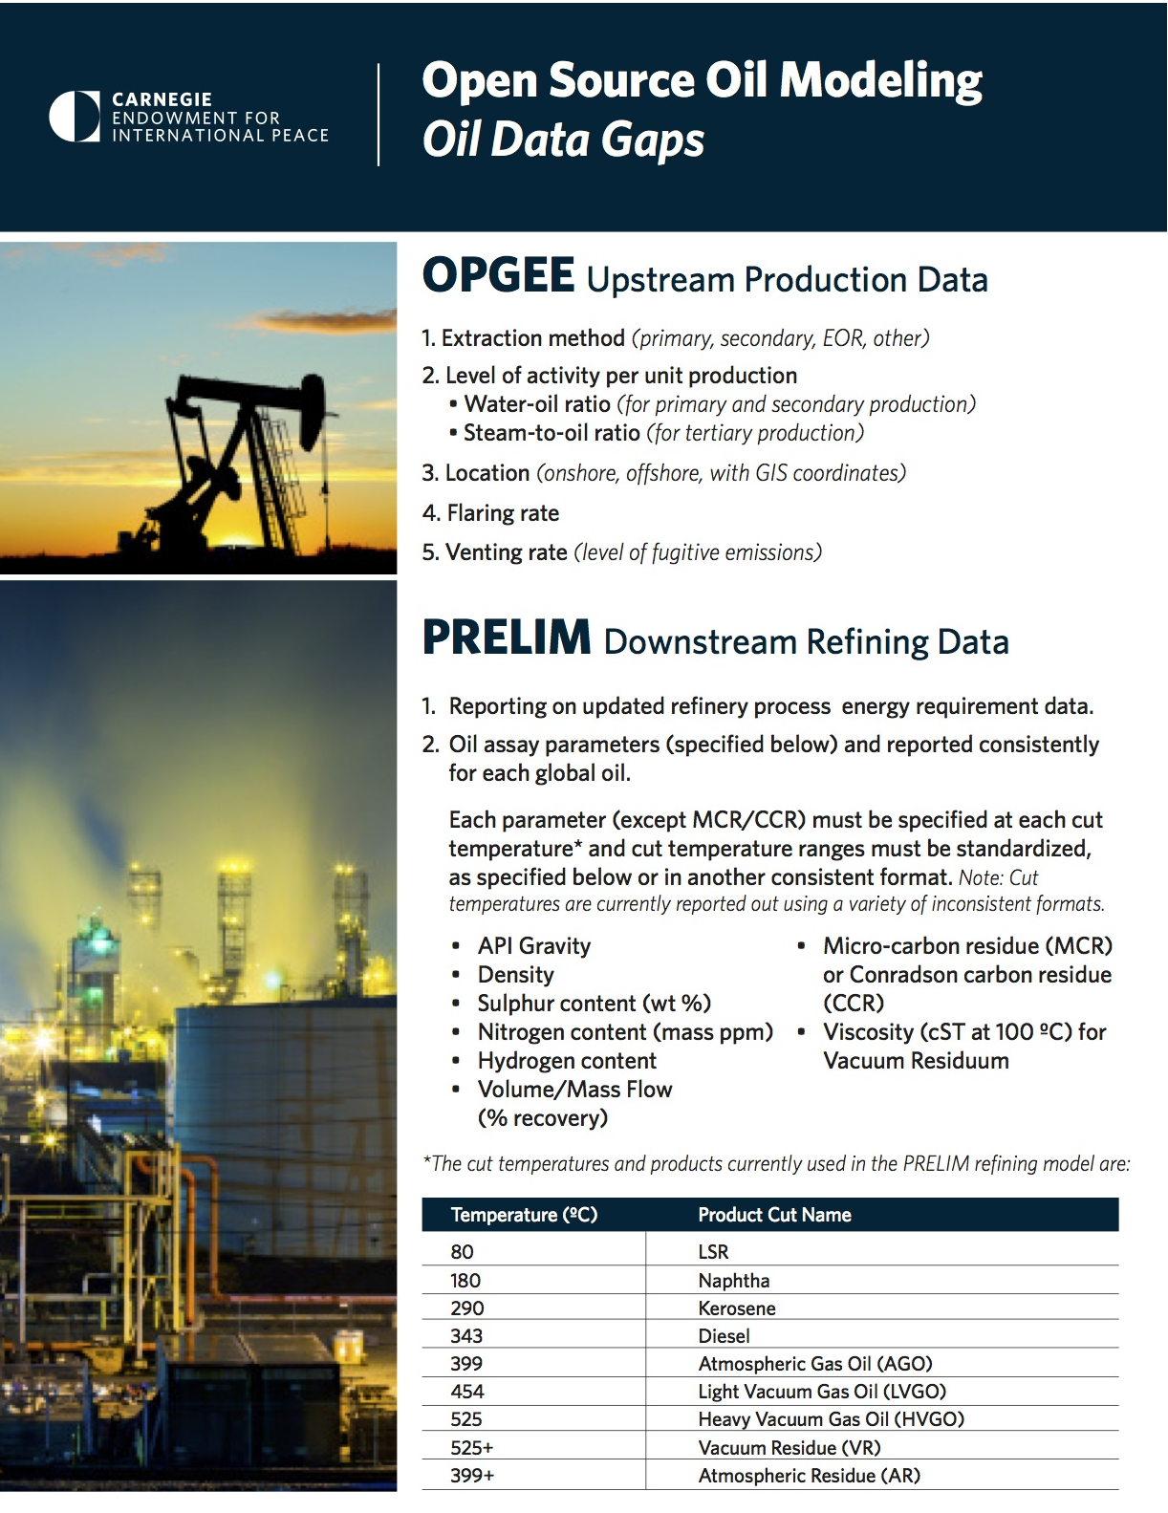

Attachment B

INTERNATIONAL ENERGY OUTLOOK 2016
Release Date: May 11, 2016 | Next Release Date: September 2017 | Report Number: DOE/EIA-0484(2016)

(Note: Relevant text taken from middle of the Chapter 2)

EIA has identified possible discrepancies in the international reporting of data on fuels consumed in the petroleum refining sector that may result in underestimation of energy-related emissions of greenhouse gases (GHG). Petroleum refining is one of the world’s most energy-intensive industries, and as demand for petroleum products in non-OECD countries continues to grow, their refining industries are adding capacity to process more crude oil into gasoline, diesel, and other petroleum-based products. Evolving crude oil inputs, changing market demands, and increasingly stringent emissions regulations all affect the refining process. As an energy-intensive industry, petroleum refining also is a significant source of GHG emissions, and understanding and tracking the industry’s fuel use is essential to understanding its contribution to global GHG emissions.

Energy consumption by refineries includes both purchased fuels and internally derived fuels drawn from the crude oil refining process itself. Petroleum coke (petcoke) is a refinery product that takes the form of a solid, carbon-rich substance resembling coal. There are two kinds of petcoke: catalyst and marketable. Most refineries worldwide produce both types of petcoke, with differences in production levels resulting from different refinery configurations and crude oil inputs. Heavier crudes typically yield higher petroleum coke production.

Catalyst petcoke, or catcoke, is a byproduct from refinery fluid catalytic cracking (FCC) units. Catcoke is burned off the catalyst matrix (generally, pellets or finer sand-sized particles) to maintain catalytic activity, providing energy for FCC processes. Catcoke cannot be collected and sold. Rather, it must be burned onsite as refinery fuel. Catcoke is a significant source of carbon dioxide (CO2) emissions. Marketable petcoke, on the other hand, is produced in coker units. Petcoke is collected and processed in sizable chunks by the refinery and marketed for various uses, such as fuel for cement kilns and power generators. Marketable petcoke also is widely used for nonfuel purposes, especially for conversion to carbon anodes used in aluminum production. When either type is burned, sizable amounts of CO2 are released, along with sulfur and volatile heavy metals. In some countries, including the United States, air quality regulations have made the burning of marketable petcoke prohibitively expensive. As a result, there has been an increase in U.S. exports of marketable petcoke, with more than 14% of the 2012 total delivered to China [29].

The International Energy Agency (IEA) historical database, among other compilations, provides data on the world supply of marketable petcoke, including production, trade, and consumption data for most nations. Many countries appear to omit catcoke consumption, possibly because it is not sold as a marketed fuel. For those that do report catcoke consumption, there often is no distinction between marketable petcoke and catcoke in the IEA database. However, it appears that most OECD nations (Chile, Mexico, and Poland are a few of the exceptions) provide data for consumption of both marketable and catalyst petcoke in the refining sector, the latter likely representing most petroleum coke consumption.

Other nations (including China, Russia, Brazil, and most of the other non-OECD nations) provide data for their petroleum coke supply but not for their refining sector consumption. All of these countries have some FCC units in their refineries, and it is possible that the catalyst coke portion of total petroleum coke consumption is not reported because it is burned in domestic refineries. This situation would cause CO2 emissions for some countries to be underestimated.
China is one country that does not report data on refinery consumption of petcoke. One possible way to estimate its consumption may be to assume that refining operations in the United States and China are not significantly different. If so, one would expect the American and Chinese systems to use about the same amount of energy per barrel of crude oil processed. Total U.S. production of petroleum catcoke (which is equal to refinery consumption of petcoke) is reported to be in the range of 200,000 b/d to 250,000 b/d, equivalent to about 0.1 million Btu of catcoke per barrel of crude processed in U.S. refineries.

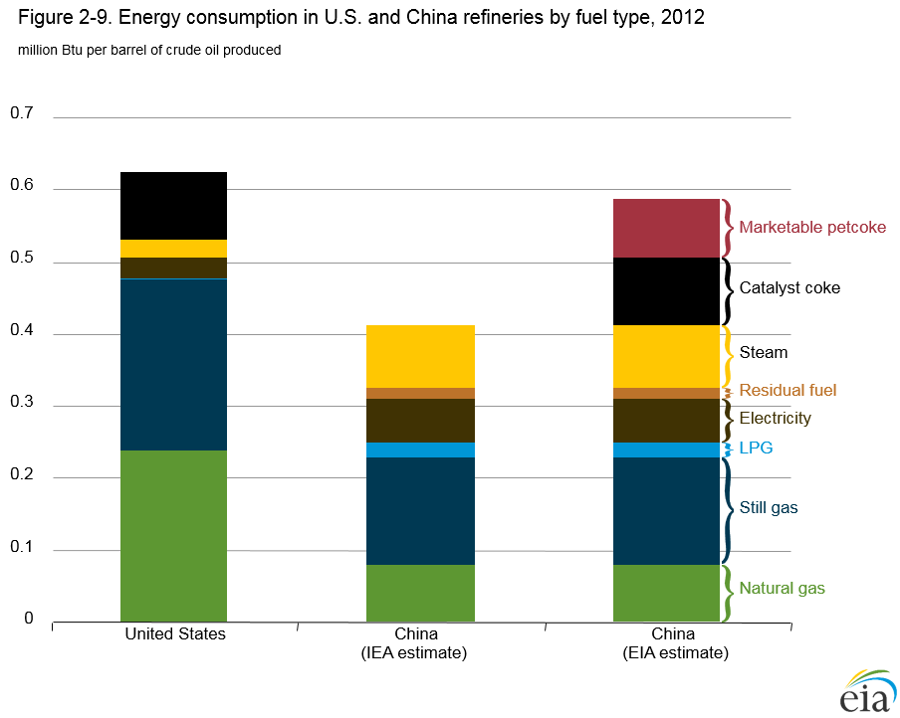
figure data
If the consumption of catcoke and marketable petcoke is not included in the estimation of energy consumption at China's refineries, then GHG emissions from China’s refining sector would be underestimated. Based on the analysis summarized here, EIA has incorporated its estimates of marketable petcoke consumed as refinery fuel in the IEO2016 baseline estimates of China’s industrial sector energy consumption. Further, China may not be the only example of a country whose consumption of catcoke or petroleum coke goes unreported. Better estimates of refinery consumption of catcoke and petroleum coke fuel, not only for China but elsewhere as well, would enable construction of a more accurate baseline for world industrial sector CO2 emissions in the future.

The hyperlinks included in our comments are detailed below for those who may receive hard copies. URL for website hyperlinked here is: http://oci.carnegieendowment.org/
URL for report hyperlinked here is: http://carnegieendowment.org/2016/10/05/getting-smart-about-oil-in-warming-world-pub-64784
URL for report hyperlinked here is: http://carnegieendowment.org/2017/03/15/need-to-know-case-for-oil-transparency-in-california-pub-68166
URL for the OCI graph from web tool hyperlinked here is: http://oci.carnegieendowment.org/#supply-chain?opgee=run000&prelim=run01&showCoke=1&carbonToggle=off&carbonTax=20.00&ratioSelect=perBarrel&stepSelect=midstream&sortSelect=true&regionSelect=North%20America
URL for the OCI graph from web tool hyperlinked here is: http://oci.carnegieendowment.org/#supply-chain?opgee=run000&prelim=run01&showCoke=1&carbonToggle=off&carbonTax=20.00&ratioSelect=perBarrel&stepSelect=midstream&sortSelect=true
URL for the OCI graph from web tool hyperlinked here is: http://oci.carnegieendowment.org/#analysis?opgee=run000&prelim=run01&showCoke=1&ratioSelect=perBarrel&xSelect=apiGravity&ySelect=midstream
URL for PRELIM linked here is: http://www.ucalgary.ca/lcaost/prelim
URL for the OCI graphs from the web tool hyperlinked here are: With coking refining and petcoke consumed – http://oci.carnegieendowment.org/#analysis?opgee=run000&prelim=run01&showCoke=1&ratioSelect=perBarrel&xSelect=ghgTotal&ySelect=midstream&oiltypeSelect=Extra-Heavy,Heavy,Depleted and without coking refining – http://oci.carnegieendowment.org/#analysis?opgee=run000&prelim=run21&showCoke=0&ratioSelect=perBarrel&xSelect=ghgTotal&ySelect=midstream&oiltypeSelect=Extra-Heavy,Heavy,Depleted
URL for Midway Sunset report hyperlinked here is: http://carnegieendowment.org/2017/03/15/drilling-down-on-oil-case-of-california-s-complex-midway-sunset-field-pub-68210
URL for the OCI graph from the web tool hyperlinked here is: http://oci.carnegieendowment.org/#oil/u.s.-california-midway-sunset?opgee=run000&prelim=run21&showCoke=1
URL for this EIA study hyperlinked here is: https://www.eia.gov/outlooks/ieo/liquid_fuels.cfm

