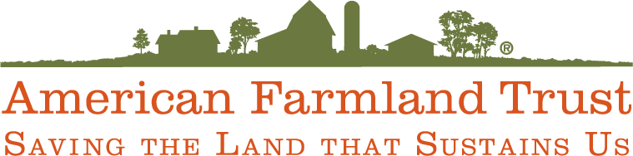

December 12, 2014

Ms. Mary Nichols, Chair
California Air Resources Board
1001 “I” Street
Sacramento, CA 95814

Re: Rice Cultivation Projects Compliance Offset Protocol and staff report released October 28, 2014

Dear Ms. Nichols:

American Farmland Trust (AFT) is a national nonprofit organization, founded in 1980. Its mission is to protect the best farmland from conversion to other uses, keep farmers on the land, and promoting sound farming practices that protect and enhance natural resources. To that end, AFT supports ecosystem services markets as an efficient mechanism to enhance the environment and farming economics. AFT applauds the State of California and the Air Resources Board (ARB) in developing an important ecosystem services market in greenhouse gas mitigation and supporting the development of the first compliance offset protocol from agricultural cropping systems in the form of the Rice Cultivation Projects Compliance Offset Protocol and the associated staff report of October 28. This protocol is precedent setting and will have national and perhaps global implication. AFT supports the protocol and guidance set forth in the staff report, and offers the following comments that hopefully will foster broader farmer participation while maintaining the scientific rigor and conservatism necessary for a compliance protocol.

Consolidated Reporting
For agricultural offset projects to be attractive and cost-effective for growers, their GHG emission reductions often need to be aggregated into quantities large enough to implement and sell to compliance entities. There are two significant drivers important to making these combined projects successful– reporting and verification.

AFT supports that the ARB will allow multiple growers to report their GHG emission reductions on a single Offset Project Data Report (OPDR) (Staff Report p. 20). This will reduce time and paperwork necessary to create a project. There are significant data collection requirements necessary to produce an OPDR from rice cultivation activities with potential costs that could exceed the revenue generated by the GHG reductions per acre. AFT appreciates ARB’s effort to create a consolidated reporting template, which should encourage more growers to participate in the protocol.

AFT appreciates the need for transparency for the protocol, but also understands the privacy concerns most growers have when reporting business information that may become public. Therefore, AFT recommends that ARB provides detailed guidance regarding the specific grower information which will be made publicly available and which data will be maintained by the ARB (Staff Report, p. 20). In order to foster maximum grower participation, it is important to recognize growers need to protect confidential business information (CBI).

Verification
Verification is the single largest burden with respect to time and cost of developing agricultural offset projects. According to the Environmental Defense Fund’s (EDF) economic analysis, this cost is typically 50% of the total project development cost. In order for growers to participate in this and future protocols, risk-based and randomized verification is necessary. As no voluntary projects have generated offsets from land-based agricultural practices, AFT recognizes the need to test and verify performance of a risk-based randomized verification process.

AFT supports the proposed Rice Cultivation Pilot Verification Program, during which traditional verification and risk-based and randomized verification will be conducted simultaneously and the results compared (Staff Report, p.19).

The design of the Verification Pilot is critically important. AFT encourages the ARB to work with a diverse team in its development. The team should include a statistician, a grower or grower representative, and a representative from one of the Offset Project Registries, and technical staff from CDFA. Results from the Pilot will be precedent setting, impacting verification requirements for future crop-based projects. AFT hopes that the Verification Pilot will demonstrate the efficacy of risk-based and randomized verification for these types of projects.

Suggested amendments
AFT has identified two potentially important issues regarding the calculation of emission reductions. Both in the name of conservatism potentially reduce the amount of emission reductions credited to the grower, perhaps unnecessarily.

The first and most important is the requirement to account for emission from rice straw burning without establishing a baseline for the amount of burning conducted by the grower prior to the project. Open field burning is highly regulated under the Rice Straw Burning Reduction Act of 1991 and the Smoke Management Guidelines. Rightfully, if burning increases as a result or in association with protocol activities, emission offset credits should be reduced commensurately. However, if burning for disease management remains the same or is even reduced (but is still conducted) relative to historic practices and in full compliance with regulation, then a grower participating in the protocol should not be penalized.

Specifically, in our review of the protocol, we see open filed burning referenced in the table on page 21, however, we don't see a factor either described in narrative or in any of the baseline equations that take it into account. Section 5.2.2 starting on page 24 and ending on page 39 describes accounting for Unadjusted Baseline Emissions. Starting on page 29, section 5.2.2.1 specifies how the baseline is established. On page 29, through page 31 specific parameter are described - d - l, as specified in 5.2.2.1(c). None of these includes open field rice straw burning. Only equation 5.6 explicitly includes a parameter for rice straw burning emissions, and subtracts from project benefits. Equation 5.10 is used to calculate straw burning emissions. There is no similar equation that we can find that performs a similar calculation to establish straw burning emissions in the baseline.

Perhaps burning emissions is a parameter built into the DNDC model, but nowhere is that explicitly stated. Appendix A, (a) (4) does require general information of post-harvest residue management, (description and dates) but not quantification. Therefore, from our review it seems that the calculations for the baseline do not adhere to the stated goals of SSR7 in the table on page 21.

The second issue is the required calculation of changes in diesel fuel use that may be associated with changes in tillage and planting practices associated with the protocol. While it is understood that since this protocol is limited to methane reductions only, crediting would not be allowed for documented (and presumed verified) reductions in diesel fuel use. However, it should be clarified in the guidance document that if the calculations result in a reduction of diesel fuel emissions, then no penalty would be assessed. AFT also recommends that the guidance document include the possibility to include in the future other well documented GHG reductions associated with practices to reduce rice methane emissions.

In conclusion
AFT greatly appreciates the work of EDF, the California Rice Commission, the Climate Action Registry, the Climate Trust, ARB staff and other partners put into developing the Rice Protocol and we look forward to having the Board pass the October 28 version, with suggested amendments of the Rice Protocol at its December meeting. This protocol demonstrates the role and opportunity that cropland can play within California’s Cap-and-Trade program to generate valuable offsets and contribute toward the state’s 2020 GHG emission reduction goals.

AFT supports ARB efforts to implement the Verification Pilot. Streamlined reporting and verification requirements that maintain rigorous accounting while preserving privacy, will allow the greatest participation resulting in maximum generation of GHG reductions. AFT offers its assistance to ARB and CDFA in piloting specific reporting and verification requirements, which will make it easier and less expensive for farmers to participate in the Rice Protocol.
Thank you again for the opportunity to comment on this important effort. We look forward to working with ARB and other stakeholders throughout the implementation of this and other agricultural-based offset protocols.

Sincerely,

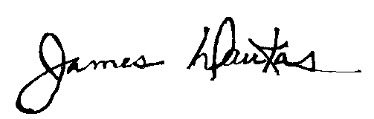

James Daukas
Vice President, Programs
American Farmland Trust

