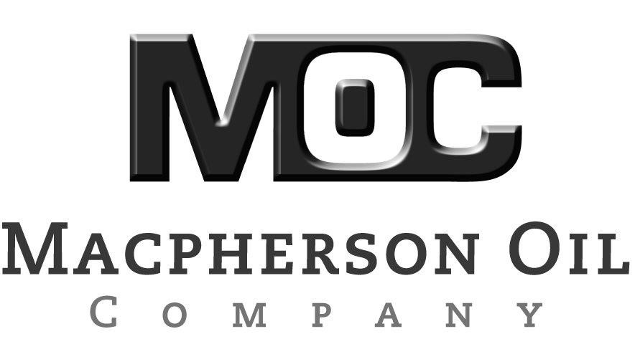

Comments to the 2017 lcfs-crude-oil-ws

James Duffy, June 5, 2018
Manager, Alternative Fuels Section
California Air Resources Board
1001 I Street
Sacramento, CA 95814

Via electronic submittal to: https://www.arb.ca.gov/lispub/comm2/bcsubform.php?listname=lcfs-crude-oil-ws&comm_period=3

Macpherson Oil Company (MOC) is pleased to submit the following comments regarding the 2017 Crude Average Carbon Intensity Value (CI).

Macpherson Oil Company is part of a third-generation California family-owned and operated energy company. MOC works to meet California's current and future energy needs. MOC's employees and families strive to make California the best place to live and work.

MOC supports CARB’S efforts to continue to improve the CI calculation through California’s Cap and Trade program to accurately reflect the impact of crude oil production CI.

It is with this understanding and efforts MOC is seeking and asking to engage with CARB to improve the accuracy of the CI calculation.
MOC requests validation of the CI results using published actual field data submitted to and already validated by CARB. In MOC's review the results in the reference document is over-estimated by 2 to 6 times our calculations as to the carbon intensity value in the Round Mountain field.

We request a specific contact in your organization in order to clarify the carbon intensity value calculations showing for the Round Mountain field.

Please contact me regarding any questions from this comment and I look forward to discussing this further with you or your staff.

Sincerely,

T. Lovley

Tim Lovley
Macpherson Oil Company

