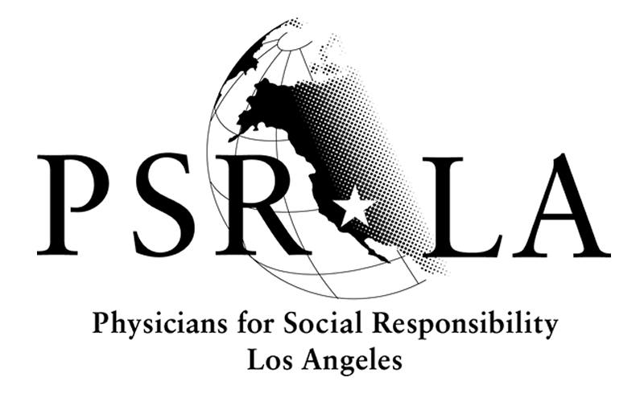
The physician and health advocate voice for a world free from nuclear threats
and a safe, healthy environment for all communities.

May 26, 2016

Via Online Submission

Ryan McCarthy
Craig Segall
California Air Resources Board
1001 I Street
Sacramento, CA 95814
ryan.mccarthy@arb.ca.gov
craig.segall@arb.ca.gov

Re: Comments on Proposed Short Live Climate Pollutant Reduction Strategy

At Physicians for Social Responsibility Los Angeles, we understand the health imperative for comprehensive climate policy that addresses climate change while also being sound health policy. For this reason, we have long advocated for polices that address short-lived climate pollutants.

We would like to thank the California Air Resources Board (CARB) for strengthening their original proposal and we encourage you to go even further making all measures mandatory.

Additionally, we have signed onto the comment letter by the Center for Race, Poverty, the Environment that offers more specific recommendations on the rules for methane and dairies. We would like to reiterate the importance of ensuring that these are health-based policies.

As you well know, methane contributes to ground-level ozone, a powerful air pollutant that can lead to asthma attacks, hospitalizations, and even premature death. Dairies represent one of the largest emitters of methane and it is critical that they play a central role in cutting methane emissions. For this reason, we believe that the failure to mandate targets for enteric emissions is a lost opportunity in this proposed strategy. Voluntary reductions have never brought about the type of aggressive action necessary for public health. We would like for the proposal to provide more incentives for dairies to switch to pasture-based systems. Pasture-based systems are better for the planet and the health of environmental justice communities; however, conversion is difficult and should be assisted.

Dairy digesters are featured heavily in the proposed strategy and as advocates concerned with public health we hope the final draft of this strategy will eliminate digesters as a possible solution. Digesters are a false solution and are known to emit methane, particulate matter, nitrogen and sulfur oxides, carbon monoxide, and ammonia.

In order for California to lead the way on climate policy, we have to look for real solutions that put health and equity at the center. CARB can and should do more to help the highly polluting dairy industry make a just transition. This can be achieved through incentives and mandatory regulations.

Sincerely,


Martha Dina Argüello

PSR-LA | 617 S. Olive St, Ste. 200, Los Angeles, CA 90014 | phone 213-689-9170 | fax 213-689-9199 | email info@psr-la.org | www.psr-la.org

PSR-LA | 617 S. Olive St, Ste. 200, Los Angeles, CA 90014 | phone 213-689-9170 | fax 213-689-9199 | email info@psr-la.org | www.psr-la.org
PSR-LA | 617 S. Olive St, Ste. 200, Los Angeles, CA 90014 | phone 213-689-9170 | fax 213-689-9199 | email info@psr-la.org | www.psr-la.org
PSR-LA | 617 S. Olive St, Ste. 200, Los Angeles, CA 90014 | phone 213-689-9170 | fax 213-689-9199 | email info@psr-la.org | www.psr-la.org
PSR-LA | 617 S. Olive St, Ste. 200, Los Angeles, CA 90014 | phone 213-689-9170 | fax 213-689-9199 | email info@psr-la.org | www.psr-la.org
PSR-LA | 617 S. Olive St, Ste. 200, Los Angeles, CA 90014 | phone 213-689-9170 | fax 213-689-9199 | email info@psr-la.org | www.psr-la.org

