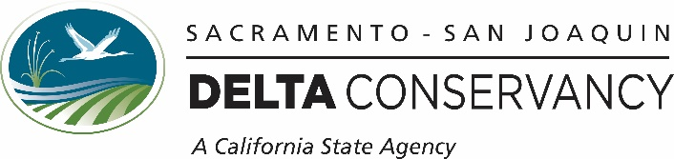

September 17, 2021

California Air Resources Board
California Climate Investments
Cap-and-Trade Auction Proceeds
Fourth Investment Plan
Fiscal Years 2022-23 through 2024-25

To whom it may concern:

Thank you for the opportunity to provide comment on the Fourth Investment Plan priorities. The Delta Conservancy is a California State agency charged with enhancing the ecosystem and economic viability of the Sacramento-San Joaquin Delta and the Suisun Marsh. We greatly appreciate the recognition of the importance of natural and working lands including the commitment to sustainable agricultural practices and wetland and riparian restoration within the Fourth Investment Plan.

We strongly believe subsidence and carbon management in the Delta should be one of the highest near-term priorities for auction proceeds. The Delta is a unique geography that includes approximately 200,000 acres of highly organic peat soils, formerly vast wetlands, that have been drained for agriculture. Drained peat lands are recognized globally as a significant source of GHG emissions through microbial oxidation of highly organic soils, resulting in land subsidence. Over the past 150 years, land elevations in the Delta have subsided to 25-30 feet below sea level. This subsidence continues at a rate of .5 to 1.5 inches per year and results in approximately 2,000,000 tons of CO2 emissions per year. By comparison, 17,000,000 acres of plant-based agriculture in California produces approximately 8,000,000 tons of CO2 per year. Delta subsidence threatens the state and federal water projects, agriculture in the region and many small rural communities, most of which are classified as either disadvantaged or severely disadvantage communities.

Stopping Delta subsidence and carbon emissions is relatively simple, re-saturate the soils. This can be done with rice cultivation which maintains and improves agricultural viability in the region, or by creating managed wetlands. In addition to reducing carbon emissions and related subsidence and flood risk, and improving economic viability of the region; these practices provide increased biodiversity by supporting avian, amphibian and aquatic invertebrate species; and when managed properly can support the basis of the food chain for surrounding waterways. Lack of food in Delta water ways has been identified as a significant stressor for several listed species and species of concern that utilize the Delta.

For many years the Delta Conservancy has led a large partnership that has developed the supporting science, established economic incentives for changed practices, and supported several pilot projects. In the coming years we expect between 4,000 and 6,000 acres of new rice cultivation and up to 3,000 acres of managed wetlands to be created in the Delta. Several landowners are considering “whole island mosaics” where managed wetlands, rice cultivation, upland habitat and higher value crops are strategically spread across a large island to address subsidence, and the long-term viability of the land. Taking these efforts to scale will require significant funding to support land conversion costs.

Growing awareness of subsidence related risk among local agencies and landowners has resulted in increasing local support for these practices. Concerns regarding loss of agricultural production are minimized by rice cultivation which increases agricultural value significantly over common commodities in the region. Additionally, as lands continue to subside, there is increasing land area that is now too wet to farm and therefore ideal for managed wetlands.

Though it is clear to us subsidence and carbon management in the Delta should be one of the highest, near-term priorities for auction proceeds and provides clear linkage to recommended funding priorities 1, 2, 4 and 6, we have found funding this work difficult because no single priority fully addresses the complexity of the Delta. For this reason, and all mentioned above, we suggest adding a section to the Investment Plan that specifically describes Delta opportunities and recognizes the region as a high priority for investment that can rapidly and significantly reduce CO2 emission from natural and working lands.

Again, thank you for the opportunity to comment.

Sincerely,

Campbell Ingram
Executive Officer
campbell.ingram@deltaconservancy.ca.gov
916-281-4145

