November 15, 2021

Clerk of the Board

California Air Resources Board

1001 I Street,

Sacramento, California 95814

**RE: Proposed Amendments to the Small Off-Road Engine Regulations: Transition to Zero Emissions**

To the California Air Resources Board:

The following comments are from the California Forestry Association.

California Forestry Association is a trade association whose membership includes California sawmills, veneer mills, several biomass powerplants, private industrial and forest landowners.

**Exemptions for Consideration for Inclusion in the Proposed Regulatory Amendments dated October 15, 2021:**

The Proposed Rule only provides for the following exemptions:

“Military tactical vehicles and equipment and military off-road tactical vehicles and equipment, all small off-road engines less than 25 horsepower that are not used to propel a licensed on-road motor vehicle, an off-road motorcycle, an all-terrain vehicle, a marine vessel, a snowmobile, a model airplane, a model car, or a model boat must comply with this proposed Rule (Sec. 2401(44)).”

California Forestry Association believes there are specific pieces of equipment that must be exempted from the Proposed Rule. Those specific pieces of equipment include large chainsaws, water pumps required during the conduct of forest management activities for the purpose of wildfire preparedness, portable pumps relied upon for drafting water to fill water trucks, off-road forestry equipment with water tank and pump for wildfire preparedness, and portable air compressors to service forestry equipment.

California Forestry Association will address separately each specific piece of equipment that we believe should be exempted from the Rule for the purposes of the conduct of Timber Operations (Ref. Public Resources Code (PRC) § 4527) and other fuel hazard reduction projects within the Timberlands (Ref. PRC § 4526):

**Large Chainsaws** **greater than 2 horsepower** (about 2.44 cubic inch engines) - Forest management, including fuel hazard reduction projects for the purposes of wildfire prevention, require large chainsaws for felling trees as well as lopping and scattering of “slash” (Ref. PRC § 4525.7) or other non-merchantable material created during Timber Operations. While, “Arborist” battery-operated chainsaws, generally less than 2 horsepower with 14” or shorter bars, may be effective alternatives to gas-powered small chainsaws, these tools are not effective in cases where Timber Operations are being conducted. Not only does it become a matter of practicality, this requested exemption also addresses issues of worker safety.

Large chainsaws used by timber fallers and other Licensed Timber Operators easily requires packing a ¼ mile daily throughout forested terrain. Chainsaws with 8 horsepower or moreand up to a 36-inch bar and chain are common.

The primary reason that battery-operated large chainsaws are not in commercial production is due to weight and the number of battery packs that would have to be made available daily, let alone carried by fellers to locations where saw operations are occurring. An equivalent electric motor that would produce over 8 horsepower would require a 40-volt to 80-volt battery producing 6-9 amps. A single battery of this capacity weighs at least 10 pounds. It would create a chainsaw prohibitively heavy to pack and operate safely in the forest. In addition, the battery pack would only provide a run time of 45-60 minutes at best. Hence, each timber faller would have to carry up to 8 always charged spare battery packs on-site. As a result, each timber faller would have to personally transport an additionally 80-pound backpack daily, resulting in tremendous fatigue and exhaustion that would certainly result in injury.

Further, each battery would cost up to $439/each, and have unknown life expectancies. At a minimum, the economic impact to each timber faller or Licensed Timber Operators would be at least $3,500 dollars for batteries alone, notwithstanding the costs associated with the purchase of replacement chainsaws. Clearly, compliance with the draft regulatory proposal would be cost prohibitive.

**Portable gas-powered water pumps in fire boxes for fire preparedness required for the conduct of Timber Operations and other fuel hazard reduction projects** (10 horsepower). Portable water pumps are relied upon to provide water under pressure for hose lays to suppress fire. Given the extraordinary remote locations of forest management projects, these pumps are not in proximity to reliable energy sources to support electric equivalent pumps.

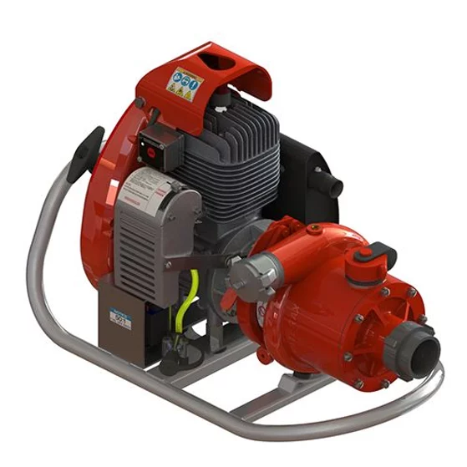

**Drafting with a water pump** (5 to 20 horsepower) into a water truck at remote locations in the forest commonly relies upon gas-powered pumps.

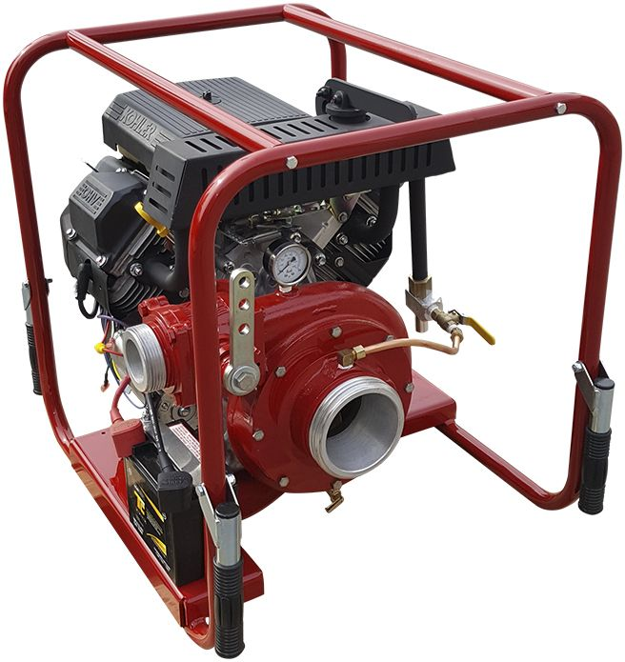

Though an all-electric pump may work in some settings, the applicability of such equipment is not compatible in remote settings that are often 25-50 miles or more from a reliable electric source.

**Off-road forestry equipment with water tank and pump –** An example of this piece of equipment is a forestry off-road vehicle called a “skidgine.”

“Skidgine”



Rubber-tired skidder with a Bolt-on 400-gallon water tank with gas-powered pump for off-road fire preparedness

**Portable off-road gas-powered air compressor (about 8-12 horsepower)-** Compressors arenecessary during the conduct of Timber Operations and other fuel hazard reduction projects to service forestry equipment, inclusive of heavy machinery. Servicing includes repair of machinery with pneumatic tools, but also, as important, is relied upon to remove buildup of fine material from machinery that can ignite if not properly maintained. As with other previously identified equipment, projects that rely upon these air compressors are dozens of miles from an available electrical source. Below is one of dozens of examples of a typical gas-powered air compressor that is relied upon for the conduct of forest management activites:

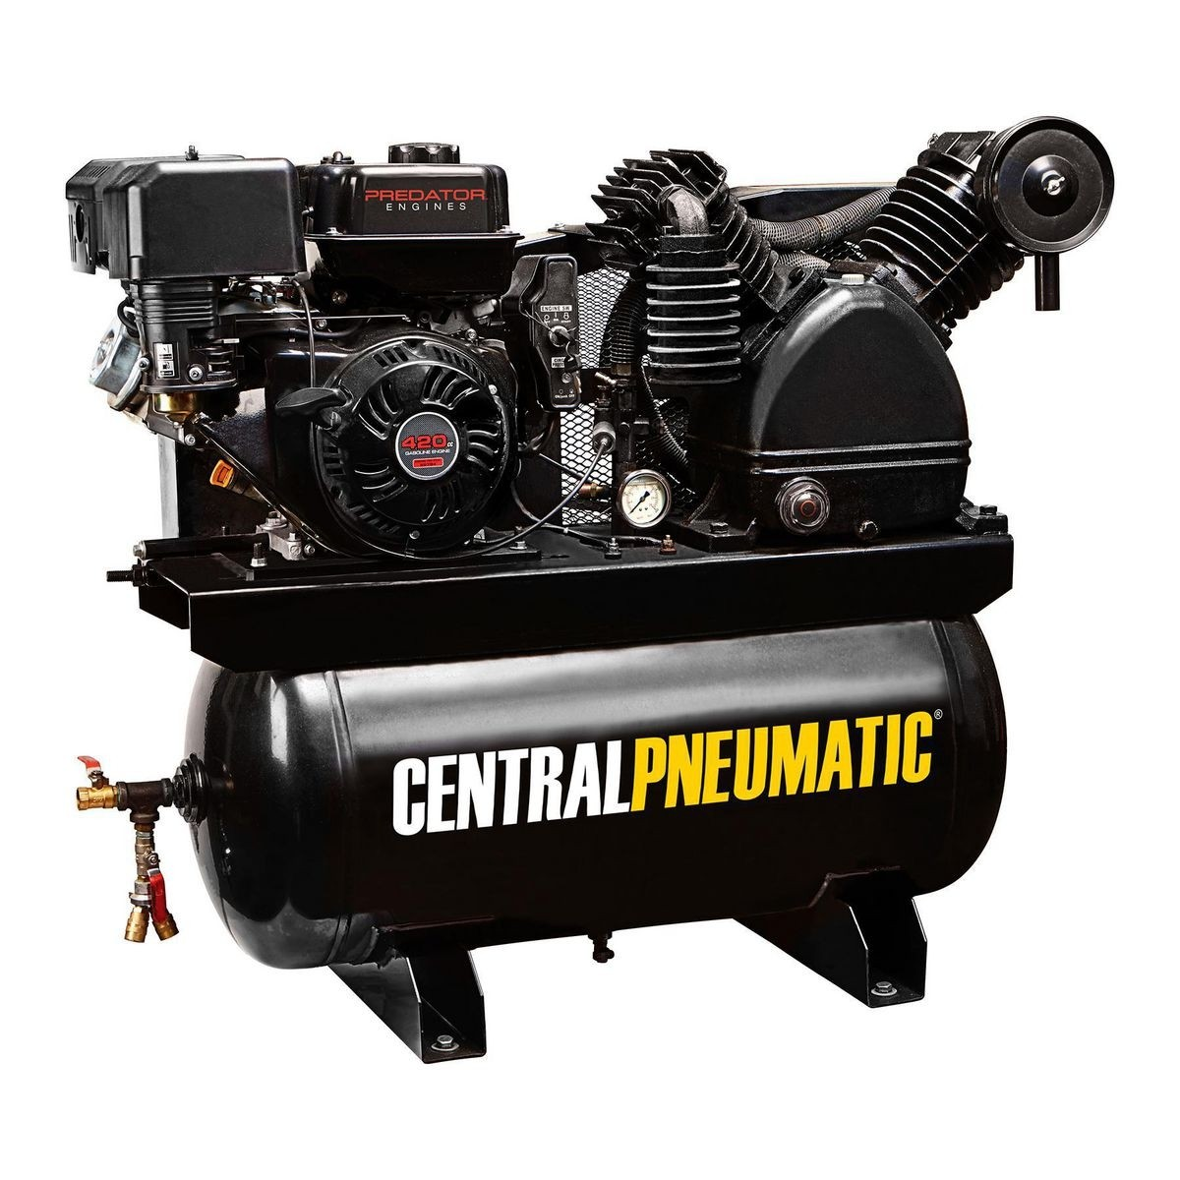

California Forestry Association appreciates the close consideration of these comments, with a specific focus on worker safety and wildfire preparedness. While the Proposed Rule may be applicable to metropolitan settings, or in areas with reliable and accessible electric power sources, the conduct of Timber Operations and other forest management activities for wildfire prevention simply do not align well with the proposed regulatory text.

Thank you for the opportunity to comment. Direct any questions to Steve Brink.

Sincerely,

STEVEN A. BRINK

Vice President – Public Resources

[steveb@calforests.org](mailto:steveb@calforests.org)

916-208-2425