April 26, 2023

California Air Resources Board

1001 I Street

Sacramento, CA 95814

Re: Proposed Advanced Clean Fleet Regulation Comments

Dear Chair Randolph and Board Members,

The Nisei Farmers League is a non-profit organization representing over 500 members. These members are growers, farm workers, packers, processors and farm labor contractors. Trucking is a huge part of growers getting their product to market. Many of the trucks necessary to carry out goods-movement equipment may not be available in a timely manner to achieve zero-emission vehicles (ZEV) being proposed.

The rapid conversion requirements necessary may not be available by manufacturers who must achieve these goals. Our members are already experiencing wait times ranging from 6 months to 18 months. This has caused considerable damage to their normal operations. Additionally, not only are vehicles and equipment on delay, but replacement parts, tractors, etc. are also experiencing wait times. This adds to more problems of products getting to market in a timely manner.

Mandatory power shutoffs in various parts of California have made a lack of available energy to power the grid. In addition, we transport goods to numerous states. We do not know if other states will have powering stations available to charge our electric fleets. Do we have the assurance that we can leave Reedley, California headed to New York and be able to accomplish that? We must have assurances that power will be available throughout the United States by 2035 before converting over to zero emission vehicles. Our food reliability depends on it.

Sincerely,

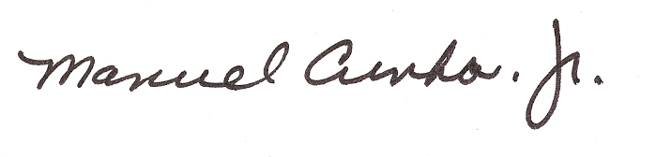

Manuel Cunha, Jr.

President

1775 North Fine Avenue, Fresno, CA 93727 Office 559-251-8468 Fax 559-251-8430



1775 N. Fine Avenue

Fresno, CA 93727

(559) 251-8468

Manuel Cunha, Jr.  
President

*Board of Directors*

## League Area 1

Maurice DiBuduo, Paul LanFranco

### 

# *League Area 2*

Bobby Sano

## League Area 3

James Oliver

## League Area 4

Bill Boos, Leland Herman,

## Mitch Bagdasarian

## League Area 5

Blake Carlson

## League Area 6

Doug Benik, Scott Peters

*Executive Board*

Maurice DiBudio 1st Vice President

Doug Benik-2nd Vice President

Scott Peters, Secretary

Paul LanFranco-Treasurer