October 30, 2015
Mary D. Nichols, Chair
California Air Resources Board
1001 I Street
Sacramento, CA 95812

RE: Comments on the Draft Short-Lived Climate Pollutant Reduction Strategy

Dear Chairperson Nichols and ARB Staff,

Sierra Forest Legacy (SFL) staff attended the Short-Lived Climate Pollutant (SLCP) scoping session on the concept paper and the Short-Lived Climate Pollutant Reduction Strategy draft plan workshop in Sacramento at Cal EPA on 10-13-15.

We appreciate the ARB Staff capturing several key points in the draft strategy (p.27) related to forest management. Specifically, the draft strategy affirms the importance of using prescribed fire and natural ignition to effectively manage forest resources and limit the occurrence of uncharacteristic wildfire. We also appreciate the recognition of prescribed fire use as a means to limit health impacts from acute emissions events during uncharacteristic wildfire (p. 36-37).

We look forward to working with ARB staff and others on the development of a comprehensive Forest Carbon Plan in 2016. In the meantime, we provide the following comments and questions for your consideration as you develop the SLCP Reduction Strategy.

Fire is a Necessary and Desired Disturbance Process in Sierra Nevada Ecosystems

The SLCP Strategy should continue the thoughtful characterization of fire as a natural ecological process in fire-associated landscapes. The challenging task of the SLCP Strategy is to discern the appropriate background levels of black carbon in the forests of California based upon a clear understanding of the fire regimes for the various vegetation types in these forests. While getting solid information is complicated by the variability of fire in these ecosystems, reasonable estimates are attainable. Using information on expected fire regimes and fire frequency and intensity allows on the estimate a natural range of variation of disturbance effects—the ecological and evolutionary driver of vegetation response to fire.

Historic reconstruction and current sensing of fire effects offer a picture of past fire regimes and changing patterns due to several factors including a century of fire exclusion, logging (high-grading and clear-cutting) large, fire-resilient trees and climate impacts. Identifying the ecologically defined background level of black carbon appropriate for today’s forests is the first task to clarify. . Determining the level of black carbon response attributed to past management (fire exclusion, increased fuels loads) leading to uncharacteristic fire (outside the bounds of NRV estimates) offers a picture of black carbon that could be considered a negative climate impact worthy of mitigation efforts.

As we stated at the public hearing and reiterate while mechanical treatments are part of the forest restoration “tool bad”, the expectation that we can log our way to fire resilience is a mistaken notion. As pointed out in North et al. (2015), only about 25% of the Sierra Nevada landscape is treatable through mechanical means. Absent a robust fire program, this landscape will lack resilience to fire, whether at historic levels or climate-driven increases in fire in California.

SFL does agree that some portion of the black carbon produced from recent uncharacteristic high-severity fires such as, Rim Fire and King Fire, contributes to climate warming to a degree that we should take steps to mitigate these effects. However, low and mixed severity fire also result in black carbon deposits but fire in low and mixed severity classes should not be counted as a “bad” SLCP since these fire types are considered within NRV for pine and mixed conifer forests in the Sierra Nevada.

Within the NRV for fire in Sierra Nevada forests there exists 3 general severity classes (Low-Mixed-High). While there is debate among scientists regarding the proportional ranges of these severity classes, the Forest Service generally characterizes the Ponderosa pine and mixed conifer forests as low and mixed severity fire regimes with a lower portion 5-15% level of high severity. Elevation, topography, climate, and other factors can cause variation in these numbers. Hugh Safford-Forest Service Regional Ecologist, Scott Stephens at UC Berkeley, Brandon Collins-PSW Research, Malcolm North-PSW Research, Marc Meyer-Forest Service Zone Ecologist, Jamie Lyderson-PSW and others are important sources of these data to help inform a characterization of black carbon that could be considered outside NRV.

If this is the case then “wildfire” contribution to black carbon emissions needs serious qualification since low-mixed and high severity fire effects all occur within a NRV range in natural functioning ecosystems and should not be characterized as a “bad” SLCP.

All of the above fire severity classes create bowl char and a level of tree mortality (and black carbon) but only the levels outside the NRV for these forest types should be characterized as a SLCP that are“bad”. Black carbon occurrence from fire as a natural ecosystem disturbance has been recorded as far back as 16,000 years in Yosemite National Park (Anderson and Smith 1997) in Fire in California’s Ecosystems (Sugihara et al. 2006). Given that lightning strikes were occurring for millennia prior to any recorded charcoal or bole scar evidence, it is fair to say fire as a natural ecosystem disturbance and the resulting level of black carbon have been a part of the California landscape for a very long time.

Burning fossil fuel is the “bad” SLCP and not black carbon that results from characteristic, ecological processes of fire burning in fire-associated forests in California. We realize that there is still an impact from such “good” black carbon but agency decision makers need to be careful not to present a picture of fire as a climate “bad” that could limit prescribed burning and natural ignition use. Such generalizations about fire effects lack scientific accuracy.

We are particularly concerned about the pie-chart on page 35 and the data used to support it.
What information contributed to the estimate that (66%) of all black carbon was attributed to wildfire? Was this estimate derived from all “wildfires” regardless of severity class, or something more refined? Did the SLCP Strategy consider the current scientific information for fire regimes and fire severity classes, spatial scale, and fire frequency of fire in the Sierra Nevada and elsewhere in California? It is critical to understand the Natural Range of Variation (NRV) for severity, scale, intensity, and frequency of fires in forested landscapes in California prior to assigning a negative label to such outcomes. While black/brown carbon from fires may contribute to warming and early snow melt, identifying the level of unnatural negative effect is a more meaningful and scientifically supported approach.

For the reasons above, we believe it is critical that the final plan clearly state that fire is a key ecological process that supports forest resilience, a level of carbon stability and fire use applied appropriately within the Natural Range of Variability (NRV) for various forest types can limit mega-emissions and benefit public health.

Drought in California’s Forests

The reference to “drought ravaged forests” (SLCP Draft p.ES-7) is an emotional characterization that should be removed from the document. The California’s climate history has shown records of wet and dry periods for millennia. (See below)

We are in a short-term dry period that is causing impacts to California culture but this current dry period is not uncharacteristic when one looks at the long-term climate-precipitation record. The period of the 1900’s was a very wet period where forest vegetation expanded downslope (while fires were being suppressed). It was also a period of major water project development in California where new water infrastructure moved water from the Sierra Nevada to urban areas and farmland throughout the State. Unfortunately, we lacked the ecological literacy (knowledge of California’s climate history and the harm stemming from fire exclusion) to accompany our hydro-engineering and fire suppression skills. We understand that the current dry period and resultant uncharacteristic wildfire are causing cultural havoc in California but, it is important that state agencies understand and frame these issues using the best scientific information so we avoid more mistakes in the future.
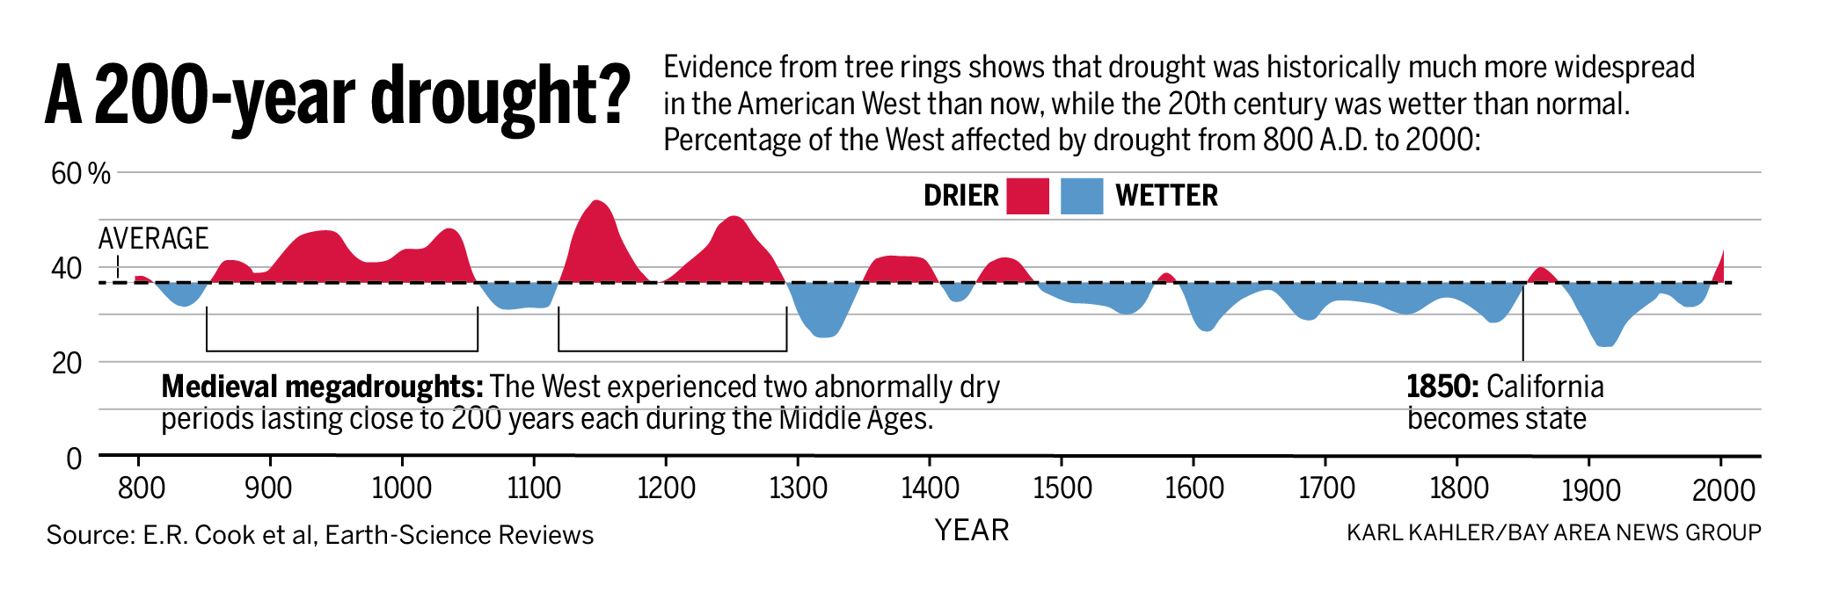
Small-scale Biomass Facilities versus Open Pile Burning
Finally, Sierra Forest Legacy has been a proponent of appropriate scaled, community-based biomass facilities adjacent to forest communities in California. Forest management practices (mechanical thinning and restoration practices) using appropriate ecological design criteria, leave significant amounts of forest residue (biomass burn piles) in the forest that are burned in place as a standard practice. Community-based, smaller-scale biomass facilities (ideally combined heat and power generation facilities for maximum wood use efficiency) can mitigate smoke emissions and off-set fossil fuel use—especially when the heat energy is utilized on-site or nearby. Bio-energy at this scale, using the best available emission control technology, should not be considered a climate “negative”.
Thank you for the opportunity to comment on the SLCP Draft Strategy.
Sincerely,
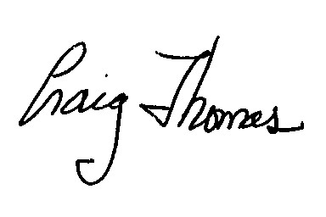
Craig Thomas, Conservation Director
Sierra Forest Legacy
P.O. Box 244
Garden Valley, CA 95633
craig@sierraforestlegacy.org
(916) 708-9409

References
Anderson, R.S., and S.J. Smith. 1997. The sedimentary record of fire in montane meadows, Sierra Nevada, California, USA: a preliminary Assessment. P 313-327 in J.S. Clark, H. Cachier, J.G. Goldammer, and B.J. Stocks (eds.) Sediment records of biomass burning and global change. NATO ASI Series 51.

North, Malcolm; Brough, April; Long, Jonathan; Collins, Brandon; Bowden, Phil; Yasuda, Don; Miller, Jay; Sugihara, Neil. Constraints on Mechanized Treatment Significantly Limit Mechanical Fuels Reduction Extent in the Sierra Nevada. Journal of Forestry. Volume 113, Number 1, January 2015, pp. 40-48(9).

Sugaihara, N.G., Van Wagtendonk, J.W., Shaffer, K.E., Fites-Kaufman, J., Thode, A.E. 2006. Fire in California’s Ecosystems. University of California Press.

