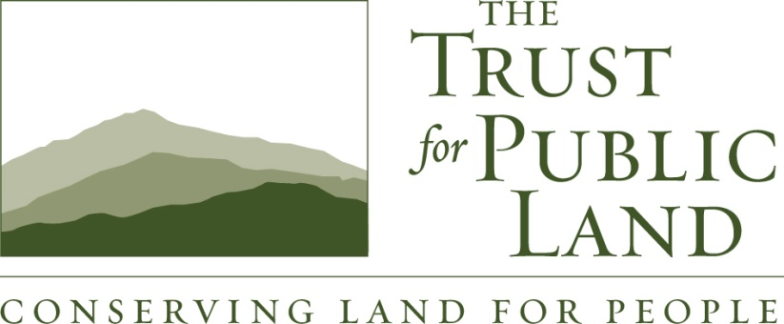
July 15, 2013
Mr. Mike Tollstrup
California Air Resources Board
State Environmental Protection Agency
Sacramento, CA 95814

Re: Scoping Plan Update – Urban Parks and Forests

Dear Mr. Tollstrup,

The Trust for Public Land (TPL) was very pleased to support both AB 1532 and SB 535, bills signed into law in 2012 that have provided the state with the framework to invest cap and trade revenues. As stated in the enabling legislation AB 1532: ‘Funding may be allocated to reduce greenhouse gas emissions associated with water use and supply, land and natural resource conservation and management, forestry, and sustainable agriculture’.

In our view, investment in natural resource protection is absolutely critical if the state is to meet its GHG reduction goals. And although TPL has consistently supported efforts to encourage public transit, clean energy and energy efficiency, a very significant investment of our resources in California has been working with disadvantaged communities building local parks for families to recreate, while improving their environment with green spaces that improve both air and water quality.

We are going to focus our input on urban parks/forests. We will also include comments we think will demonstrate the nexus of these sectors to disadvantaged communities and job creation, the co-benefits local parks have to other important sectors like energy and transit, scale of opportunity, and finally links to existing programs that can put the investment revenue ‘on the ground’ working toward our AB 32 goals quickly and efficiently.

Urban Parks and Forests

Most people in California, including people in our most disadvantaged communities, live in our large cities, and as a consequence focusing GHG reductions in our urban areas are key to meeting our AB 32 goals and beyond. However, poor communities are subjected to a disproportionate amount of exposure to climate change pollution, while also having very little in the way of green spaces and trees. For example, in Los Angeles, 2/3 of children under the age of 18 do not live within walking distance of a park. Numerous studies have shown that this lack of green space coincides with a greater incidence of childhood obesity and diabetes, lost economic opportunity, and higher crime rates. Communities can make progress on parks, and step one is recognizing that open space is just as vital to healthy cities as are roads and bridges. In fact, investments in ‘greening’ our urban areas will not only sequester carbon, but also reduce our energy consumption, induce non-motorized transportation, and improve our water resources.

GHG Benefits

- The built environment plays a powerful role in human behavior and by extension transportation choices. Local parks, river parkways, bike paths and walking trails connect people to their schools, jobs, and shops creating attractive options that get people out of their cars.
- Urban parks can be designed to capture and infiltrate and clean stormwater. Some of the amenities include permeable walking paths, planted swales, cisterns and water storage galleries. These features filter and capture stormwater, recharge groundwater and make local water supplies more reliable.
- Urban parks and forests sequester carbon and reduce energy consumption by lowering the temperature of cities. Trees also hold water in the urban landscape, create shade to cool buildings, parking lots and the urban environment and capture particulate matter that contributes to air pollution especially as cities become increasingly warm.
Co-Benefits
- Obesity, diabetes and respiratory disease are rampant in our cities, particularly in children and the poor. U.S. Center for Disease Control and Prevention determined the creation of access to places for physical activity can result in a 25% increase of people who exercise at least three times a week. Exposure to nature improves psychological and social health, and plays a critical role for child development.
- More than 30 studies have shown that parks have a positive impact on nearby residential property values. Other things being equal, most people are willing to pay more for a home close to a nice park. Green spaces in our cities also increases tourism – both of these factors can provide local governments with direct income to its treasury.
- Urban parks create jobs ranging from landscape design and construction, to maintenance, management and gardening.
- Reaching our AB 32 goals is dependent on compact development and SB 375 implementation. Local parks and green space make cities livable and therefore successfully help ensure the success of dense development and transportation systems.

- Local Parks have inherent environmental benefits. Trees and shrubs remove air pollutants such as nitrogen dioxide, sulfur dioxide, carbon monoxide, ozone, and some particulates. The retention of rainfall by the park system’s trees, bushes, and soil, can cut the cost of treating stormwater.
- “Know-your-neighbor” social capital increases social community and safety while helping to ward off antisocial problems that would otherwise cost the city more in police and fire protection, prisons, counseling, and rehabilitation.
Existing Programs and Scale of Opportunity
- AB 31, The Statewide Park Development and Community Revitalization Act of 2008, a bill that enabled the Department of Parks and Recreation to invest $400 million to build parks in our most park-poor disadvantaged communities. The Department received more than 900 applications representing over $3 billion in requests to build local parks.
- Local parks and urban forests programs have and can continue to be efficiently implemented by the Department of Parks and Recreation, Strategic Growth Council, CalFire, DWR and the Resources Agency.
In conclusion, TPL would like to thank the Environmental Justice Advisory Committee for your leadership and vision to get us well along the way to meeting our AB 32 goals, while focusing on the communities that suffer the most from climate change and its associated pollution. Clearly, natural resources protection needs to be a part of the focus if we are to solve what many think is the challenge of our lifetime - addressing climate change and global warming by addressing our GHG emissions and the sequestering of CO2. This challenge is one we believe can be accomplished while improving our economy and overall health of disadvantaged communities and our environment, all of which are inherently addressed by investing in natural resource protection.

Sincerely,

Rico Mastrodonato
Senior Government Relations Manager

