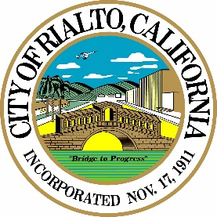
City of Rialto
California

11.3.22 Joint Coordination Meeting CTC/CARB/HCD
Statement
Good morning, members of the CTC, CARB and HCD. My name is Marcus Fuller, and I’m the City Manager for the City of Rialto.
The City of Rialto sits in the heart of San Bernardino County and serves as a major connector in the movement of goods throughout the region. As many of you know, the Inland Empire and particularly San Bernardino and Riverside counties contributes over $160 billion in GDP toward the growing and robust economy for the state of California. One of the primary driving factors in this large economic impact is the growing industry of warehouses, logistics and trade and the significant increase in ecommerce experienced during the COVID19 pandemic. This has subsequently increased the demand for the movement of goods throughout the region and has significantly increased the volume of freight along our trade corridors.
For the City of Rialto in particular, this has meant a significant increase in the number of warehouses and distribution centers located in our community, currently around 4 million square feet just south of I-10 among the 30 largest employers. These industries deploy over 60% of the existing 17,700 trucks on I-10. This high volume of freight movement of course has a significant impact on our residential communities. On the one hand the increase in jobs and local economic opportunity reduces the number of commuters as they employ our local residents, but there is also an environmental impact on local communities with the volume of freight and air pollution from just the sheer volume of trucks and idling as our existing infrastructure struggles to meet the demands of the growing economy.
The City of Rialto takes our role seriously in maintaining the viability of Interstate 10 as California’s primary east-west freight corridor, and also how our main freight corridor along Riverside Ave plays into the broader movement of freight in the region. We’re interested in pursuing additional opportunities to partner with both regional as well as state agencies to ensure the continued success of the trade sector in our City and the region. Rialto remains hopeful that through the implementation of CAPTI, and particularly the alignment of transportation infrastructure, environmental justice and freight mobility plans can align with our local efforts to improve both operational efficiencies, multimodal needs, safety and economic prosperity.
Thank you for your collective efforts to address freight infrastructure needs in the greater Inland Empire that will also better serve the community of Rialto.
Thank you,

Marcus Fuller
City Manager, City of Rialto

