October 16, 2015
Mary D. Nichols, Chair
California Air Resources Board
1001 “I” Street
Sacramento, CA 95814

Re: AB32 Scoping Plan Update for 2030 Target
Dear Chair Nichols,
Edgar & Associates (EA) has been an avid supporter of long term climate related goals as they relate to the waste industry, most notably the Target set by the Scoping Plan update of Net Zero emissions by 2030. We would like to ensure that these goals remain in the updated Scoping Plan, as they were not mentioned in the First Workshop on October 1, 2015.
EA has been assisting haulers, processors and composters in calculating their greenhouse gas emissions for close to a decade, where best practice methodologies are used to also estimate avoided greenhouse gas emissions for all the materials that are composted and recycled. Through these estimates we understand the clear connection our recycling and composting efforts make in the battle against climate change. We support continued focus on the important role our industry can play in CARB’s Climate Change Goals and Policies, including achieving Net Zero Facilities.
Net-Zero’ GHG Emissions by Mid-term (2030 to 2035)
The AB 32 Scoping Plan First Update was adopted on May 15, 2014 by the California Air Resource Board and includes the Net-Zero concept as copied below. Net-Zero has been defined by the California Air Resource Board as when an organization’s avoided indirect emissions offset their operational emissions. By reporting the progression of operational vs avoided emissions, it is possible to evaluate the achievement of this goal now, already showing compliance. To meet Net-Zero, one’s avoided GHG emissions must be greater or equal to one’s operational GHG emissions. Our clients, who do not own active municipal solid waste landfills, have demonstrated how they are Net Zero Now as the efforts made to recycle and compost materials far outweigh the emissions associated with collecting them, providing a crucial solution for California.
Net-Zero Equation:
Operational Emissions – Avoided Emissions = 0

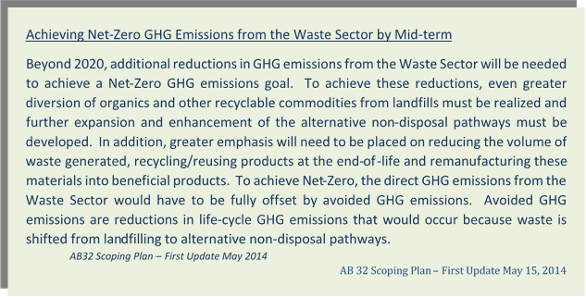

Conclusion
Edgar and Associates believes the materials management industry is vital to the battle against climate change, where we can reduce emissions associated with transportation by using alternative fuels, but more importantly, divert materials from landfills by recycling and composting them. The avoided emission from these activities far outweigh the emissions associated with collecting them, where regulatory drivers and public education play a vital role in guaranteeing the success of these programs. Please ensure the Net Zero by 2030 goals remain in place and are discussed throughout the Scoping Plan Update Workshops.
Very truly yours,

Evan Edgar
Principle Civil Engineer
Edgar & Associates

