TO: ARB 2030 Scoping Plan Staff and Committee Members

FROM: Judy Robinson, Sustainability Manager

DATE: September 26, 2016

RE: Comments on 2030 Target Scoping Plan Workshop-Transportation Sector – 9/14/16

First of all, thank you for the excellent presentations and particularly the attention being given to health, transportation and land use – and how these sectors influence GHG emissions, our quality of life and overall livability. The presentations were informative and insightful and greatly appreciated. With that said, here are comments related to the workshop and subject matter for the 2030 Scoping Plan.

- Little if any attention is paid to efforts to reduce GHG emissions due to waste hauling, despite the fact that, transportation accounts for the largest contributor to GHG emissions. Strategies should be created that incentivize reductions in VMT or otherwise require offsets for the unnecessary GHG emissions. This strategy needs to be modified to account for the entire carbon footprint of the waste system, controlling disposal and flow. In Sacramento, each year 40% of the waste tonnage is exported, primarily to the Lockwood landfill, 147 miles away. Over the past 5 years this has amounted to 8.3 million additional VMT’s versus disposal at the closer Sacramento County landfill. El Dorado County has its waste hauled from Placerville to the Portrero Hills landfill in Solano County, 87 miles away. These are not isolated examples. These types of situations exist throughout California. So for example, if a jurisdiction chose to long-haul their waste when a much shorter-haul option was available they would have to purchase credits to do so. This cap-and-trade incentive could also protect against an increasingly real threat – that waste will be hauled out of state. That has been happening in the Sacramento market for over 15 years, and is part of the long-term plans for the haulers serving El Dorado County and San Francisco. It would be a disaster, for our air and our economy, if the Scoping Plan unwittingly chased waste out of the state with no consequence. (See attached document)

- Connect active transportation, active design and health being developed and incorporated into the draft Regional Transportation Plan Guidelines, currently underway.

- As ARB prepares the Economic section of the scoping plan, as well as the upcoming workshop, the cost for healthcare and loss of productive work days can be reduced and needs to be quantified to realize these economic benefits. (i.e. reduced hospitalizations and ER visits, reduced missed work days, increased worker productivity, reduced injuries, improved health and livability. Additionally, walkable and bikeable communities that incorporate active design, mixed land uses, landscaping, and transportation choices are highly desirable places to live and increase the economic value of these areas.

- When considering the scoping plan, and rural/urban connections, the local city or county needs to be in the formula and more importantly the region as a whole. GHG emissions, urban heat island, particulates, even water does not stay in one location. One impacts the other so this needs to be looked at, and policies created, that consider strategies and solutions that can be locally and regionally implemented.

- On the topic of equity – a great deal of training needs to happen! Many people and local governments do not understand the difference between equality and equity. Further, significant education and training needs to occur in order to change the way in which community outreach and engagement occurs – particularly in communities of color and those with vulnerabilities. Local governments also need to be encouraged to prioritize resources to target these residents and communities, provide much needed infrastructure improvements, investment, job training, employment, education and services.

- Equity outcomes need to be prioritized as critical outcomes of policy and implementation, and also tied to funding.

- We’re very glad to see Public Health involved significantly in this Scoping Plan and process. This is a positive sign that stakeholders have been heard and that the best solutions for health and healthy communities will be represented and included in this new plan. By engaging Public Health both physical and mental health need to be considered and addressed. We often identify only the physical health benefits related to GHG reductions; but mental, social and emotional health is just as important and needs a strong presence as well.

- As transportation and health are being addressed Public Health needs to be at the table, and engaged in dialogue to ensure health is appropriately addressed. CalTrans took some steps for the 2017 ATP Grant program in designing the rubrics that award points for engaging and documenting the communication with the respective Public Health Department. This is critical because far too often non-health people do a web search for answers and drop that into grant applications. They miss the true aspects of what imbeds health and a healthy design into a project so that it does in fact achieve positive health outcomes. A project with poor or incorrect design fails and wastes limited funding. This also goes to ensuring equity is also included in the project scope and design. To ensure correct design Public Health or designated health experts need to be engaged by Planners and Engineers. Public Health continues to experience funding reductions and new additional funding is needed in order to include them and have their input included in the plan and project.

- The white paper is an excellent document and really addresses sustainability in the holistic manner it is worthy of. Many times we get lost in the data collection and quantification of outcomes. In relationship to the health piece to be addressed, urban greening and livability also need to be placeholders in the Scoping Plan. Again, the design of community land uses and infrastructure is critical in reaching the right balance of what makes a community resilient, sustainable and livable. Infill development is important, and building residential on small lots supports GHG reducing policies and goals. It needs to be balanced with urban greening, green spaces for people to “Be” in (this relates to the mental, social and emotional health of individuals) and places for people to stretch out. We can look at many cities and see how this has been successfully done. Unfortunately, all too often local governments give up or give away their parks and green spaces so a developer can do their project. This is very problematic and needs to be guarded against.

- In considering CEQA and other GHG impacts master plan communities, and large developments will include a university, hospital, commercial and office projects that will show VMT reductions designed into the community. The flaw in this is that these “other” uses that are designed to keep VMT/GHG down often aren’t built until decades after the residential is already in place. Until these other uses are built, these new developments contribute to sprawl and impact transportation and health. There need to be incentives (or disincentives) that would advance construction of these other uses into the early years of the new community development.

Thank you again for the opportunity to comment. On the following pages is a white paper written and circulated a couple of years ago for the 2014 Scoping Plan, that provides detailed information contained in my Comment #1. Thank you in advance for considering the important data and information contained in this document.

Accounting for Waste Sector Vehicle Emissions in the AB-32 Scoping Plan
Paul Philleo, Director
Department of Waste Management and Recycling, County of Sacramento

The AB-32 Scoping Plan Focus Group working papers were posted on March 14, 2014. For the Waste Management focus group, the emphasis was, predictably, on alternatives to landfill disposal. This, despite the fact mentioned on page 98 of the working paper, that landfill methane emissions constitute 1% of California GHG emissions. The strategies in the paper espoused incenting investment into the construction of alternative infrastructure to landfills, while dis-incenting landfill disposal through eliminating alternative daily cover diversion credit, banning organics disposal, and perhaps subjecting landfills to cap-and-trade. Amazingly there is no attention paid whatsoever to efforts to reduce GHG emissions due to waste hauling, despite the fact that, according to the Transportation Focus Group working paper, transportation
accounts for the largest contributor to GHG emissions at 38% of the total. My objective here is to illustrate how the strategies in the working paper will have little effect on GHG emissions if waste transporting is ignored, and to present an incentive idea that does account for waste related VMT’s.

The waste utility is unique among utilities in that the conduit by which the commodity travels is a truck on a road. That means there are few physical limitations to where waste can flow; and since the road network is built and maintained by a different industry, there is little capital investment necessary to participate. Further, the movement of a commodity by truck is virtually unregulated (some would argue it is constitutionally protected). As a result waste flow is very random, subjected to various influences including tip fees, fuel prices, market share, individual contracts, and corporate directives. Take, for example, the Sacramento waste market. Sacramento has 2 in-county landfills: the county-owned Kiefer landfill, a Class III municipal solid waste landfill, and L&D landfill, a privately-owned landfill permitted to receive non- putrescible waste. Together these two landfills have more than enough permitted and constructed capacity to receive all the landfill-bound waste from the market, about 1,000,000 tons per year. Kiefer has, at $30 per ton, the lowest tip fee in the region, and has contracted tip fees as low as $26 per ton. Given these landfills’ proximity to the market centroid (14 miles for Kiefer, less than 5 for L&D) one would think they have a lock on the market. Yet each year 40% of the tonnage is exported, primarily to the Lockwood landfill, 147 miles away, and the Forward landfill, 57 miles away (see attached map). Once waste is buried at these landfills it has the exact same GHG emission effect as if it were buried at Kiefer. The difference, on the emission ledger, is the transport. Over the past 5 years this has amounted to 7.7 million additional VMT’s versus disposal at Kiefer (see attached table). Another example: El Dorado County has its waste hauled from Placerville to the Portrero Hills landfill in Solano County, 87 miles away. These are not isolated examples. These types of situations exist throughout California.

Yet the waste management working paper turns a blind eye to this reality, promoting a strategy requiring even more transport to a series of as yet non-existent facilities that will somehow magically appear through some kind of “if it comes you will build it” philosophy. The likely reality is that in the near term newly forbidden-from-landfills organic material will be trucked great distances to the few existing outlets, with a net increase in GHG emissions. This strategy has to be modified to account for the entire carbon footprint of the waste system, controlling disposal and flow. “Flow control” is an explosive concept in this industry, having led to two US Supreme Court rulings, yet it is quite practical to implement since most local jurisdictions contract for their waste services. For example, in its recently awarded disposal contract, the City of Sacramento required disposal at Kiefer instead of Lockwood. Since this went into effect in 2011, the City has reduced its carbon footprint due to waste hauling by 90%. Likewise the Scoping Plan should incentivize this kind of thinking for every California jurisdiction via the state-mandated general plans, climate action plans, or integrated waste management plans. Subject the entire system, hauling and disposal, to cap-and-trade.

So for example, if a jurisdiction chose to long-haul their waste when a much shorter-haul option was available they would have to purchase credits to do so. This could also become an incentive for local jurisdictions to host the new infrastructure foreseen in the working paper. Local resistance to waste facilities of any kind is very high. In the current environment it is all too easy for electeds to take an “out of sight out of mind” approach, because there is no penalty for long hauling.

This cap-and-trade incentive could also protect against an increasingly real threat – that waste will be hauled out of state. That has been happening in the Sacramento market for over 15 years, and is part of the long-term plans for the haulers serving El Dorado County and San Francisco. It would be a disaster, for our air and our economy, if the Scoping Plan unwittingly chased waste out of the state with no consequence.

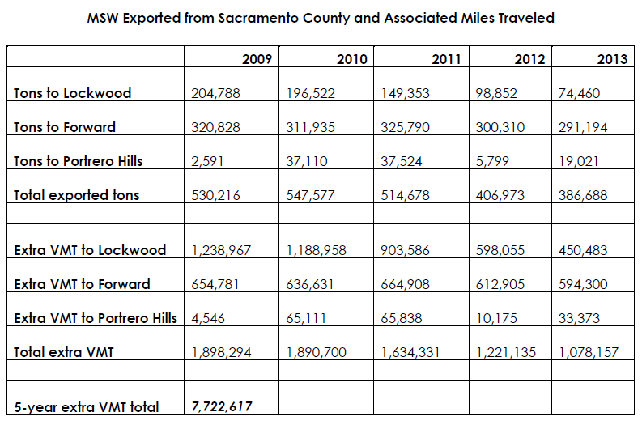

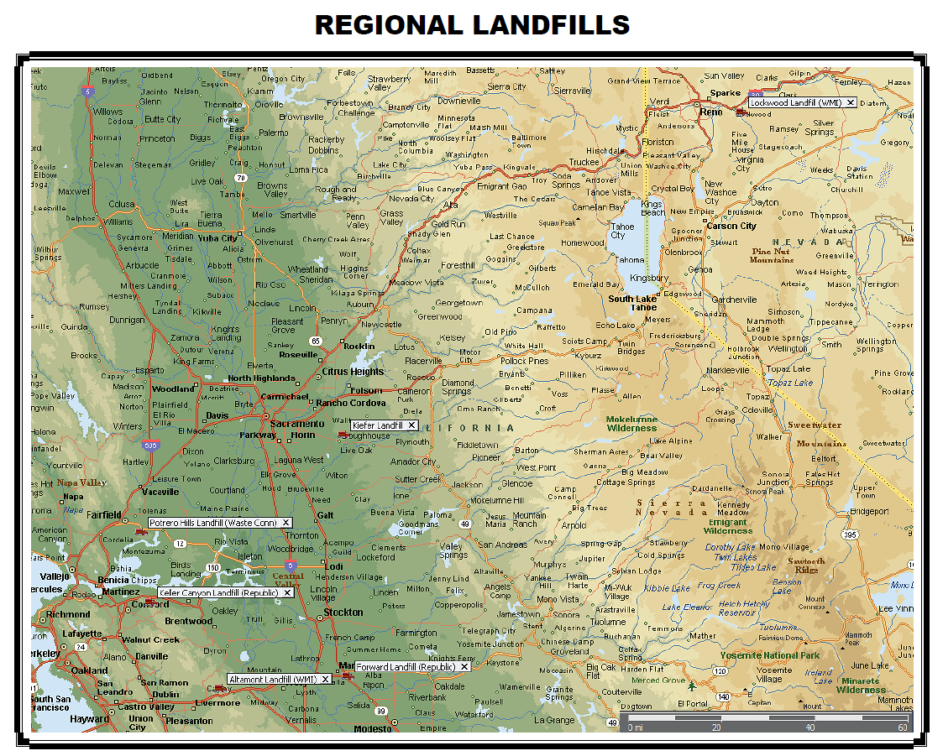
Vibrant Communities and Landscapes

A Vision for California in 2050
California’s history and future are built upon its land and its people. The State is home to the most
diverse population in the United States, and its landscapes include productive agricultural areas and
spectacular natural beauty – from the shoreline to the mountains to the deserts. This natural beauty,
alongside world class cities and thriving communities, draws visitors and residents alike to support the
State’s innovative economies, spur its entrepreneurial spirit, and sustain its creative culture. Together,
California’s people, communities, and natural resources support its status as the sixth largest economy
in the world.

California has long been a leader in protecting the environment. California is committed to reducing its
greenhouse gas (GHG) emissions 40 and 80 percent below 1990 levels by 2030 and 2050, respectively.
At the same time, the State’s population is projected to grow to 50 million residents by 2050. As the
State acts to achieve these emission reductions and support future growth, California has the
opportunity to realize critical benefits in public health, natural resource, economic, equity, and resiliency
outcomes through thoughtful and comprehensive policy implementation. Realizing this potential
requires a departure from past land use practices and an integrated vision for how the State develops communities and preserves and protects its landscapes. This can ensure that all Californians have equitable access to housing, health care, jobs, and opportunity. This document provides a vision for this future that forms a common foundation for actions related to land use across State agencies and programs that will be implemented in partnership with multiple stakeholders at all levels of government, native tribes, landowners and the private sector

Vision
As the State - together with local, regional, public and private partners - works toward its 2030 and 2050 climate change goals, its land base, including natural, working, and developed areas, is recognized as foundational and integral to the State’s climate policy, economy, and quality of life. As such, the State plays a meaningful and impactful role in shaping the future communities and landscapes of California. Because of the pivotal role of land use in the State’s environmental, economic, health, and related policies, California is taking action to grow in a manner that assures:

Development and conservation investments and decisions focus on building social equity and
supporting thriving and healthy communities with improved access to and supply of affordable
housing, transportation alternatives, open space and outdoor recreational opportunities, affordable
healthy foods, living-wage jobs, social support, and economic and educational opportunities;

Land is protected, managed, and developed in a manner that balances private and public interest and maximizes resilient carbon storage, food security, and other ecological, economic, and health objectives. Natural and working lands are used in partnership with landowners and tribes to build resilience in natural, built, and social systems, and provide buffers against changing climate conditions that will preserve economic and agricultural benefits and allow for flexible adaptation pathways;

New private development and infrastructure opportunities are built primarily in locations with existing infrastructure,
services, and amenities (i.e., previously-developed locations), greenfield locations are preserved; and infill developments are emphasized, including specific strategies to promote livable, walkable, beautiful places that are healthy and restorative;

The value of ecosystem services conferred by natural systems are accounted for and included in
State, local, and regional planning and investment decisions, resulting in protection of these services
and California’s globally significant biodiversity.

- Adaptation and retrofitting of existing communities and infrastructure that buffers communities from the changing climate conditions and effects.

Actions
State, local, and regional governments need to work together to achieve this shared vision and to
encourage land use and transportation decisions that minimize GHG emissions. While recognizing its
focus on urban development and transportation, the State will build on framework and governance
structure established by Senate Bill (SB) 375 to achieve deeper GHG emission reductions, and will
integrate the protection, conservation, and management of natural and working lands.

A number of current and emerging State planning and policy efforts provide the opportunity to
articulate and implement this vision, and provide State leadership through work with local and regional
partners. These include the Climate Change Scoping Plan, the Regional Transportation Plan Guidelines,
the Sustainable Freight Action Plan, updated General Plan Guidelines, implementation of AB 2087 for
regional conservation planning, the State Wildlife Action Plan, the Water Action Plan, Safeguarding California Action Plan, Let’s Get Healthy California, California Transportation Plan 2040 and implementation of SB 743 guidelines and other updates to the California Environmental Quality Act.

The State will prioritize the following actions to support regional and local governments and to maximize
GHG emission reductions, while increasing climate resiliency and livability, through the conservation and protection of natural and working lands, reductions in vehicle miles traveled, green infrastructure and direct emission reductions associated with compact development patterns:

Develop performance metrics for environmental, health, and equity outcomes associated with stronger land use policies: Working with local and regional governments, the State will develop systems to measure the environmental, health, and equity impacts of land use, infrastructure , and development policies and programs and will allow all levels of governments to maximize benefits, avoid harm, and measure and track the results. Furthermore, the State will continue to direct resources, infrastructure, services, jobs, training, and technical assistance to disadvantaged communities (particularly those facing or affected by historical disadvantage) to improve resource availability, access to goods and services, amenities, safety and quality of life.
Establish land conservation targets: The State will develop quantitative and achievable goals to
protect and limit the conversion of the State’s most productive farmland, rangeland, and forests, as
well as the natural and working lands most critical to preserving California’s biodiversity and the
ability for Californians to adapt to climate impacts, alongside complementary policies to focus new
development in currently developed areas, discourage growth-inducing infrastructure expansion, reduce conflicts among adjacent land uses, and minimize risks to existing land uses and public health and safety.
Update regional greenhouse gas reduction targets to achieve 2030 and 2050 greenhouse gas
emission reduction targets: The State will work with local and regional governments to develop
stronger GHG emission reduction targets for regional sustainable community strategies under SB
375 and identify opportunities to strengthen and advance implementation success.
Develop policies and processes for infrastructure siting that are consistent with the State’s conservation, development, and population health goals: The State will develop supportive policies and tools to help private and public sector partners, including local and regional agencies, to identify sites for infrastructure projects, including renewable energy projects, that are consistent with and support the State’s conservation, development, and climate change and adaptation goals. Infrastructure projects would include and not be limited to: Green/sustainable streets, concrete creek channel naturalization projects, expansion of tree canopy, low impact development landscapes, and taking a systems-approach to all projects to ensure co-benefits (i.e. improved health, conservation, GHG reductions, improved access) are substantially addressed and included in projects. The State will continue and strengthen policies that facilitate substantial increases in the proportion of investments in transit, active transportation, fix-it-first maintenance of existing infrastructure, and shared mobility infrastructure, as well as reducing urban heat islands and increasing and integrating natural and green infrastructure in developed areas, including tree planting, parklets, and other strategies. Design and place making are key elements to ensure goals are actually realized.
Explore and develop financing, regulatory, and other tools to support more efficient and more equitable development: The State will evaluate and develop financing mechanisms, incentives, guidelines, and other tools to substantially accelerate more efficient and equitable development outcomes. This includes: reducing barriers to housing development in infill areas; promoting infill development and necessary infrastructure in existing communities; and implementing strategies to ensure that long-time residents can stay in place as neighborhoods improve.
Explore and develop financing, regulatory, and other tools to promote land protection and carbon-oriented land management practices: The State will examine, evaluate, and develop
financial or regulatory compliance incentives to private landowners to promote both permanent and
temporary conservation and management for carbon sequestration.
Support transportation policies such as priced express lanes, reduced parking requirements for development, and transit commuter incentives that promote infill development and reduce vehicle miles traveled: The State will implement road user and parking pricing policies, and coordinate these policies with programs to avoid adverse impacts on low-income drivers and with infrastructure investments as described above. Further, the State will invest in technology to improve transportation system efficiency that provide choices that enable people and goods to reach destinations quickly and cleanly.

Benefits of the California 2050 Vision
Research, analysis, and implementation demonstrate the myriad benefits to the State’s residents, local
and regional governments, and the economy that can result from an integrated “systems” approach to land use, transportation, health and climate adaptation. These include, among others:

Tangible, short- and long-term benefits for landowners and the public: Development of carbon sequestration and carbon farming practices can expand investments in land conservation and habitat preservation, diversifying the economic base of the state’s agricultural and forest sectors and providing significant public benefits of air and water quality and open space .

Tangible, short- and long-term benefits for disadvantaged communities: Focusing on infill and compact development patterns and coordinated investments to expand low-cost and low-carbon
transportation options encourages investment in existing and underserved communities, reduces household costs, helps alleviate pollution burdens in the highest-impacted communities, and increases access to economic opportunities.
Improved public health: More compact development patterns, access to parks and green spaces, and abundant recreational options provide opportunities for active transportation and physical activity.
Increases in these activities help provide respiratory and cardiovascular health benefits and reduce
the burden of chronic diseases such as diabetes, certain types of cancers, and dementia, while also
improving mental and emotional health. Furthermore, an integrated conservation and development strategy will contribute to significant air quality benefits, which improve respiratory and cardiovascular health.
Resilience to the impacts of climate change: Protection of natural systems, conversion of existing infrastructure to more “naturalized systems,” urban greening, increased tree canopy, expansion of transportation options, and compact development patterns can reduce exposure to the risks of a changing climate, especially in disadvantaged communities. Protected and managed natural systems can mitigate impacts of floods, protect water quality and supply, enhance food security, reduce urban heat island and air quality impacts, and protect against other climate impacts. Compact development patterns and integrated transportation and green infrastructure reduce pressures on natural systems and also result in lower water and energy use, both of which contribute to greater resilience.
Maintenance of California’s global economic leadership: California’s natural resources alongside its urban environments form the very fabric of what attracts businesses and residents to the State and fosters California’s leadership in the global economy. Taking an integrated approach to creating attractive living, working, and recreational environments will help the State to remain competitive.
Monetary savings for residents, businesses, and governments resulting from lower transportation and energy costs: More compact development patterns save local municipalities – as well as the State - money by reducing the long-term costs of providing services and infrastructure to low density development. Multi-modal transportation choices improve universal access and enable the efficient movement of people and goods. This type of development pattern also provides increased opportunities for physical activity thereby reducing healthcare costs and improving the quality of life. More development and use of the ITHIM (Integrated Transportation Health Impact Modeling) tool needs to occur to analyze projects for appropriate infrastructure and land use projects and quantify the related benefits including monetary savings.
Promotion of urban-rural connectivity in all regions: Recognizing the climate change benefits of functioning natural systems and sustainable working lands is necessary for making fully informed
land use and resource management decisions, and can serve to drive investment and jobs to rural
communities, support urban-rural cohesion, and bolster the economic value of rural lands. Utilizing regional upstream and downstream considerations in planning and project development is essential in arriving at the best and most effective solutions. Forrest management in the rural area has direct benefits downstream with GHG reductions, air quality, water supply, conservation and flood control impacts in downstream urban areas. A holistic and systems-approach needs to be utilized to make the most correct and beneficial decisions at the regional scale, while obtaining participation and resources from urbanized areas.
Promotion of a sustainable balance between conservation and development across each ecoregion: Full consideration of conservation and development goals across regions provides an
opportunity to integrate economic and community development goals alongside the ecosystem
service co-benefits of protecting and managing our natural and working lands and waters, and the resources they provide.

