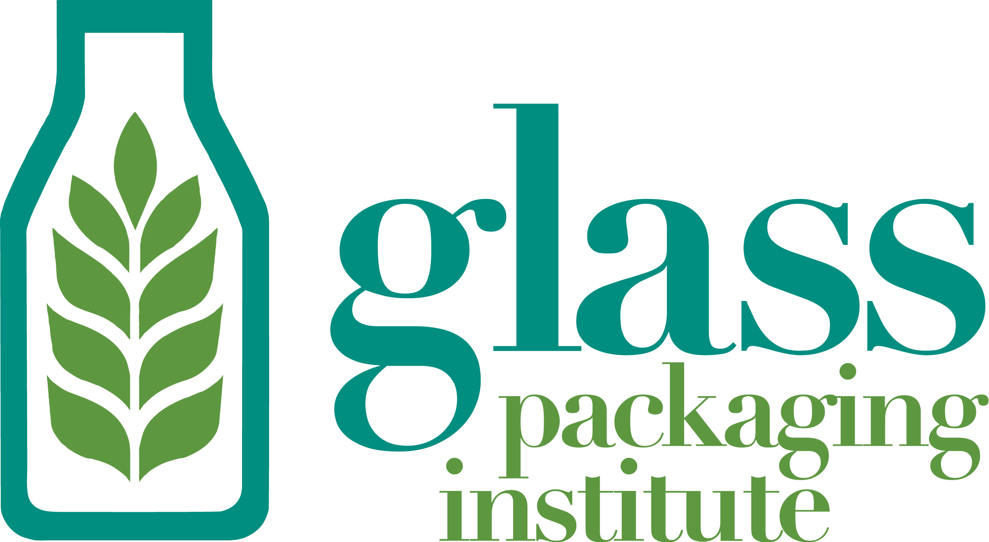

January 20, 2017

California Air Resources Board
1001 I Street
Sacramento, CA 95814

The Glass Packaging Institute (GPI) provides the following comments on behalf of the California glass container manufacturing industry, representing more than 2,000 employees at the four remaining glass container manufacturing plants.

These comments are in response to the December 21, 2016 ARB issued Modified Text and Availability of Additional Documents and/or Information for the California Cap on Greenhouse Gas Emissions and Market-Based Compliance Mechanisms Regulation.

The California glass container manufacturing industry request our industry’s post-2020 industry assistance reflect our “high-leakage” status and be retained at 100% of our current allocated credits. Reducing the allocation to 81% will have a significant and potentially devastating production impact on the four remaining California facilities.

We are also requesting that our use of recycled glass, sourced from California, be retained as an early action credit and part of any changes to the industries emissions benchmark.

As explained in comments submitted in 2016, and below, to CARB, California’s container glass container manufacturing industry competes directly with out of state and international glass plants. In fact, GPI has advocated since 2011, that the Cap-and-Trade program puts facilities that operate in the state under constant competitive pressures and costs that other facilities operating throughout North America do not face. Further, providing a 100% assistance factor to the glass container manufacturing industry does not in any way jeopardize the state’s GHG reduction goals, or give industry a free pass on compliance.

University of California, Berkeley Report:

In the final report to CARB issued in May 2016 Final Report to CARB on Employment and Output Leakage under California’s Cap-and-Trade Program, on page 16, clearly states that no EITE industry participant is impacted more by leakage than the glass container manufacturing industry, anticipated to lose significantly in terms of output (17.10%) and jobs (13.31%). Further, the report made the following conclusion about the impact on industries who operate and purchase energy in the state: “an increase in California energy prices relative to prices in nearby regions will raise production costs in energy-intensive industries located in California and likely result in short-term (one year) losses in output, employment, and value added for those industries.”

California Glass Container Manufacturing Company Capital and Environmental Investments:

The three California glass container manufacturing companies have made sizable investments to improve the efficiency of their plants, and to reduce greenhouse gas emissions. The California glass container manufacturing industry investments were made well in advance of Cap and Trade program regulations.

Since 1993, California glass container manufacturing companies have invested $101.1 million directly into efficiency of their glass container plants ($66.3 million of this investment since 2006), thereby reducing associated GHG emissions levels.

Specific investments have been made in the following equipment and technology include at multiple California glass container manufacturing plants:

- Converted furnaces to oxygen or “oxy-fueled” – reducing the levels of nitrogen oxide, fuel consumption and associated greenhouse gas emissions.
- To further improve efficiencies, oxygen plants have also been installed. In glass container manufacturing furnaces, this permits oxygen to be more effectively used to reduce energy needed to reach optimum melting temperatures, and improve the overall melting process.
- Updated and installed Continuous Emissions Monitoring Systems (CEMS) at the plants, as well as replacing and upgrading flow monitoring equipment.
- Scrubber and EP Systems have been updated and installed to reduce air emissions.
- Installed additional recycled glass bunkers and silos, in order to accommodate hundreds of thousands of tons of recycled glass annually.
- Replaced furnace burners to improve energy efficiency.
- Upgraded furnaces designs to improve energy efficiency.
- Installed predictive controls on furnaces to improve energy efficiency.

These investments in energy efficiency improvements do not include an additional $105 million California glass container manufacturing companies have spent over the past decade to keep plants operational.

Credits for Early Action Need to be Maintained:

In addition to the efficiency investment described, California glass container manufacturing companies have purchased substantial recycled glass, for use in the manufacture of new bottles and jars. The use of recycled glass in the production of new glass containers reduces energy (2-3% for every 10% of recycled glass and associated greenhouse gas emissions (4-8% for every 10% of recycled glass).

This is an important issue for the GPI companies. The glass container manufacturing industry purchases large amounts of recycled glass processed in the state and the industry benchmark should continue to recognize this point.

Maintaining early action credit and a high industry assistance factor does not eliminate the cost of compliance for GPI members, and by extension the market signal to reduce GHG emissions. Purchasing California recycled glass is costly. In fact, recycled glass sourced in the state is often at a 30% higher cost than recycled glass in neighboring jurisdictions.

Since 2014, the glass container manufacturing industry has purchased roughly 1.5 million tons of recycled glass for reuse in California glass container plants, at an estimated cost of $135 million. This effort, along with the installation of energy efficiency based equipment and technology, has helped reduce overall GHG emissions levels in California glass container plants by 4% from 2014 to 2016.

The attached chart demonstrates that glass container manufacturers increased the use of cullet prior to the current cap-and-trade program implementation. Preserving the early action credit only helps to advance the state’s recycling and emissions reduction goals.

Nonetheless, the benchmark was intended to provide early action credit to our industry consistent with the requirements in AB 32. Early action credit helps manufacturing facilities operating in the state to compete with out of state manufacturers which either have not taken early action or do not operate under a similar program. And therefore, producing similar products without the burden of additional cost. These circumstances have not changed, and eliminating early action credit would simply increase the trade exposure and risk of leakage.

Industry is Trade Exposed:

Without certain considerations around the industries benchmark and use of cullet, California glass container manufacturing companies will continue to be affected in a disproportionate manner. Leveling the playing field should be the goal for any climate policy. However, simply adding additional regulatory compliance costs to manufacturers in California may lead to further market erosion to competition outside the State. These include: continued erosion of containers made in-state, quickened market erosion to alternative packaging materials, increased imported product (food and wine and food and wine packaging) from China, product shift to jurisdictions throughout North America where electricity costs less and is more reliable.

The Census Data tab in the CARB issued Post-2020 Assistance Factor Calculations Spreadsheet shows a trade exposure rate of 23.1%. However, this calculation’s latest data is from 2012. As outlined below, trade exposure for the California glass container industry is much higher.

According to data collected by the US International Trade Commission (ITC) 2.1 billion additional containers were imported into the US in 2015, then in 2008. Nationally, imports of glass containers have increased 3-5% annually since 2008. Further collected data culled from the U.S. Census Bureau, Datamyne ® and internal company estimates the following:
- Annual growth rate for imports over 10 years is 14%; including the most recent five years’ growth at 13%, with no signs of slowing.
- In 2015, China surpassed Mexico for most overall glass food and beverage container imports (now accounting for 32% of all imports).
- Imports account for a significant share of the California glass container supply (28% in California, versus 13% nationally).
- The value of glass containers imported into California has doubled between 2009-2015 from $210 million to $510 million.
- In 2015, 81% of all imported glass wine bottles from China came in through the ports of San Francisco, Los Angeles and Seattle. These West Coast ports are the top three in terms of all glass food and beverage packaging points of entry.
- In fact, for the first 6 months of 2016, 47% of all imported glass wine bottles came from China.
- California glass container manufacturing represents 20% of the total US glass container demand.
- The number of imports of 12-ounce glass bottles have increased 16.5% since 2011.
Additional Carbon Credits Purchased

In order to ensure productivity from the four facilities remains constant, the California glass container manufacturing industry, collectively, has purchased 277,933 carbon credits since 2014, at a cost of just over $3.8 million dollars.

These purchases reflect further financial investment in the Cap and Trade program, and clearly demonstrate that the glass container manufacturing industry does not have a “free pass” in terms of compliance obligations.

In conclusion, taking into consideration of the unique, increasing and competitive pressures facing the California glass container manufacturing industry, we request that our industry’s credit allocation remain at 100% of the current allocated amounts and the industry’s early action credits also remain an important part of the benchmark.

Thank you for your thoughtful consideration of our comments. We look forward to working with you on this important issue.

Sincerely,
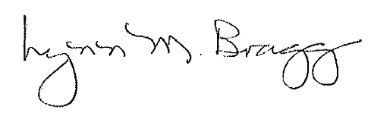
Lynn M. Bragg
President

