March 15, 2022

California Air Resources Board
1001 I Street
Sacramento, CA 95814

Rajinder Sahota
Deputy Executive Officer, Climate Change and Research

Matthew Botill
Division Chief, Industrial Strategies Division

Cheryl Laskowski
Branch Chief, Low Carbon Fuel Standard

Re: LCFS 4th Public Workshop – Comments on the role of waste biomass in the LCFS

To Rajinder, Matthew and Cheryl,

Conservation Strategy Group (CSG) submits this comment letter in response to the Public Workshop to Discuss Potential Changes to the Low Carbon Fuel Standard (LCFS) held on February 22, 2023. We comment on the role of waste biofuels and their exclusion from the California Transportation Supply (CATS) model. We provide recommendations to align the LCFS program with the 2022 Scoping Plan.

Overall, we recommend that CARB develop a Tier-1 calculator for the conversion of biomass into fuels within CA-GREET. Biofuels could then be reflected in the CATS model in a manner that is consistent with the 2022 Scoping Plan, including (for example) a significant role for BECCS-hydrogen. Short of this, we recommend that CARB develop guidance on acceptable approaches to perform woody biomass lifecycle assessments. This is currently a key hurdle to project development, as multiple projects are challenged to move forward without a carbon intensity (CI) value for biomass feedstock from CARB. As a first iteration, this guidance could be limited to waste feedstocks in California to limit complexity.

This letter follows previous letters we have submitted to CARB on woody biomass in collaboration with researchers and local community and environmental groups.

Neglecting waste biomass will result in significant new emissions sources for the state

California has an abundance of forest and agricultural waste biomass. It is estimated that the state produces about 35 million dry tons of these residues each year, the majority of which are either open burned, combusted in wildfire, left in piles to decay, or landfilled (Figure 1). As a rough calculation, this amount of waste is equivalent to 64 million tons of carbon dioxide (CO₂), or about 17% of the state’s GHG inventory. This excludes the possibility of the CO₂ being emitted as methane or black carbon – both with much higher radiative forcing impacts. In other cases, the biomass may contribute to catastrophic wildfire. For example, the 2020 fire season alone emitted over 100 million tons of CO₂ – an amount greater than the state has reduced since the passage of AB 32. Overall, a strategy to manage biomass waste is important for the state to avoid falling short of its 2030 and 2045 climate targets.

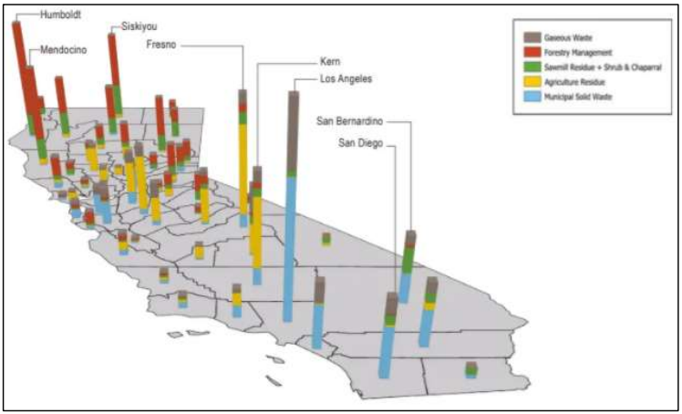
Figure 1. This figure highlights California’s biomass waste resources on a per-county basis. Significant volumes of forest waste (red) are available in Northern California, while the Central Valley is dominated by agricultural waste (yellow). Source: LLNL (2020)

Multiple studies identify the need to convert waste biomass into liquid and gaseous fuels via processes such as gasification and pyrolysis to achieve economy wide net-zero emissions targets. In a literature review of potential wood biomass-to-product options, the Joint Institute for Wood Products Innovation identified liquid and gaseous transportation fuels as the most commercially and technologically viable conversion option. There are a number of such projects in development around the state.

CATS model misaligned with state policy on waste biomass and CDR

The CATS model proposes zero fuels production from waste biomass, including forest and agricultural residues, projected out to 2045. The model also proposes zero bioenergy with carbon capture and storage (BECCS) to provide needed carbon dioxide removal (CDR). This is misaligned with the 2022 Scoping Plan, which identifies key roles for both hydrogen to support transport decarbonization and BECCS to provide tens of millions of tons of annual CDR for California to achieve net-zero by 2045. It is also inconsistent with Governor Newsom’s directive to CARB to achieve 20 Mt per year of CDR by 2030.

The CATS model is also misaligned with CARB’s mandate to ban agricultural field burning from 2025. Getting to Neutral estimates that there are about 10 million tons of woody agricultural residues produced annually in California. This is a significant amount, and it is currently unclear how producers will meet the mandate. CARB can support its own mandate by enabling LCFS incentives for wood waste diversion to produce liquid and gaseous fuels. The avoided short-lived and criteria pollutant emissions that come from field burning and pile decay can also support CARB’s air pollution goals.

Finally, the CATS model is misaligned with numerous state policies at sister agencies that seek to incentivize forest biomass waste conversion to low-carbon fuels. These include DOC’s $50 million grant program to support forest biofuels projects, CAL FIRE’s $25 million Wood Products Grant Program to support forest bioenergy and other wood products, IBank’s $50 million Climate Catalyst Fund to support forest bioenergy, OPR’s $5 million grant program to resolve challenges related to forest biomass feedstock supply, and CEC’s $9 million solicitation to support ultra-low carbon fuels from forest biomass.

Overall, the CATS model and LCFS program more broadly can be aligned with the 2022 Scoping Plan and state policies at sister agencies by incorporating deployment of low-carbon biofuels and BECCS. To achieve this, we recommend that CARB develop a Tier-1 calculator for the conversion of biomass into fuels within CA-GREET. Short of this, we recommend that CARB develop guidance on acceptable approaches to perform woody biomass lifecycle assessments. This is currently a key hurdle to project development. As a first iteration, this guidance could be limited to waste feedstocks in California, limiting counterfactual considerations in particular to avoid pile burning and decomposition.

Cost estimates for BECCS

CARB staff had requested cost estimates for low-carbon biofuels and BECCS technologies. We direct CARB staff to two leading reports: Getting to Neutral by Lawrence Livermore National Laboratory and Net-Zero America by Princeton University. Each of these studies provide cost estimates for BECCS. Figure 2 shows Getting to Neutral’s cost estimates, which are $64/ton for forest and agricultural BECCS.

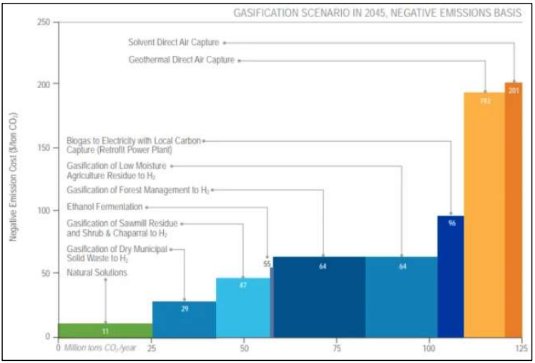
Figure 2. Marginal abatement cost curve of negative emissions options for California. Nature-based solutions are highlighted in green, BECCS in blue, and DACCS in orange. Source: LLNL (2020)

Conclusion

We hope these comments are useful and we stand ready to assist CARB staff with any questions.

Respectfully submitted,

Amanda DeMarco, Conservation Strategy Group
Sam Uden, Conservation Strategy Group

This includes an assumption that the state achieves its forest treatment goal of 1 million acres per year.
1 dry ton of biomass contains 50% carbon. Therefore, 35 million dry tons of biomass contains 17.5 million tons of carbon. To convert carbon to CO2, multiply by 44/12. Therefore, 25*(44/12) = 91 MtCO2 per year.
For example, see: IPCC AR6 Climate Change 2022: Mitigation of Climate Change or the Net-Zero America study.
A subset includes: Mote, Clean Energy Systems, Yosemite Clean Energy, H Cycle, Kore, Raven SR, Aemetis and SG H2 Energy.
2022 Scoping Plan – Appendix H, Table H-13.
2022 Scoping Plan – Table 2-3.

