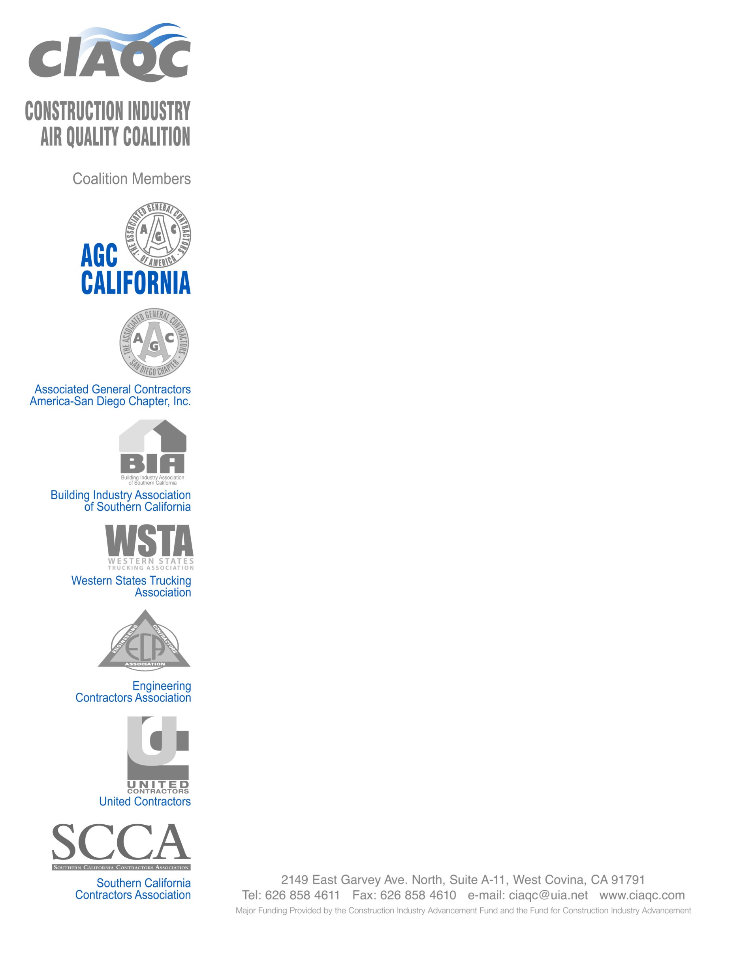
September 25, 2018
Clerk of the Board
California Air Resources Board
1001 “I” Street
Sacramento, CA 95814

SUBJECT: Comments on Proposed Amendments to the Periodic Smoke Inspection
Program (PSIP) 15-Day Comments

Dear Chair Nichols and Members of the Board,

On behalf of our Construction Association members and the thousands of contractors, who operate tens-of-thousands of on-road trucks, we would like to express our dismay at the failure of the final changes to the PSIP to follow the guidance of the CARB Board.

At the May 25th hearing on the adoption of the PSIP amendments we raised five significant concerns about the complexity and cost of the amendments. In addition to burdening a small percentage of the California fleets the proposed amendments establish a reporting system that is unwieldy and unnecessary to the goal of identifying non-compliant trucks. Our biggest concern is that the DMV and CARB systems don’t track vehicles by the same identifying factors and that alone will put every fleet owner out of compliance, through no fault of their own.

We also raised serious concerns about the new requirement to provide a smoke test within 90 days of sale. This was not something that had been presented at any of the workshops or in any of the drafts of the regulation and was added at the very last minute to the staff changes. There is simply no mechanism between DMV and CARB to enforce this, so it becomes unenforceable. In fact, there is no provision in the Vehicle Code for DMV to make a sale contingent upon this test. In reality, it leaves every fleet owner in jeopardy of non-compliance because the two agency systems don’t track the same data in the same fashion and the legal authority to enforce does not exist.

It was our impression at the hearing, that the Board’s adoption made clear the intent to “work with our staff on a 15-day change that might alleviate that reporting burden.” The motion went further to include emphasis that the 15-day changes include “working with the Chairwoman on the issue of record keeping.”

We greatly appreciate the Board’s direction in this regard, but there is nothing in the final proposal to indicate how the inconsistencies and burdensome reporting process will be resolved. Suggesting that some future legislation may resolve the problem is not sufficient certainty for fleet owners. Pushing the start date out to 2023 only adds to the uncertainty.

The resolution needs to include language that would provide for re-opening of the regulation by a date certain to resolve, at a minimum, the issues between CARB and DMV records. Those items include the real owner vs. the operator, engine model year vs. vehicle model year and the registered GVWR vs. GVWR of the vehicle.

As for the smoke test within 90 days of sale issue with respect to legality and enforceability, this must be resolved prior to OAL approval of these amendments. This change must uniformly affect all diesel vehicles > 14,000 pounds GVWR, or be removed from the regulation altogether as discriminatory, and there needs to be some form of state statute in place that provides a level playing field for enforcement.

The construction industry has been a cooperative partner with CARB in developing and operating the PSIP program since its inception. Our members want an understandable and affordable compliance path that will result in real emission reductions. As currently proposed our members are in jeopardy of paper-work violations that could result in substantial fines but result in no emission benefits. Creating more paperwork that doesn’t improve air quality is merely a cost and liability to the construction industry and will not result in scofflaw fleets coming into compliance.

Thank you for the opportunity to comment on these proposed changes. We believe that the Board should withdraw the current 15-Day changes and propose modifications that reflect the intent and direction of the Board to “alleviate the reporting burden.”

The members of the Construction Industry Air Quality Coalition are available anytime to work with the staff on language the will address the Boards concerns.

Thank you.

Sincerely,
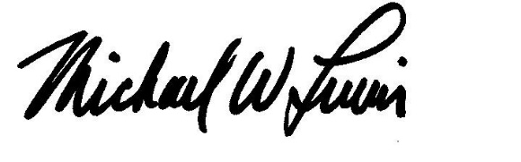
Michael Lewis
Senior Vice President

