January 17, 2017

Clerk of the Board
Air Resources Board
1001 I Street
Sacramento, California 95814

Submitted electronically: www.arb.ca.gov/lispub/comm/bclist.php

Re: Revised Proposed Short-Lived Climate Pollutant Reduction Strategy

Dear Clerk of the Board,
The Association of Home Appliance Manufacturers (AHAM) would like to comment on the California Air Resources Board’s (CARB) November 2016 Revised Proposed Short-Lived Climate Pollutant Reduction Strategy (Revised Proposed Strategy). The previous Proposed Strategy did not align with AHAM’s February 9, 2016 statement indicating the U.S. and Canadian household refrigeration industry has voluntarily set a goal to eliminate the use of high Global Warming Potential refrigerants after 2024. We appreciate CARB’s removal of specific dates when a refrigerant in a product type would be banned. Dates in this area should not be a strategic plan because it would prejudge the rulemaking process that could occur and would not take into consideration changes that may occur once a rulemaking process were to be undertaken.

AHAM represents manufacturers of major, portable and floor care home appliances, and suppliers to the industry. AHAM’s membership includes over 150 companies throughout the world. In the U.S., AHAM members employ tens of thousands of people and produce more than 95% of the household appliances shipped for sale. The factory shipment value of these products is more than $30 billion annually. The home appliance industry, through its products and innovation, is essential to U.S. consumer lifestyle, health, safety and convenience.

Any transition to alternative refrigerants is complex and must be considered at the product design phase. The use of any new refrigerant has to start with safety, thermodynamic properties, toxicity, flammability, material compatibility, and compressor reliability with the proposed substance. Additionally, the use of these new refrigerants will include changes to other parts of the refrigerator (i.e., switches, printed wiring boards, compressors and defrost heaters). Appliance design, engineering and supporting manufacturing infrastructure represent the most expensive and resource-intensive efforts manufacturers must undertake when complying with regulatory changes and will affect the entire household refrigeration category. The many facets of product design include the coordination of environmental, energy efficiency and safety requirements.

Production processes and design are complex and require additional investment if alternative substances present other risks. Hydrocarbons have been identified as an alternative refrigerant, but they are flammable, which impacts both product and production safety. As identified in the October 2014 UNEP Technology and Economic Assessment Panel (TEAP) report, significant barriers and restrictions for HC use include compliance with safety standards, personnel training from manufacturing to supply chain to field service technicians to handle flammable HCs, and proper building code compliance, among other things.

Additionally, HCs are limited to a maximum charge size of 57g in the U.S. and Canada for safety as per UL 250 standard, the tri-national CANENA 60335-2-24, and CSA standard C22.2 NO. 63-93. The 57g restriction limits the ability to cost effectively design and engineer all sizes and types of household refrigerators and freezers. The process to consider and revise product safety standards requires time and effort by both Standards Development Organizations as well as the product safety committee stakeholders.

AHAM appreciates the opportunity to comment on the Revised Proposed Strategy and would be glad to discuss further these important public policy issues. Please contact me at (530) 309-5629 or kmessner@aham.org with any questions or to discuss further.

Sincerely,
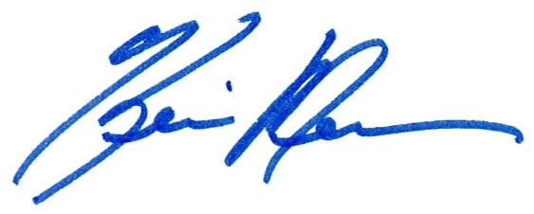
Kevin Messner
Sr. Vice President, Policy & Government Relations

TEAP Report – October 2014

