SANTA MONICA MOUNTAINS CONSERVANCY STAFF COMMENTS
NWL DRAFT CONCEPT PAPGER

The staff of the Santa Monica Mountains Conservancy (Conservancy) is grateful for this opportunity to provide comments to the California 2030 Natural and Working Lands Climate Change Implementation Plan (nwl) Draft Concept Paper and applauds the designation of State Conservancies as Implementing Entities. California’s Conservancies are particularly well-suited to meet near term greenhouse gas emissions reductions goals and targets because they already have the mechanisms and partnerships in place to implement regional programs that serve statewide priorities. Conservancies will be able to leverage allowance revenues with existing funds, form strategic partnerships with local entities, and utilize existing administrative infrastructure to efficiently roll out projects that incentivize and foster ghg reduction goals and further the purposes of ab 32.

After reviewing the draft Concept Paper, the Conservancy is recommending the following changes:
- To be included as an implementing agency for existing categories and activities
- For chaparral and shrubland management to be included along with the existing forest management activities and categories
- Inclusion of Urban Greening and Green Infrastructure activities in recognition of the importance natural spaces can have in urban environments and the related Climate Change benefits.

existing categories and activities

The Conservancy was included as an implementing agency for 3 activities including Oak Woodland Restoration, Land Protection, and Urban Forests. The Conservancy requests to be included as an implementing agency for the following categories and activities:

- Management Practices on Agricultural Lands: Riparian Restoration
- Management Practices on Forest Lands: Partial Cut, Less Intensive Forest Management, Increased Forest Biomass Utilization, Forest Area Expansion/Reforestation

Management Practices on Agricultural Lands: Riparian Restoration.

Recognizing the natural resource value of the Los Angeles River (River), the Conservancy has been planning and implementing riparian restoration projects since 1994. Beginning with the eight-mile soft bottom portion of the river extending south from Griffith Park to Downtown, the Conservancy and the Mountains Recreation and Conservation Authority (mrca) began to develop parks along the river connecting densely populated neighborhoods with parkland and recreational opportunities.

Since the 1940s, the County of Los Angeles and Army Corps of Engineers have managed the River as a concrete flood channel. The communities through which the River passes have had limited contact with or responsibility for the River. In the last several decades, the River has received greater public attention and support for its restoration and availability as an environmental and recreational resource.

Assembly Bill 1558 (ab 1558), Chapter 452, Statutes of 217 requires the Santa Monica Mountains Conservancy and the San Gabriel and Lower Los Angeles Rivers Conservancy to collaborate with the Department of Parks and Recreation, the California Conservation Corps, and the State Lands Commission to develop a river ranger program to provide a network of river rangers who assist the public at sites along the Los Angeles River and its tributaries, as prescribed. The legislation requires the Conservancies, to develop a plan for the design and implementation of the program.

Assembly Bill 466 (ab 466), Chapter 341 of the Statutes of 2017, established, within the Conservancy, the Upper Los Angeles River and Tributaries Working Group (Working Group). ab 466 requires, through watershed-based planning methods and community engagement, the Working Group develop a Revitalization Plan for the Upper Los Angeles River, the tributaries of the Pacoima Wash, Tujunga Wash, and Verdugo Wash, and any additional tributary waterway that the Working Group determines to be necessary.

The unique obstacles that state and local governments encounter while managing the Los Angeles River and its surrounding areas require consideration and coordination with Natural Resource priorities. The Conservancy requests to be included as an implementing agency for riparian restoration to continue restoration efforts along the Los Angeles River and allow for consideration of Climate Change impacts through the process.

Management Practices on Forest Lands: Partial Cut, Less Intensive Forest Management, Increased Forest Biomass Utilization, Forest Area Expansion/Reforestation.

The Conservancy lands serve as a vital carbon sink, provide critical ecosystem services, soften local heat island effects, mitigate dangerous levels of air pollution, support tourism and recreation, and provide critical species habitats in an area where climate change is already altering species natural ranges. The nwl program has the potential to support some of these important programs and functions that make our communities more livable and sustainable. Already, some funds are allocated towards forest management and preservation. However, as climate change increases the risk of droughts, intense flooding, reduced snowpack, invasive species and fires, there should be increased funding for California’s open and natural space conservation and management needs.

In addition, while forest preservation is vital in California, nwl should not risk favoring conservation of forests over chaparral, shrubland, and grasslands. Climate change adaptation and mitigation programs need to foster holistic mitigation and adaptation throughout California in order to prevent disproportionally negative local impacts. Thus, open space and carbon sink management programs should ensure that programs not only target forests in Southern California as well as Northern California, but also target chaparral, which acts as vital carbon sinks and stores large amounts of carbon in soils, where it is less vulnerable to release through fires. In addition, chaparral programs provide important climate change adaptation benefits like storm water capture, water filtration, erosion prevention, heat island mitigation, and biodiversity protection. Increased forest management as well as chaparral and grasslands solutions should be a priority for the nwl implementation plan.

For the reasons stated above, the Conservancy requests to be included as an implementing agency for these activities and that chaparral and shrubland management be added.

additional categories and activities

On Page 2 of the nwl Draft Concept Paper, one of the implementation goals it to “Enhance the resilience of and potential for carbon sequestration on lands through management and restoration, including expansion and management of green space in urban areas, and reduce GHG black carbon emissions from wildlife and management activities.” While there is an Urban Forests category and an Urban Forest Expansion activity, the Conservancy requests that Urban Greening and Green Infrastructure be added or combined with this category with the additional activities below.

The Conservancy has invested in researching the greenhouse gas impacts of various conservation and development scenarios. Our studies found that, by implementing the Conservation Strategies of the Conservancy to curb peripheral development, encouraging infill development instead of suburban development in the greater Los Angeles area, the Conservancy’s Conservation Strategies would reduce ghg emissions per unit of new housing 40% annually while reducing local infrastructure costs 37%. It is important to consider the impacts of transportation, buildings, water, and energy as well as land consumption itself when creating the nwl implementation plan. Conservancies and other major land use partners can act to own, manage and restore peripheral open space and greenbelts. In addition, with appropriate urban conversation program funding, Conservancies can develop attractive urban parks and active transportation routes to make living in urban areas healthy and convenient, facilitating the growth of urban transit-oriented developments attractive to families of all income levels that would otherwise seek suburban sprawl housing.

In addition, delivering multi-benefit green infrastructure can help address longstanding inequalities of opportunity and risk in low-income areas. For example, carbon mitigation in urban areas requires reducing energy use, such as lessening reliance on motorized transportation and lowering home energy use required for cooling. The economic co-benefits of facilitating these changes will have particularly meaningful benefits in low-income neighborhoods where energy costs have a disproportionate impact on household budgets.

Further, the inequitable distribution of green infrastructure amenities also exacerbates the climate vulnerability of low-income populations to threats such as extreme heat and flooding. For example, the strong correlation between urban tree cover and income level within means that low-income neighborhoods where residents are less likely to have air conditioning and more likely to face heat-related health risks also have the most intense urban heat islands.

Urban Greening and Green Infrastructure
- Expansion of Trails and Walk-Bike Corridors
- Expansion of Green Spaces to Reduce Urban Heat Island
- Expansion of Nature-Based Stormwater Projects.

As a regionally-focused entity, the Conservancy has engaged many climate challenges facing large urban areas like Los Angeles. In addition to providing an attractive amenity for urban households, urban green spaces are a cost-effective way to reduce greenhouse gas emissions. Multiple benefit parks that incorporate water recycling and filtration techniques produce verifiable water and energy savings, while urban parks also reduce the heat island effect, improve air quality, and sequester carbon. Furthermore, strategic development of parks, bike paths and greenways along waterways encourages non-motorized transit and promotes investment in disadvantaged or park-poor neighborhoods. Green infrastructure investments provide parks, vegetation, water infiltration and other natural infrastructure to sequester carbon, filter air pollutants, temper heat islands, promote active transportation and incentivize urban (instead of sprawl) living.

Urban greening also contributes significant economic and public health benefits to communities. Park construction and ongoing maintenance creates local jobs that cannot be outsourced. Parks provide a venue for public recreation and social gathering, and are used by individuals of every age, ethnicity, and economic position.

The Trust for Public Land (tpl) has worked with cities to help make vulnerable communities more equitable, livable, and resilient to the effects of climate change. They partnered with city leaders and residents in developing their Climate-Smart Cities program to design, fund, and build climate-smart parks and green spaces where they're needed most.
tpl’s program helps cities use parks and natural lands as “green infrastructure.” The Conservancy encourages the inclusion of these and similar activities from the Climate-Smart Cities program and the designation of the Conservancy as an implementing agency.

Expansion of Trails and Walk-Bike Corridors.

In order to sustain a growing population, sustainable urban development must focus on creating livable communities in the urban cores. Cities are focusing on transit-oriented development and working to incentivize infill development to counteract the fact that greenfield development on the periphery is still cheaper and easier. Urban green space and green corridors are a critical piece of the solution to building a healthy, less carbon intensive and attractive urban living environment. Investing in urban parks and green spaces provides important natural and recreational amenities desired in neighborhoods. The Conservancy has experience with active transportation improvements, such as walking and biking paths. These programs are vital to making greenspace accessible and, in terms of climate change, important for creating the urban network of pedestrian and bike friendly paths that connect the public to public transit.

Trails and walk-bike corridors provide carbon-free transportation and link residents to popular destinations and each other. The map to the right depicts opportunities identified by tpl within the Conservancy Zone where active transportation and mobility connections by the various populations considered in the analysis, including low-income populations) priorities (moderate to high).
(Source: TPL Los Angeles – Connect)

tpl’s research found that within the Conservancy Zone, connecting and expanding walk-bike corridors reduces transportation-related emissions by allowing urban residents to make trips by foot or bicycle that they would otherwise make by car. This has a direct, positive impact on greenhouse gas (ghg) emissions, as trip emissions are reduced by 100 percent. Research has demonstrated that increasing a neighborhood’s “walkability” by just 5% is correlated with driving 6.5% fewer miles per capita. By providing urban residents with lower-carbon transportation options and reducing the need for driving will contribute to emissions reductions in the transportation sector, which accounts for 26.9% of regions total ghg emissions.

Expansion of Green Spaces to Reduce Urban Heat Island.

Green spaces reduce the urban “heat island” effect, protect people from heat waves, and reduce summer energy use. Elevated daytime temperatures affect communities, and especially disadvantaged communities by increasing energy demand, such as air conditioning costs, which increases air pollution, and greenhouse gas emissions. tpl found that this can necessitate an extra 5 - 10 % of energy use for cooling urban buildings during peak energy use periods. This has important climate change impacts, as extra energy use for cooling results in additional greenhouse gas emissions, a vicious cycle that will further increase global air temperatures and urban heat challenges.
This map highlights urban heat island hotspots in the Los Angeles area. (Source: TPL Los Angeles – Cool).

Expansion of Nature-Based Stormwater Projects.

Water-related energy consumes roughly 19% of the State’s electricity. Of that 19%, 2-3% of California’s total electricity consumption is dedicated to pumping water over the Tehachapi Mountains, bringing water into Southern California population centers. Water-smart parks, playgrounds, and green alleys absorb rainfall, reduce flooding, and recharge drinking water supplies while saving energy for water management. The Los Angeles region currently imports approximately 85% of the water it uses. As the region continues to grow and develop the demand for water increases but imported water supplies stay the same or decrease. Additionally, changes in land use coupled with changing precipitation patterns are increasing the amount of stormwater runoff during rainfall events and altering the natural hydrologic regime. Increased stormwater leads to stream channel erosion, increased levels of pollutants entering streams, rivers, and the ocean, increased flooding potential, and higher demands on combined sewer systems. Stormwater also creates other challenges, including increased carbon emissions as water is pumped through sewer systems and then treated in treatment plants.

The Conservancy has an extensive 1,000 square mile jurisdiction in the Southern California region in the Los Angeles urban metropolitan area including the Rim of the Valley Corridor and the upper Los Angeles River and its tributaries. In addition to significant urban greening and strategic buy-back/avoided development programs, the Conservancy is positioned to make significant contributions to water and energy savings in the Los Angeles region.

Water and energy conservation have been central to the Conservancy’s approach to preserving the Mediterranean biome in one of the largest metropolitan areas in the nation. The Conservancy and mrca have created dozens of natural parks along the Los Angeles River and its tributaries, have participated in major planning efforts, and have developed innovative solutions using parkland to clean and infiltrate water running off of city streets before it enters the waterways. The Conservancy has the capability to implement immediate water recycling and energy reduction projects in disadvantaged communities that will have immediate and extensive ghg reduction impacts, and foster local job growth.

The Conservancy along with the Coastal Conservancy recently funded the Community Conservation Solutions’ (ccs) metrics-driven Green Solutions tool shows how nature-based stormwater projects in the Los Angeles area, on existing public land, can create new water supplies, reduce greenhouse gases, restore natural habitat and help improve under-served communities by creating new open space. In this study, ccs found that implementing these stormwater projects would:

- Create 450 acres of new natural habitat in under-served communities
- Create new local water supplies for 52,000 homes/ year
- Replace 9% of energy-intensive imported water
- Reduce greenhouse gases – equal to over 1 billion vehicle miles
- (475,775 tons of carbon over 20 years)
- Prioritize projects in disadvantaged communities

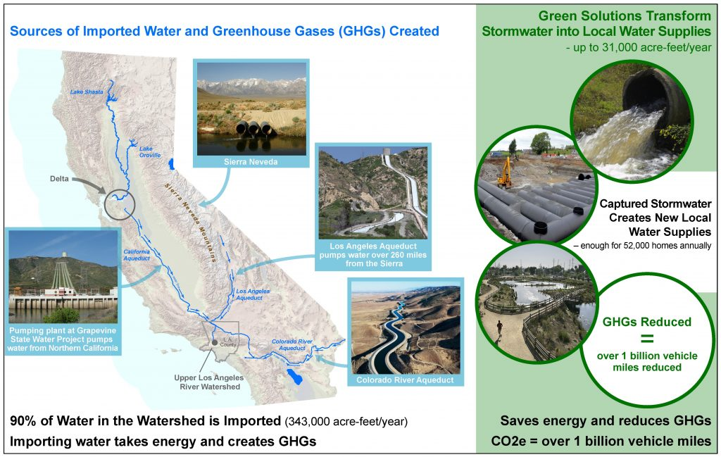

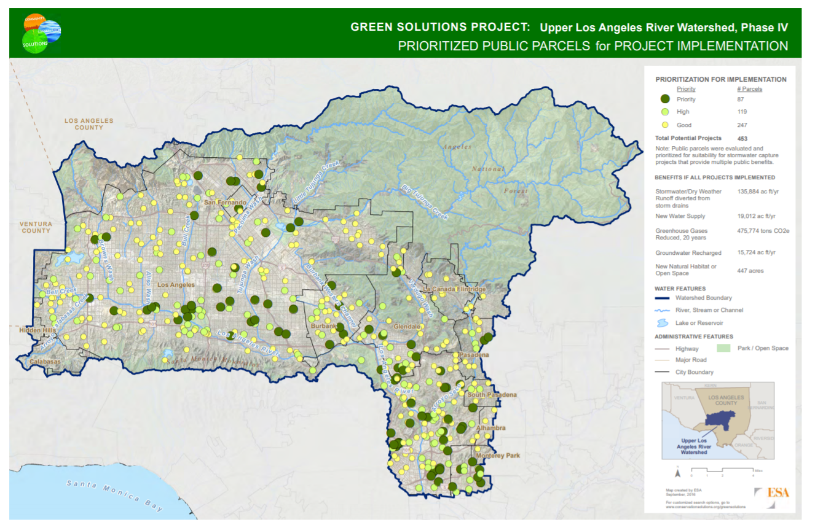

In summary, the Conservancy has the following recommendations:

- To be included as an implementing agency for the following categories and activities:
  - Management Practices on Agricultural Lands: Riparian Restoration
  - Management Practices on Forest Lands:
    - Partial Cut
    - Less Intensive Forest Management
    - Increased Forest Biomass Utilization
    - Forest Area Expansion/Reforestation
- That the Management Practices on Forest Lands listed above, also be implemented on chaparral and shrublands.
- The addition of an Urban Greening and Green Infrastructure Category, to include:
  - Expansion of Trails and Walk-Bike Corridors
  - Expansion of Green Spaces to Reduce Urban Heat Island
  - Expansion of Nature-Based Stormwater Projects.

The Santa Monica Mountains Conservancy is uniquely qualified to help the state achieve its ghg reduction targets and further the aims of AB 32. As a regionally based state agency, the Conservancy has been a leader in promoting partnerships with all levels of government to leverage funds and scientific expertise to achieve common goals of protecting open space and creating public parkland serving a diverse population of more than 15 million. The Conservancy is poised to help the state achieve immediate, measurable, and significant ghg reductions in Southern California with projects in disadvantaged communities that leverage funds, foster job growth, and create lasting impact and appreciates this opportunity to comment on the Natural and Working Lands Draft Implementation Plan Concept Paper.

