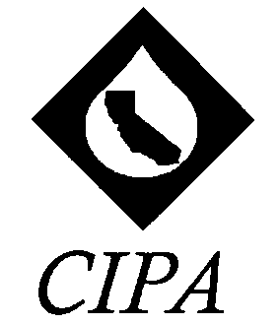
California Independent Petroleum Association
1001 K Street, 6th Floor

Sacramento, CA 95814
Phone: (916) 447-1177
Fax: (916) 447-1144

Comments of the California Independent Petroleum Association
on the Proposed Amendments on the Allowance
Formula in the Cap and Trade Regulations

June 21, 2016
California Air Resources Board
1001 I Street
Sacramento, CA 95814

Via electronic submittal to: http://www.arb.ca.gov/lispub/comm2/bcsubform.php?listname=ctleakagestudies-ws&comm_period=1

The California Independent Petroleum Association (CIPA) appreciates the opportunity to submit the following comments to the California Air Resources Board (CARB) for its consideration. These comments respond to and focus on the May 18, 2016 Leakage Workshop and their considerations on the calculation of industry assistance in determining allowances in the Cap and Trade program.

The mission of CIPA is to promote greater understanding and awareness of the unique nature of California's independent oil and natural gas producer and the market place in which he or she operates; highlight the economic contributions made by California independents to local, state and national economies; foster the efficient utilization of California's petroleum resources; promote a balanced approach to resource development and environmental protection and improve business conditions for members of our industry. In-state petroleum production can play a role in helping the state meet its dual goals of a strong statewide economy while reducing GHG emissions in California.

Maximizing the industry Assistance Factor is the best way to combat the threat of GHG emissions leakage from our industry. CIPA understands the importance of addressing this issue within the Cap and Trade Program, but also highlights that failing to maximize the free allocations to California industry prior to a more uniform and ubiquitous carbon price signal worldwide puts California entities at a disadvantage. Crude oil is an international commodity. Any reduction in the Assistance Factor from its current level will create added pressure for potential leakage of GHG emissions to other regions not similarly regulated. Though a few additional jurisdictions are beginning to start down the road of putting a price on carbon, the transition relief currently provided is still needed as the threat of leakage from world crude oil imports hasn’t decreased since California’s Cap and Trade Regulation was first adopted.

Uneven regulation of GHG emissions has the unintended consequences of incenting the importation of crude oil. The pull from other markets, lesser regulated oil producing regions, is real. California’s progressive implementation of emissions targets make carbon an additional factor affecting costs for petroleum producers. Retaining the current Assistance Factor for in-state oil producers will continue to ease the disparity caused by the Cap and Trade compliance costs.

Further, more stringent 2030 GHG targets should look to coincide with potential advances in emissions reducing technologies available to industry. The industry Assistance Factor is one part of the overall allowance formula; however maximizing that value provides an opportunity for limited capital to be directed at emission reductions, rather than purchasing compliance obligations.

As this process moves forward, CIPA looks forward to continually working with CARB on this program. Thank you for your attention to this important matter. Any questions or follow-up comments can be directed to rock@cipa.org.

Sincerely,
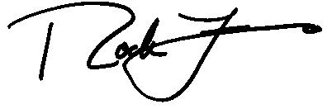
Rock Zierman
CEO

317184653.1

