September 23, 2013

Clerk of the Board
California Air Resources Board
1001 I Street
Sacramento, CA 95912
via web portal - http://www.arb.ca.gov/lispub/comm/bclist.php

RE: Proposed Amendments to the Aerosol Coating Products and the
Consumer Products Regulations

Clerk of the Board:

Aervoe Industries, Inc. appreciates the opportunity to comment on proposed amendments to the Consumer Products Regulation and the Aerosol Coating Products Regulation. These proposed amendments are scheduled to be heard on September 26 by the California Air Resources Board (CARB).

Aervoe Industries is a leading manufacturer and formulator of paints, specialty coatings, cleaners, lubricants, and other products for industrial use for more than 40 years.

Aervoe has the following comments:
- Aervoe is very concerned that the Aerosol Adhesive limits being proposed by the staff are not technologically and commercially feasible. Aervoe does not have a current path to meet these limits. We will research available technologies for formulations to meet these limits. Aervoe respectfully requests the staff to review the Aerosol Adhesive limits one year prior to the effective date to ensure that the technology exists to comply with these very stringent limits.
- Aervoe supports the addition of the terms Single Purpose Cleaner and Single Purpose Degreaser. These terms were needed to clarify that products designed as a specific cleaner/degreaser are not general-purpose products. Certain cleaning applications require specific needs, which cannot always be met by a general-purpose product.
- Aervoe supports the definition changes to the Dry Lubricant, and Multi-purpose Lubricant. The Dry Lubricant change was needed to ensure that Dry Lubricants were not subject to other lubricant VOC limits. The Multi-purpose lubricant change was needed to clarify that product for uses as a single use are not regulated by the Multi-purpose Lubricant limit. Both changes clarified the regulation.
- Aervoe supports the extension of the Multi-purpose Lubricant VOC limit from 12/31/2015 to 12/31/2018. This change was needed to provide Industry more time to meet this very stringent limit.
- Aervoe supports the CARB staffs’ scientific approach to the Low Vapor Pressure (LVP) definition issue. The Industry has invested significant dollars in research and development to utilize LVP compounds to improve the Air Quality in the State of California.
- Aervoe supports the Specialty Coating limits and the fact that CARB capped these limits to prevent future increases.

Aervoe Industries, Inc. supports the amendments to the Consumer Products regulation and Aerosol Coating Products regulation with added consideration on all comments mentioned above. Thank you for your consideration. Any questions or comments feel free to contact our consultant Doug Raymond at 440-474-4999 or at djraymond@reg-resources.com.

Sincerely,
Aervoe Industries, Inc.
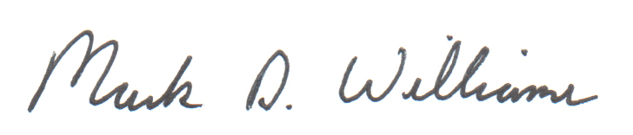
Mark D. Williams
President

