California Air Resources Board

Joint Agency Symposium on the Governor’s Greenhouse Gas Reduction Goals

CLEAN COALITION COMMENTS ON THE IMPACT OF TRANSMISSION ACCESS CHARGES ON IMPEDING DEVELOPMENT AND CONTRIBUTION OF DISTRIBUTED RENEWABLE GENERATION IN ACHIEVING GREENHOUSE GAS REDUCTION GOALS

Kenneth Sahm White
Economics & Policy Analysis Director

Clean Coalition
16 Palm Ct
Menlo Park, CA 94025

August 7, 2015
CLEAN COALITION COMMENTS ON THE IMPACT OF TRANSMISSION ACCESS CHARGES ON IMPEDING DEVELOPMENT AND CONTRIBUTION OF DISTRIBUTED RENEWABLE GENERATION IN ACHIEVING GREENHOUSE GAS REDUCTION GOALS

INTRODUCTION

On July 9th the California Public Utilities Commission, California Energy Commission, California Air Resources Board, and the California Independent System Operator held a Joint Symposium on the Governor’s Greenhouse Gas Reduction Goals. The Clean Coalition offers these comments regarding the impact of the application of Transmission Access Charges on the ability of non-transmission dependent distributed renewable generation to contribute to greenhouse gas reduction.

The Clean Coalition is a nonprofit organization whose mission is to accelerate the transition to renewable energy and a modern grid through technical, policy, and project development expertise. The Clean Coalition drives policy innovation to remove barriers to procurement and interconnection of distributed energy resources (“DER”)—such as local renewables, advanced inverters, demand response, and energy storage—and we establish market mechanisms that realize the full potential of integrating these solutions. The Clean Coalition also collaborates with utilities and municipalities to create near-term deployment opportunities that prove the technical and financial viability of local renewables and other DER.

SUMMARY
Cost effective reduction of GHG emissions requires accurate assessment of the cost of alternatives and selection of the lowest total net cost option. Under current CAISO tariff language, transmission access charges (TACs) are assessed against the gross customer load of the state’s major investor owned utilities instead of the portion of load served by transmission resources (i.e. as measured at the transmission interface). This has the impact of assessing the delivery cost of local distributed renewable resources that serve loads without the use of the transmission system comparably to generation delivery cost of utilizing the transmission system. As a result, local renewable generation is not credited with the full avoided cost value it can offer, and development of lower net total cost local renewables is depressed. Correction of this cost allocation would support accurate least cost and best fit procurement of resources required to reduce GHG emissions.

DISCUSSION

Locational Value
Distributed generation has significant locational value to ratepayers, including avoided transmission costs, avoided line losses, and avoided transmission and distribution upgrade costs. Such value especially applies to any portion of the generation that is deemed Deliverable and does not exceed 100% of the coincident load at the substation, as all such generation avoids use of transmission system and costs associated with delivering energy to load. This local generating capacity may also avoid, reduce, or defer the need for additional new transmission capacity.
For example, in collaboration with Pacific Gas & Electric, the Clean Coalition is currently performing a detailed analysis of the economic and environmental impacts of a high distributed generation and intelligent grid project for the underserved Bayview-Hunters Point area of San Francisco. The Hunters Point Project, named after the substation that serves both the Bayview and Hunters Point areas, will demonstrate the feasibility and practicality of providing up to 25% of total electric energy consumption though local renewable generation, effectively meeting the bulk of current RPS requires through a combination of wholesale DG and DG on the customer side of the meter. As part of the Hunters Point Project Analysis, the Clean Coalition found that over the course of 20 years, each additional 10 MW of local distributed generation could avoid $7,580,000 in Transmission Access Charges, $2,367,000 in line losses, and an average of $6,100,000 in new transmission capacity costs.

Transmission Access Charges
Transmission related costs of delivering energy from remote generation are often combined into costs that are charged by the transmission operators. In California, these costs are called Transmission Access Charges (TACs). This is a flat “postage stamp” fee for every kWh delivered to the distribution system from the transmission grid. TACs are avoided on energy that is delivered directly to the distribution system to serve loads on the same substation.
The High Voltage TAC currently is charged at $8.86/MWh and is consistent throughout the CAISO system. The Low Voltage TAC applies to the CAISO operated portion of systems within each individual utility service territory. For PG&E the use rate charged is currently $6.057/MWh, resulting in a total 2013 charge of $14.92/MWh (1.492¢/kWh). While the threshold definition of sub-transmission voltage and ISO operation varies between utilities, comparable cost allocation occurs either through ISO charges or internal utility accounting.
TAC rates have increased at an annualized rate exceeding 15% since 2005 as new transmission dependent generation has been approved, and new transmission capacity is far more costly than maintaining existing capacity. CAISO mid value estimates for the rate of increase in TAC charges will be substantially less than the recent trend and prior CPUC estimates, as illustrated below. Utilizing CAISOs current projected average future estimate of 7% nominal escalation (5% real) over the next 20 years, the levelized current value of avoidable TAC charges applicable to a 20 year DG PPA is 2.8¢/kWh.

Historical and Projected High Voltage Transmission Access Charges ($/MWh)
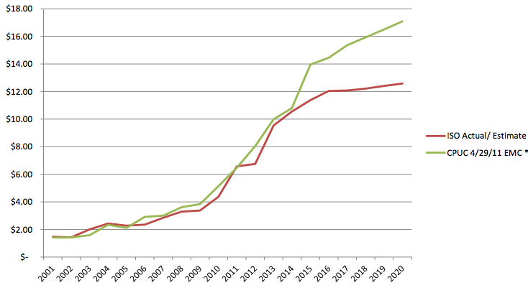
source: CAISO 2012

Avoided Line Losses
Where line losses are avoided, these should be recognized in determining the value of a resource. Average transmission losses are tracked by CAISO for each regional transmission zone and average 3% statewide (with the exception of the LA Basin). Losses also occur on the distribution system, averaging 3%, and proportional to the distance between energy supply and load. Where generation is located in closer proximity to load, these losses may also be reduced. System wide losses are substantially higher due to congestion factors during peak demand periods, averaging approximately 10%, and time of delivery differentials should be recognized.

Avoided future TAC Rate increases on all transmission dependent energy
Deploying distributed generation projects that displace transmission sourced energy during peak demand periods avoids the need to increase transmission capacity, which allows existing transmission investments to depreciate and preempts future investments in transmission – both of which reduce future TAC rates, as reflected in the diagram below.

Figure 3: Clean Coalition estimate of TACs
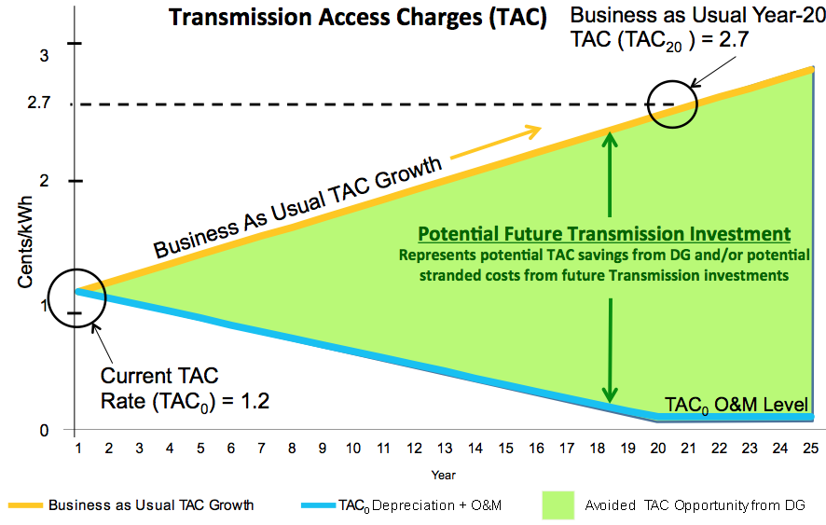
Source: Clean Coalition 2012

The orange “Business as Usual” line represents the expected growth in TACs as more investment is made in the transmission system to accommodate additional remote generation. The blue line represents the decrease in TACs that is possible if that net new additional remote generation was entirely replaced with distributed resources (the down ramp is based on a 40-year average depreciation schedule for TACs-related assets like transmission lines). Thus, the green wedge represents the potential cost savings achieved with distributed resources and continued operation of existing transmission capacity.
Reduced demand on transmission will reduce or defer the need for additional investment to expand transmission capacity, slowing the growth in TAC rates that is driven by the need to recoup new investment costs. Reducing the need for new investment in transmission will reduce charges across the board for all energy utilizing the system in a Merit Order Effect.
Transmission costs vary widely between projects, but if an average figure of $1 Million is used as the marginal cost per Megawatt of new transmission capacity, the savings are seen to accrue rapidly. While existing transmission will still be broadly utilized to supply energy during hours in which local intermittent DG is not available, even intermittent DG can offset its full generation capacity in new transmission capacity required for peak annual transmission loads.
With approximately $20 Billion in planned future investments, 1 GW of aggregated avoided new transmission capacity resulting from procurement of DG represents a 5% reduction in the basis for future TAC rates, or 0.005% per fully qualifying MW. Taking a levelized 20 year TAC rate of 2.4¢/kWh, a 0.005% reduction results in a savings of 0.0012¢/kWh. This appears a very small number, but this savings would be realized by virtually all of the 254,000 GWh consumed within CAISO transmission system electricity by 2020 which is subject to TAC charges. These Merit Order cost savings in TAC charges at 0.0012¢/kWh would equal $30,540 in annual CAISO wide ratepayer savings for each MW reduction in required transmission capacity, assuming a 1:1 peak annual capacity reduction. Applied to a DG PV output of 1,500 MWh/MW/yr, this results in an added ratepayer value of 2¢/kWh. While the applicable transmission capacity reduction will depend on CAISO projected relationship between the generation and peak demand profiles, the value of avoided future transmission capacity cost is too large to ignore.

Issue
Transmission cost is allocated based on electricity use rather than use of the transmission system

The Low Voltage Access Charge and the High Voltage Access Charge are assessed by CAISO against Transmission Users based on Gross Load. Gross Load is defined in the CAISO tariff to include substantially all load served, as distinct from load served by the transmission system:
The CAISO tariff does exclude from Gross Load served by wheeled power, certain station power load, and certain customer-sited generation:
Gross Load shall exclude (1) Load with respect to which the Wheeling Access Charge is payable, (2) Load that is exempt from the Access Charge pursuant to Section 4.1, Appendix I of the ISO Tariff, and [3] the portion of the load of an individual retail customer of a Utility Distribution Company, Small Utility Distribution Company or MSS Operator that is served by a Generating Unit that: (a) is located on the customer’s site or provides service to the customer’s site through over-the-fence arrangements as authorized by Section 218 of the California Public Utilities Code; (b) is a qualifying small power production facility or qualifying cogeneration facility, as those terms are defined in the FERC’s regulations implementing Section 201 of the Public Utility Regulatory Policies Act of 1978; and (c) secures Standby Service from the Participating TO under terms approved by a Local Regulatory Authority or FERC, as applicable, or can be curtailed concurrently with an Outage of the Generating Unit serving the Load.
However, these exclusions do not apply to the load served by typical wholesale distributed generation facilities, because such resources are not necessarily customer sited, and generally serve more than two properties. Accordingly, such load is included in Gross Load even if none of the energy from the locally-sited generation uses the transmission system. In other words, CAISO’s definition of Gross Load allocates the cost of transmission investments based on total electricity consumption in a Transmission User’s service territory, rather than based on a Transmission User’s usage of the transmission system.
This facet of California’s transmission cost allocation scheme is of concern to the Clean Coalition because it partially conceals the benefit of siting generation close to load.

Proposed Solution
Allocate TAC based on usage of the transmission system instead of “Gross Load”

Clean Coalition proposes that Access Charges be allocated based on load actually served by the transmission system, as measured at the interconnection of the CAISO transmission system with local distribution systems, rather than on total load served within. If that proposed policy change were implemented, the selection of a wholesale distributed generation option over a remote generation option would be expected to decrease Gross Load while identifying true least cost contribution potential of generation resources to GHG reduction.

Kenneth Sahm White
Economics & Policy Analysis Director
Clean Coalition
16 Palm Ct
Menlo Park, CA 94025
sahm@clean-coalition.org

Dated: August 7, 2015

The Clean Coalition’s Hunters Point Project Benefits Analysis is available at http://www.clean-coalition.org/site/wp-content/uploads/2013/12/HPP-Benefits-Analysis-19_jb-20-Dec-2013.pdf.
http://www.caiso.com/Documents/BriefingLong-TermForecastTransmissionAccessCharge-Memo-Nov2012.pdf
CAISO, 2012 Local Capacity Technical Analysis Final Report and Study Results, April 29, 2011
Table ES-1: Comparison of Loss Factors, A Review of Transmission Losses in Planning Studies, August 2011, California Energy Commission, CEC-200-2011-009
California Energy Demand 2012-2022 Final Forecast Volume 1: Statewide Electricity Demand and Methods, Mid Energy Demand
The referenced exception applies to: Station Power Load that is directly connected to the transmission facilities or directly connected to the Distribution System of a UDC or MSS Operator located in a PTO Service Territory and that is determined to have been served by On-Site Self-Supply shall be deemed not to have used the CAISO Controlled Grid and shall not be included in the Gross Load of the applicable UDC or MSS Operator. Station Power that is served by Wheeling service and that is determined to have been served by On-Site Self-Supply shall be deemed not to have used the CAISO Controlled Grid and shall not be included in the hourly Self-Schedules (in kWh) of the applicable Scheduling Coordinator that are subject to the Wheeling Access Charge.

