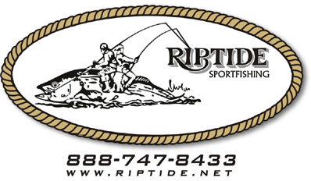

Capt. William E. Smith 1169 Davis st. Redwood City Ca. 94061

Ms. Liane Randolph, Chair
California Air Resources Board, c/o chc2021, 1001 I (eye) Street, Sacramento, CA 95814

Ahoy there,
My name is Captain William Smith of the vessel and company RIPTIDE CHARTERS.
I have owned and operated my business since 1998 as a sole proprietor and this is how I feed my family and pay my bills and operate my business.
I am in the process of repowering my vessel (RIPTIDE) to a tier 3 engine. I am committed to reducing emissions with his expensive project. I am doing this to comply with regulations and to be able to continue my business to pay my bills.
The regulations as drafted require technology that has not been developed or proven safe at sea, and consequently are economically and structurally impossible to comply with – requiring boats constructed of wood/fiberglass to be removed from service as soon as 2031.
Timing could not be worse. With the COVID-19 pandemic came economic consequences and now we are expected to finance a new boat and have it in operation no later than 2034.We can’t afford a new metal boat. Few financial institutions will approve a loan when my existing boat has no resale value in California after being deemed non-compliant.
A very large portion of my business is SEA BURIALS. This is partly done as a public service to offer families a way to inter their loved ones in the ocean. It is a viable alternative to cemeteries both for economic and for religious purposes. This is a vital public service for families to help with the closure of there loved one’s life. Yes, we also operate fishing and whale watching charters as well. These trips help to bolster our local community with the support of hotels and restaurants and stores as these clients spend many dollars in the local community.

Historically, CARB has regulated commercial fishing/whale watching boats
and commercial passenger boats the same way – their engines are technically identical. CARB’s proposed regulations apply a double standard with commercial fishing boats subject to substantially less stringent and less costly requirements. CARB should return passenger boats to the same vessel category as commercial fishing boats so that we can continue to transition to lower emission engines as it is economically feasible, and technology becomes available.

I have worked on the ocean for 50 years. To lose my business would be financially devastating and would force me onto welfare. I am 68 years old, and this is all I have done for my working career.

Capt. Smitty
www.riptide.net
650-728-8433
888- RIPTIDE

