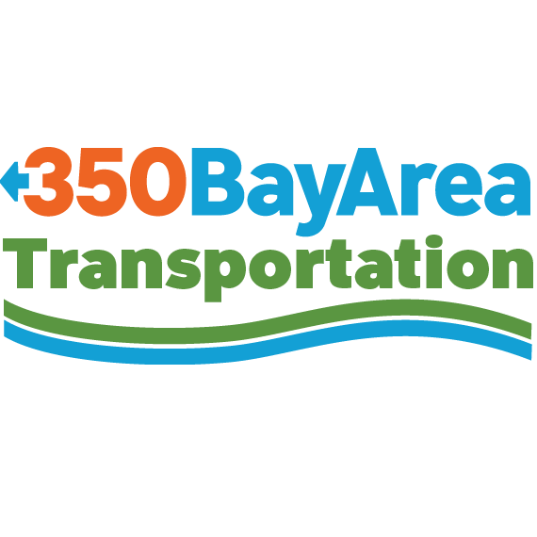

Mary Nichols, Chair

California Air Resources Board

1001 I Street

Sacramento, CA 95814

RE: Proposed Changes to the Clean Vehicle Rebate Project (CVRP)

Dear Chair Nichols:

The Transportation Committee of 350 Bay Area is part of the larger 350BA.org climate advocacy organization working in the greater Bay Area. We have first-hand experience working with cities, community organizations and residents in outreach and education to speed adoption of electric vehicles. In collaboration with various cities and non-profit organizations, we have been giving EV101 classes to the public for the last two years. For the past four years we have been organizing the National Drive Electric Week Ride and Drive event in San Francisco. Therefore, our comments on the proposed changes to the CVRP being considered by the ARB board arise out of our direct involvement promoting broader adoption of EVs among diverse California consumers.

We have reviewed the proposal on the CVRP, and we urge that certain portions not be adopted. We urge that the waiting list for the rebates be retained. People considered an EV need to know what it will cost with certainty. It would be bad faith to tell the public there will be rebates for purchasing an EV, but then have the State refuse to honor the incentive once the funds run out.

As funds are limited, we believe the rebates should apply to all electric vehicles only, not to hybrids nor to plug-in hybrids, unless the latter comes on the market with a more robust range or 80 miles or so. We must now move towards all electric vehicles and phase out ICE vehicles as quickly as we can; the rebates should encourage such behavior.

The number of rebates any one person can receive should be retained at 2 since this continues to incentivize leasing, which has been very popular, and which will continue to provide cars more quickly to the used EV market. The rebate should continue at the $2,500 level.

We appreciate the work staff and the board have done to develop additional elements for the CRVP going forward and believe that the design of these elements is important to get right.

Thank you for your consideration,

Elena Engel, Co-Coordinator, 350 Transportation Committee