Core Program main link
CORE Implementation Manual (Jun 2020 update)

Manufacturer Purchase
The option for a manufacture to use CORE funding for a self purchase was allowed in the original program
Based on available funding and program activity, a manufacturer may, upon CARB case-by-case approval, use a CORE voucher to purchase an eligible equipment piece or conversion kit it manufactured itself to deploy as a demonstration unit.
If the CORE program is planning stop offering the ‘Manufacturer Purchase’ option for some categories, we request that new categories, Locomotives being one of them, be allowed to maintain the Manufacturer Purchase option.

Proposed CORE Locomotive Table
* From 2020 Core IM, all other values RPS proposed
ARB In-Use Regulation cost info

Locomotive Categories or Applications
For the most part a big locomotive can usually do a small locomotive job, but a small locomotive cannot replace a bigger locomotive. For this reason the industry is typically purchasing bigger and more efficient locomotives for long distance train service with longer and longer trains being put together for operating efficiency. The older, smaller locomotives get relegated to local services in urban areas.
Locomotive categories are as more a description off how the locomotive is used more than an exact type of locomotive. Lower power 4 axle freight locomotives have not been manufactured in several decades. All ‘new’ low emissions 4 axle freight locomotives have been manufactured using older locomotives as cores.
The EPA breaks down locomotives into only two categories, CARB has locomotive broken down into 3 categories. We are going to break them down into four categories, but consider only 3 of them appropriate for inclusion in the CORE program in the near future

EPA Certification Duty Cycles
The EPA has two categories for locomotives
- < 1006 HP is not considered a locomotive and should be certified under Part 1039 as an offroad engine
- 1006 < HP <2300 is considered a switcher locomotive
- >2300 HP is considered a line haul locomotive
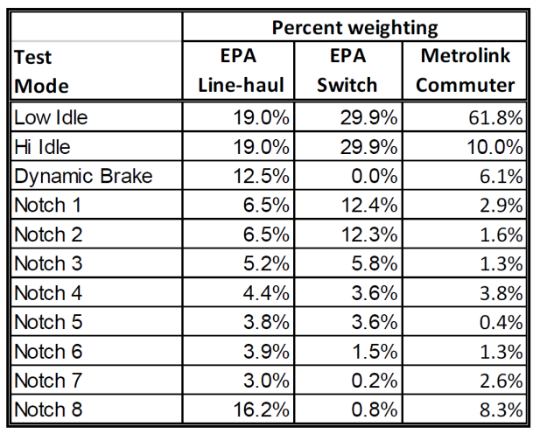
Both switcher and line-haul locomotives are tested at the 11 different power setting in Table 1. The weighting percentages are used to adjust the grams/hphr for each throttle setting into a single weighted value for that criteria emissions.
Passenger locomotives are currently certified at line-haul locomotives, RPS is petitioning both CARB and EPA to determine a more appropriate duty cycle for commuter and intercity passenger locomotives in the next rulemaking that brings about the Tier 5 standard (this is at least 5 years away)
In near future RPS will be applying its own intercity passenger locomotive duty cycle for its passenger locomotive retrofits. This duty cycle is based on limited test data from a Metrolink emissions system demonstration program done in 2009

CARB Locomotive Designations
ARB staff categorizes U.S. diesel-electric freight and passenger locomotives into three major groups, primarily based on horsepower and types of operations:
- Interstate line haul – (>4,000 hp);
- Medium horsepower (MHP) – (2,301 to 3,999 hp); and
- Switch (yard) – (1,006 to 2,300 hp).

ARB staff further refined the U.S. EPA definition of a freight line haul locomotive. ARB recognizes the significant differences between interstate and MHP line haul locomotives based on: 1) age, 2) horsepower, 3) pulling power or tractive effort, 4) activity and annual fuel consumption levels, and 5) the type of work performed. (from ARB 2016 Freight Locomotive Tech Assesment)

Proposed Locomotive Applications for CORE Consideration
from small to large
- Rail Car Movers
- Industrial Switchers or Spotting Locomotives
- Yard Switching locomotives
- Road Switching Locomotives
- Passenger Locomotives
- Line Haul Locomotives

Railcar movers
Not actually a locomotive application, but a vehicle separately classed and regulated by CARB because unlike a locomotive, it also will have rubber tires and can move off of the rails, so in some cases is could be more useful than a locomotive that cannot jump from rail to rail.
The capability of railcar movers will overlap with two type of locomotive, at the low end it could compete with Spotting Locomotives used in industrial services and higher cost units can have similar capabilities to smaller yard locomotives but will require higher maintenance over time.
These units are already covered by the CORE program and only discussed briefly for reference

Industrial Switcher Locomotives
Industrial switcher locomotives are also commonly referred to as spotting locomotives. Typically these locomotives would be under 1006 HP so they would be EPA certified for emissions as off-road equipment and not as a locomotive. They typically are light duty applications and will move a single or short strings of rail cars. ‘Spotting’ means to place a railcar in a position to either fill it or empty it by placing the railcar inline with the ground equipment that does the loading and unloading. These come in 2 axle units as pictured or 3 and 4 axle units. More axles allow more weight and adhesion.

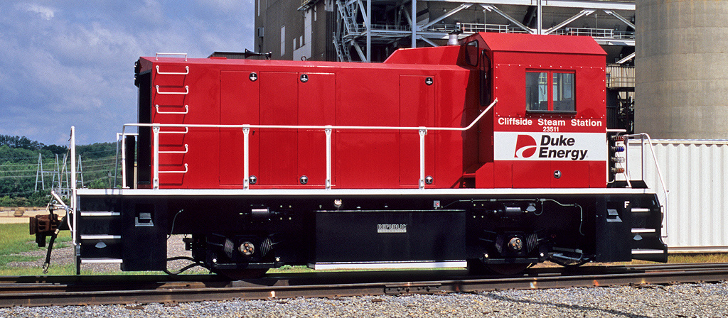

Yard switching locomotives
Yard switching is the process of sorting rail cars in a switching railyard. In this application a smaller locomotive is used to sort railcars between many tracks. In yard switching, the locomotive do not leave the railyard or travel faster than 10 miles per hour. This means that the locomotives do not need more than 1500HP.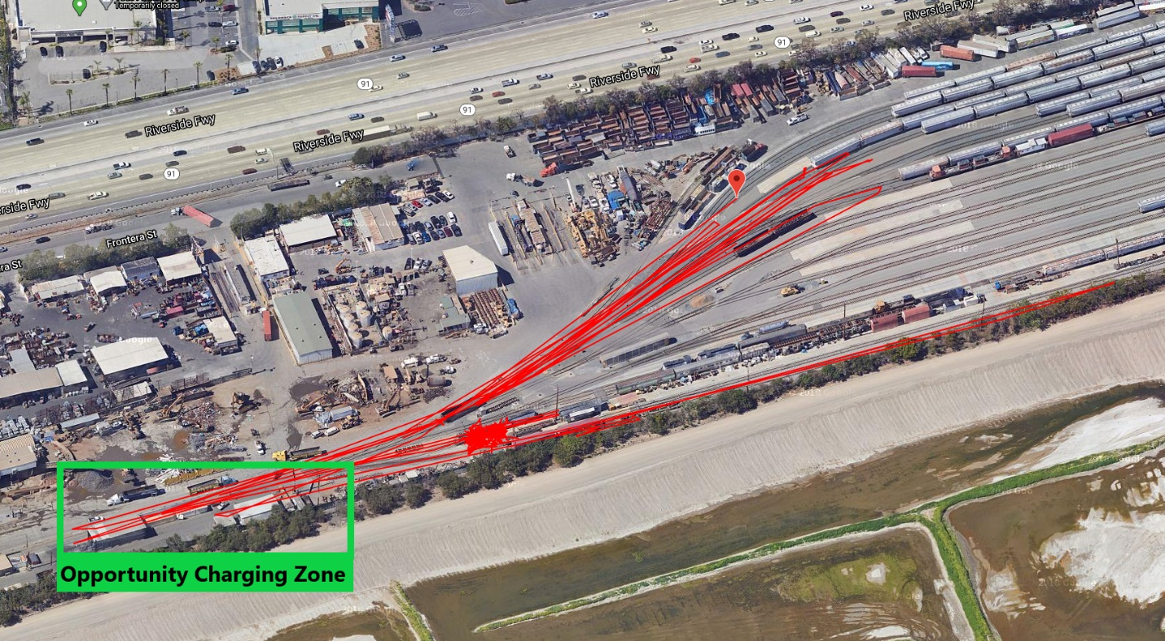
Even though the yard switching application is low horsepower, as it is always starting and stopping small trains it does require high tractive effort which requires a heavy locomotive. For this reason, yard switcher locomotives typicaly are 4 axle units weighing 280,000 pounds, but in some cases will be remanufactured 6 axle line haul locomotives weighing up to 420,000 pounds. In really heavy duty yard switching applications needing more tractive effort, mutliple switcher locomotives will be coupled together or a special mother-slug unit will be used.
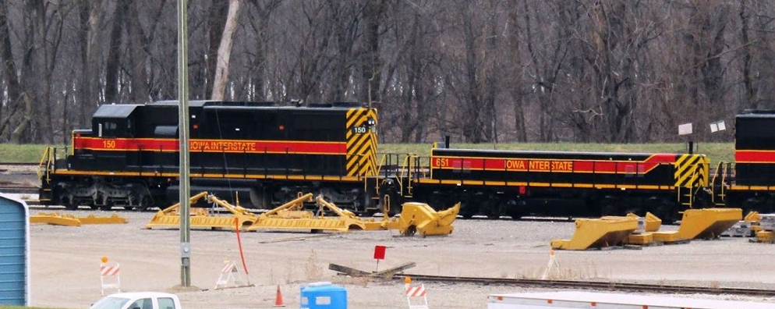

Road Switching
Road switching is less a type of a specific type of equipment and more of a type of service, it is done by higher capacity 4 axle locomotives that also typically serve as yard switchers in larger rail yards. Road switching service involves picking up some strings of railcars from locations within 20 miles of a major railyard. These strings of cars will be built up into longer trains at the railyard which will then be moved by line haul locomotives over longer distances (typically > 500 miles) by line haul locomotives.
Under CARB guidelines road switching locomotives would fall under Medium Horsepower.
For CORE consideration in the near term, road switcher locomotives will be built similar to a higher power yard switcher, but with a range extender. We believe this is the highest capability of locomotive that is likely to fall under the CORE program.

Line-Haul Locomotives
Line haul locomotives are where the larger railroads make their money, in modern times these are all 6 axle locomotives weighing over 400,000 pounds and producing 4300HP of tractive power. Typically they are used in groups of 3 to 5 locomotives. One group of locomotives is always at the front of a train, as radio control technology has matured, the industry is moving more and more towards intercontinental trains over a mile long with additional remove controlled locomotive groups at the end of the train and sometime in the middle.

Passenger Locomotives
Passenger locomotives were typically built up from 4 axle freight locomotives with minor modifications for higher speeds (79 thru 110 mph instead of 55 mph for freight) and the accommodation for hotel power to provide heating, cooling and lights for the passenger cars.
Legacy passenger locomotives typically had a main engine at 3000 tractive horse power for propulsion and a second smaller 800 hp diesel genset for the hotel power.

